Reedley College
Proposed Course Modification

Course # / Title | AUTOMOTIVE ESSENTIALS

CHECK OFF SHEET
PRELIMINARY STEPS. Do before completing Course Modification Form.
(EACH BOX SHOULD BE CHECKED AS COMPLETED BEFORE SUBMISSION.)
☑ 1. Communicate with the Curriculum Chair regarding intent to modify an existing course outline (recommended, not required).
☑ 2. List term for implementation of modifications:
[ ] | Fall |  | [ ] | Spring | 2007 | [ ] | Summer
☑ 3. Check one:
Do not complete Fresno City College course alignment page if:
 | No similar course or program at FCC.
X | Course currently in common with FCC course or accepted in lieu of and changes will not affect status.

Complete Fresno City College course alignment page if:
Course currently in common with FCC course or accepted in lieu of. Changes may affect status. Consult with counterparts at FCC and complete alignment page
Course not in common or accepted in lieu of but may be with proposed changes consult with FCC counterparts

☑ 4. Changes sought in the following:

CSU General Education Code | Yes |  | No | x
Transfer Baccalaureate List | Yes |  | No | x

If yes to either, schedule an appointment with the Articulation Officer
☑ 5. Changes sought in number of repeats for credit:

 | Yes
X | No

If yes, secure a Course Repetition form from the Curriculum Office.
PROPOSED COURSE MODIFICATION FORM
☑ Appropriate sections of Course Outline of Record completed.

FINAL steps (Do after completing Course Outline of Record)

☑ 1. Signature Form. Secure signatures of the Department Chair and the Associate Dean before submitting the completed course proposal to the Curriculum Office.

☑ 2. Program Description. Course modification will change an existing program which is or will be described in the college catalogue.

 | Yes | X | No

If yes, complete Program Description Form before submitting modification.

☑ 3. Final Check. All items above have been completed and checked off before modification is submitted.

Reedley College
PROPOSED COURSE MODIFICATION

All changes and modifications in the official course outline must come to the Curriculum Committee. Though minor changes may seem obvious, even these need to come to committee for information and to update the official curriculum. Changes in programs or in several department offerings should be submitted together if possible so that the whole picture is clear.

OUTLINE. Please fill in current existing course number, title, and units for course to be modified.

Department | AUTOMOTIVE | Course No. | AUTOT 9
Course Title | AUTOMOTIVE ESSENTIALS | Units | 3
 | Effective Date | 10-05-2006

A. PROPOSED CHANGES.
(Indicate below all proposed changes to be made in the course outline.)

I. Cover Page
 | 1. Course ID |  |  | 8. Classification (Degree applicable, Non-degree applicable, or
 | 2. Course Title |  |  | Pre-collegiate Basic skills)
 | 3. Units |  |  | 9. General Education Pattern, Graduation Requirement, and
 | 4. Lecture/Lab Hours |  |  | Major Category
 | 5. Grading Basis |  |  | 10. General Education Pattern/Baccalaureate (CSU)
 | 6. Entrance Skills: Basic Skills Prerequisites/Advisories |  |  | 11. Repeatability
 | 7. Subject Prerequisites/Corequisites/Advisories |  |  | 12. Catalog Description

Other pages

X | II. Course Outcomes |  |  | VI. Methods of Grading
X | III. Course Objectives |  |  | VII. Levels of Educational Materials
 | IV. Course Content Outline |  | Additional Pages (optional depending on course)
 | V. Approved Readings |  |  | Request for Repeatability/Limitation on Enrollment

B. DESCRIPTION OF CHANGES AND MODIFICATIONS.

ITEM NO. | CHANGED FROM | CHANGED TO | REASON
II |  |  | RESTATEMENT: LANGUAGE
III |  |  | RESTATEMENT: LANGUAGE

(Additional sheets may be attached if necessary.)

C. EXPLANATIONS. If course modification results in changes in the program which will require use of the program description form, please give rationale.

No descriptive change is required. A language restatement occurs in the outcomes and objectives.

Please attach the complete outline before modifications to this form. If only the first page of the outline is being modified, also attach the new first page. If other pages of the outline are being modified, please attach the complete new outline.

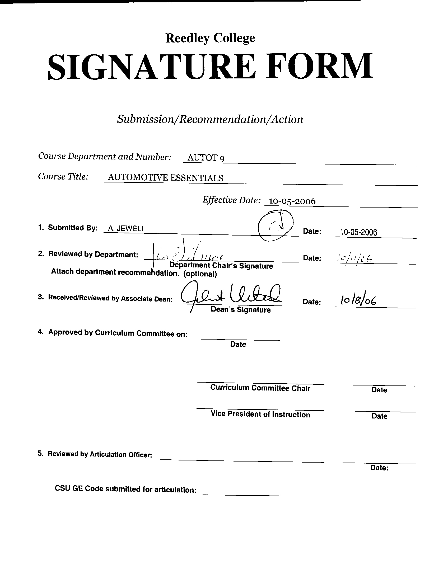
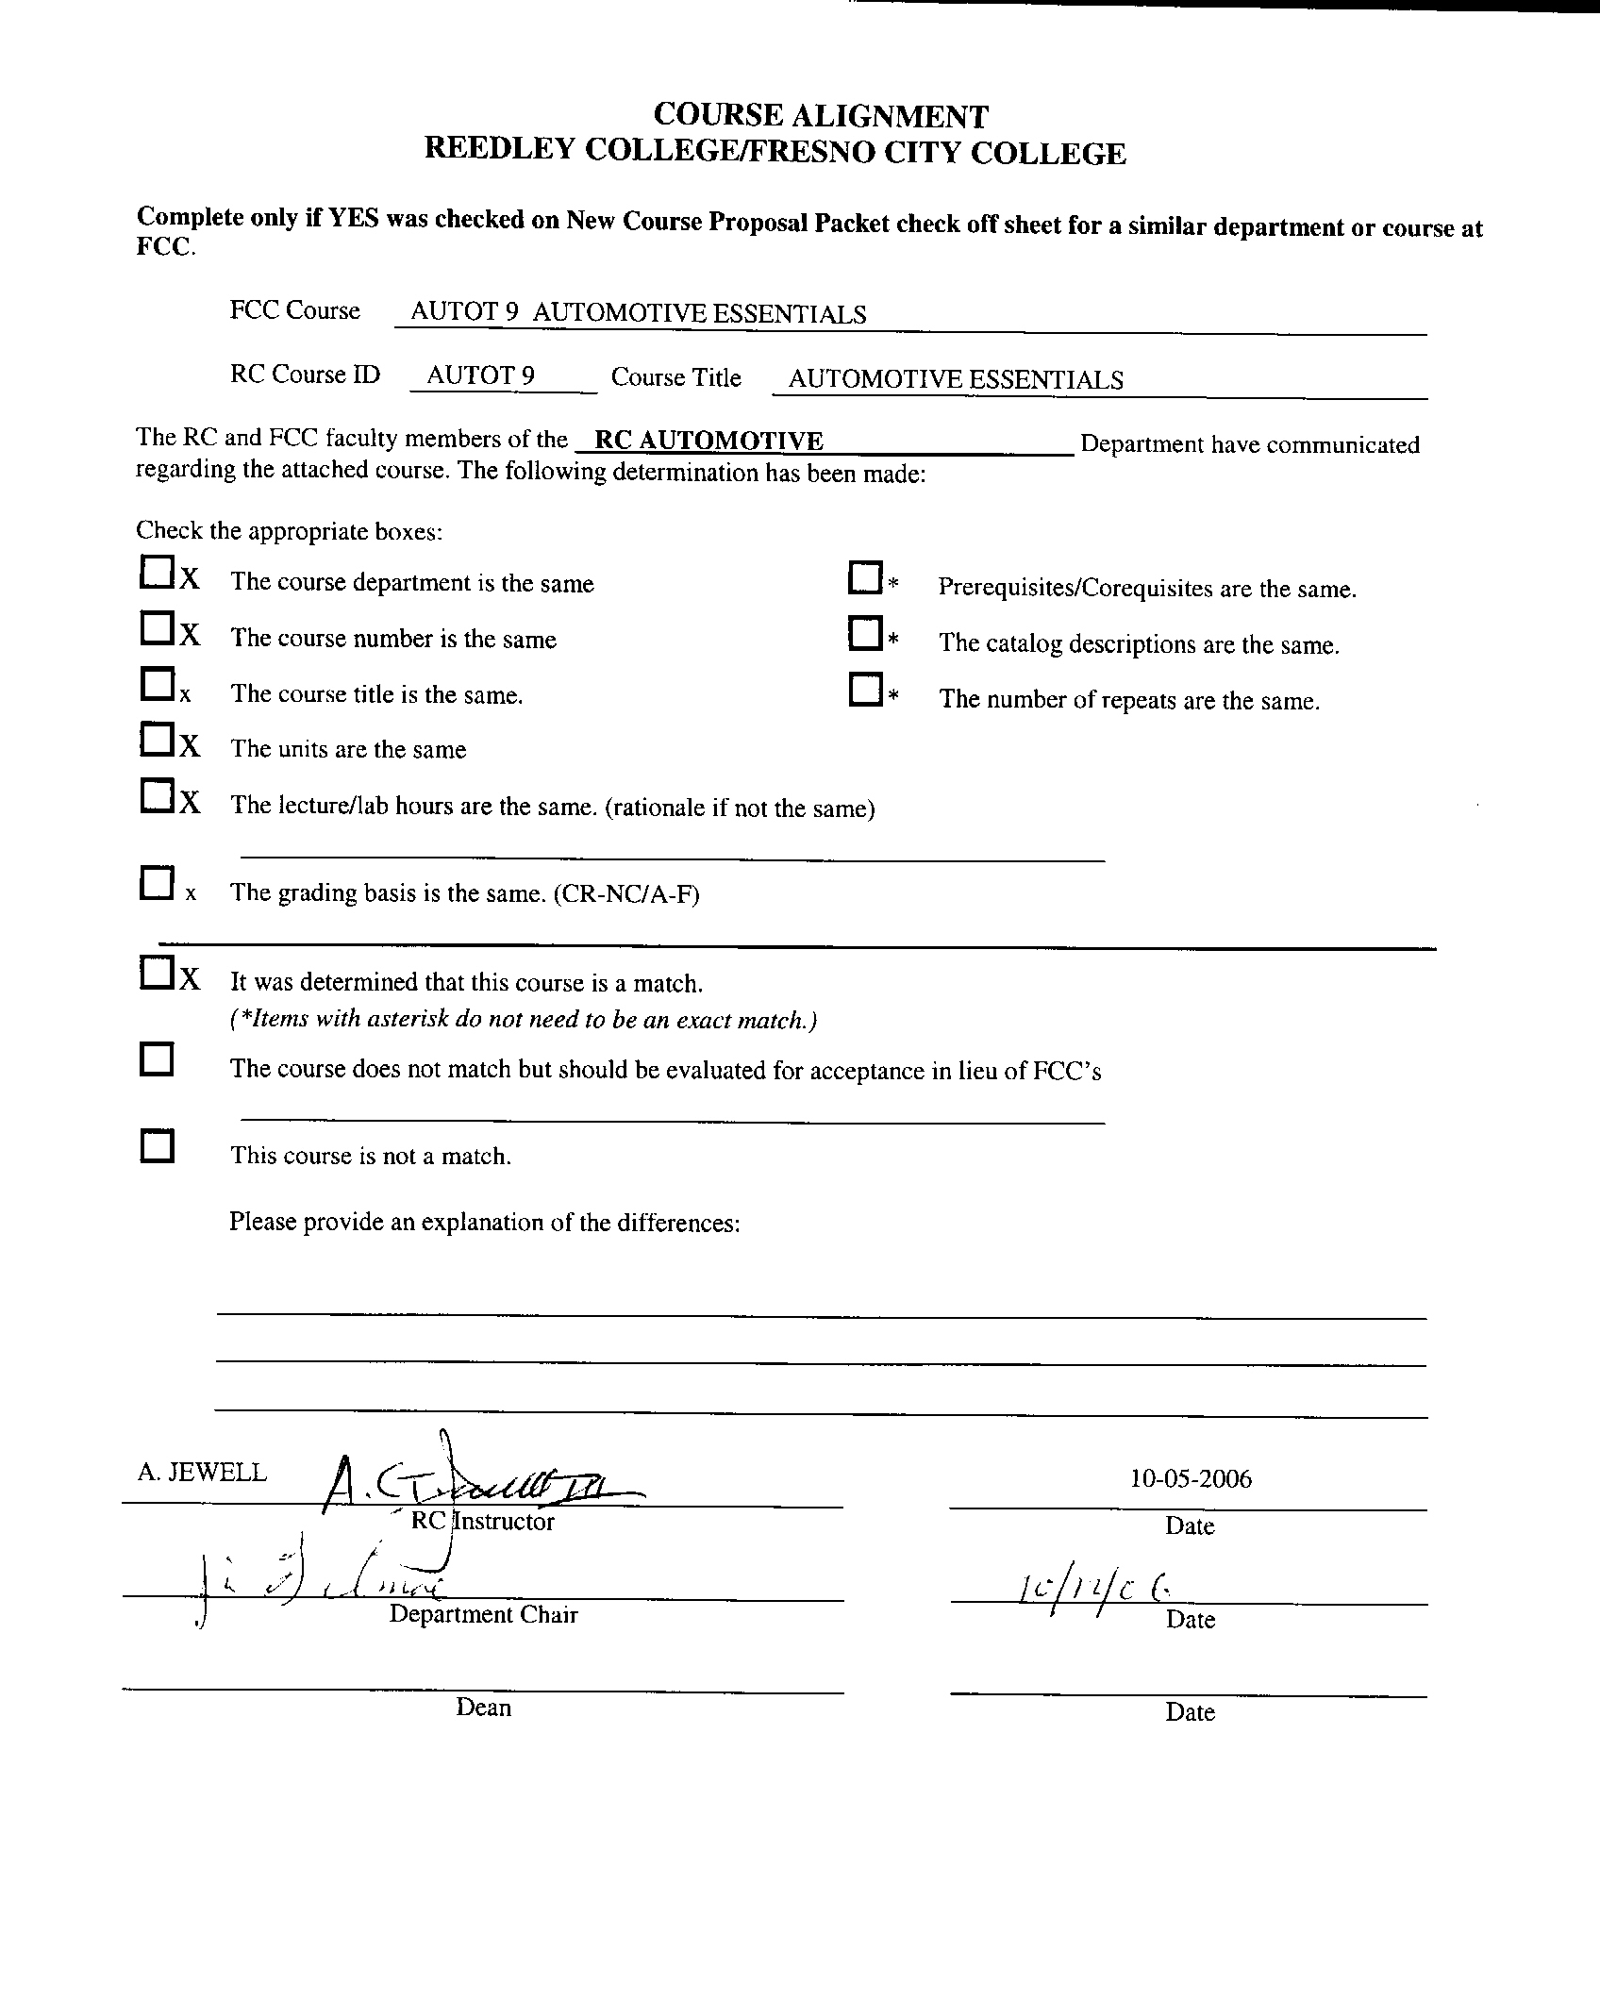


CREDIT COURSE OUTLINE

I. COVER PAGE

(1)  Course ID: AUTOT 9 |  | (2)  Course Title: Automotive Essentials |  | (3)  Units: 3

(4) Lecture / Lab Hours: |  |  | (8)Classification:
Semester course  Hours per week | Lec hrs: | 3
 | Lab hrs: |  |  |  | Degree applicable: |  |  | X
Lab will generate ______ hour(s) per week outside work. |  |  |  |  | Non-degree applicable:
Short-term course:  Hours per course | Lec hrs: |  |  |  | Pre-collegiate basic skills:
 | Lab hrs:
Lab will generate ______ total hour(s) outside work. |  |  | (9)RC | Fulfills AS/AA degree requirement: (area)
(5)Grading Basis: | Grading scale only | X |  | General education category:
 | CR/NC option |  |  | Major:
 | CR/NC only
(6)Basic Skills Prerequisites: |  |  | (10)CSU: |  | Baccalaureate: |  |  | X
 |  |  | (11) Repeatable: (A course may be repeated  three times) |  |  |  |  | 0
Basic Skills Advisories:  Eligibility for ENGL 125, ENGL 126. |  |  | For Office Use Only
 |  |  | CATID: |  |  |  | DATATEL:
(7)Subject Prerequisites (requires C grade or better):  NONE |  |  | Course LHE: |  |  |  | Unit Code:
 |  |  | VEA Code: |  |  |  | SAM Priority:
 |  |  | TOPS Code: |  |  |  | Effective Date:
Subject Corequisites: NONE |  |  | CSU: |  |  |  | Replaces:
Subject Advisories: NONE |  |  |  |  |  |  | Replaced by:  Date:
(12)Catalog Description:

An overview of the automobile and its basic components. General servicing procedures and basic troubleshooting are included for anyone needing an introduction to the operating principles of the automobile.

Course ID: AUTOT 9 |  | Course Title: Automotive Essentials

II. COURSE OUTCOMES:

(Specify the learning skills the student demonstrates through completing the course and link critical thinking skills to specific course content and objectives.)

Upon successful completion of this course, students will be able to:

A. identify and discuss automotive systems and subsystems.
B. explain normal system operations and malfunction diagnostic strategies.
C. identify and describe the tools and service equipment used for automotive service and repair.
D. demonstrate safe use of hand tools and service equipment.
E. recommend repair methods and cost estimates for common automotive service and repair.

III. COURSE OBJECTIVES:

(Specify major objectives in terms of the observable knowledge and/or skills to be attained.)

In the process of completing this course, students will:

A. Describe vehicle operating systems and subsystems.
B. Analyze vehicle malfunctions.
C. Demonstrate the safe use of automotive hand tools and shop service equipment.
D. Recommend repair methods and cost estimates for vehicle repairs.

Course ID: AUTOT 9 |  | Course Title: Automotive Essentials

IV. COURSE CONTENT OUTLINE:

A. Introduction
1. Course orientation
2. Automotive history

B. Shop Practice
1. Hand tools
2. Shop equipment
3. Safety

C. Engines
1. Engine types
2. Engine operating theory
3. Engine size measurement and performance
4. Engine lubrication systems
5. Engine cooling systems

D. Basic Fuel Systems
1. Fuel systems components
2. Principles of carburetion
3. Principles of fuel injection
4. Fuel system servicing
5. Fuel system troubleshooting

E. Basic Automotive Electrical Systems
1. Fundamentals of electricity
2. Electrical meter operation
3. Electronic test equipment
4. Electrical/electronic components
5. Starting systems
6. Charging systems
7. Troubleshooting electrical systems

F. Basic Ignition Systems
1. Ignition system components and wiring
2. Operation of battery ignition system
3. Servicing and troubleshooting ignition systems

G. Preventive Maintenance
1. Vehicle safety and maintenance inspection
2. General servicing procedures

H. Power Train
1. Clutch construction and operation
2. Manual transmission
3. Automatic transmissions
4. Drive lines
5. Differential construction., operation and service
6. Basic power train servicing and adjustment procedures

I. Brake System
1. Brake theory of operation
2. Brake servicing and adjustment
3. Power brake operation

J. Steering System
1. Power steering systems
2. Servicing and alignment

Course ID: AUTOT 9 |  | Course Title: Automotive Essentials

K. Chassis and Suspension system
1. Basic components
2. Operation and servicing

L. Writing service estimates
1. The legal aspects of the law
2. Write it correctly.

Course ID: AUTOT 9 |  | Course Title: AUTOMOTIVE ESSENTIALS

V. APPROPRIATE READINGS

Reading assignments may include but are not limited to the following:

A. Sample Text Title: Automotive Service by T. Gilles 2004
Automotive Technology, J. Halderman 2003

B. Other Readings: Shop manuals and computer service data

Global or international materials or concepts are appropriately included in this course
Multicultural materials and concepts are appropriately included in this course.

If either line is checked, write a paragraph indicating specifically how global/international and/or multicultural materials and concepts relate to content outline and/or readings.

Course ID: AUTOT 9 |  | Course Title: AUTOMOTIVE ESSENTIALS

VI. METHODS TO MEASURE STUDENT ACHIEVEMENT AND DETERMINE GRADES:
Students in this course will be graded in at least one of the following four categories. Please check those appropriate. A degree applicable course must have a minimum of one response in category A, B or C.

A. Writing
Check either 1 or 2 below
x | 1. Substantial writing assignments are required. Check the appropriate boxes below and provide a written description in the space provided.
 | 2. Substantial writing assignments are NOT required. If this box is checked leave this section blank. For degree applicable courses you must complete category B and/or C.
 | a. essay exam(s) |  | d. written homework
X | b. term or other papers(s) |  | e. reading reports
X | c. laboratory reports | X | f. other (specify) Repair orders
Required assignments may include but are not limited to the following:

Repair orders
Diagnostic strategies

B. Problem Solving
1. Computational or non-computational problem-solving demonstrations, including:
X | a. exam(s) | X | d. laboratory reports
X | b. quizzes |  | e. field work
 | c. homework problems | X | f. other (specify) cost estimates
Required assignments may include, but are not limited to the following:

Diagnostic strategies
Cost estimates

Course ID: |  | Course Title:

C. Skill demonstrations, including:
X | a. class performance(s) |  | c. performance exam(s)
 | b. field work |  | d. other (specify)
Required assignments may include, but are not limited to the following:

D. Objective examinations, including:
X | a. multiple choice |  | d. completion
X | b. true/false |  | e. other (specify)
 | c. matching items

COURSE GRADE DETERMINATION:
Description/Explanation: Based on the categories checked in A-D, it is the recommendation of the department that the instructor’s grading methods fall within the following departmental guidelines; however, the final method of grading is still at the discretion of the individual instructor. The instructor’s syllabus must reflect the criteria by which the student’s grade has been determined. (A minimum of five (5) grades must be recorded on the final roster.)

If several methods to measure student achievement are used, indicate here the approximate weight or percentage each has in determining student final grades.

25% written assignments
25% quizzes
50% exams

FOR DEGREE APPLICABLE COURSES

Course ID: AUTOT 9 |  | Course Title: AUTOMOTIVE ESSENTIALS

VII. EDUCATIONAL MATERIALS
For degree applicable courses, the adopted texts, as listed in the college bookstore, or instructor-prepared materials have been certified to contain college-level materials.

Validation Language Level (check where applicable): | College-Level  Criteria Met
 | Yes | No
Textbook | X
Reference materials | X
Instructor-prepared materials
Audio-visual materials

Indicate method of evaluation:
Used readability formulae (grade level 10 or higher) | X
Text is used in a college-level course | X
Used grading provided by publisher
Other: (please explain; relate to Skills Levels)

Computation Level (Eligible for MATH 101 level or higher where applicable) |  | X

Content
Breadth of ideas covered clearly meets college-level learning objectives of this course |  | X
Presentation of content and/or exercises/projects:
Requires a variety of problem-solving strategies including inductive and deductive reasoning. |  | X
Requires independent thought and study |  | X
Applies transferring knowledge and skills appropriately and efficiently to new situations or  Problems. |  | X
List of Reading/Educational Materials

Vehicle specific literature
State of California Emissions and Air Quality Reports

Comments:

 | This course requires special or additional library materials (list attached).
X | This course requires special facilities: Automotive Laboratory

FORM A
TARGET COURSE | AUTOT 9 |  | AUTOMOTIVE ESSENTIALS
 | Number |  | Title

BASIC SKILLS ADVISORIES PAGE The skills listed are those needed for eligibility for English 125, 126, and Math 101. These skills are listed as the outcomes from English 252, 262, and Math 250. In the right hand column, list at least three major basic skills needed at the beginning of the target course and check off the corresponding basic skills listed at the left.

Math Skills (eligibility for Math 101)
(as outcomes for Math 250)

Performing the four arithmetic operations on whole numbers, arithmetic fractions, and decimal fractions.
Making the conversions from arithmetic fractions to decimal fractions, from decimal fractions to percents, and then reversing the process.
Applying the concepts listed above to proportions, percents, simple interest, markup and discount.
Applying the operations of integers in solving simple equations.
Converting between the metric and English measurement systems
Reading Skills (eligibility for English 126)  (as outcomes for English 262)  X Using phonetic, structural, contextual, and dictionary skills to attack and understand words.  X Applying word analysis skills to reading in context.  X Using adequate basic functional vocabulary skills.  X Using textbook study skills and outlining skills.  Using a full range of literal comprehension skills and basic analytical skills such as predicting, inferring, concluding, and evaluating. | Automotive texts and service procedures are written at the college level.  Comprehension of technical service manuals.  Apply analytical skills to problem diagnosis and resolution.
Writing Skills (eligibility for English 125)  (as outcomes for English 252)  X Writing complete English sentences and avoiding errors most of the time.  X Using the conventions of English writing: capitalization, punctuation, spelling, etc.  X Using verbs correctly in present, past, future, and present perfect tenses, and using the correct forms of common irregular verbs.  Expanding and developing basic sentence structure with appropriate modification.  Combining sentences using coordination, subordination, and phrases.  Expressing the writer's ideas in short personal papers utilizing the writing process in their development. | Written reports will be of technical details and problem oriented.  Lab reports must clearly state the problem, diagnosis, and resolution.  Repair orders must be written to legal compliance and standards.

Check the appropriate spaces.
Eligibility for Math 101 is advisory for the target course.
x Eligibility for English 126 is advisory for the target course.
x Eligibility for English 125 is advisory for the target course.
If the reviewers determine that an advisory or advisories in Basic Skills are all that are necessary for success in the target course, stop here, provide the required signatures, and forward this form to the department chair, the appropriate associate dean, and the curriculum committee.

Content review completed by |  | Date

