Reedley College

New Credit Course Outline

Course # / Title | NR 51 Portable Pumps & Water Use

CHECK OFF SHEET
PRELIMINARY STEPS (Do before completing Course Outline):

☑ 1. | Communicate with the Curriculum Chair regarding intent to propose a new course (scheduling an appointment for discussion is highly recommended for first time proposers).

☑ 2. | List term for Implementation: | [ ] | Fall |  | [ X] | Spring | 2007 | [ ] | Summer

☑ 3. | Determine if there is a similar course or program at FCC:
 | Yes
X | No

If yes, you will fill out the RC/FCC Course Alignment form (included in packet) after you have completed the cover page (Part I, Items 1-12) of the Course Outline of Record.

☑ 4. | Determine placement of course:
Desired CSU General Education Code | Yes |  | No | X
Transfer Baccalaureate List | Yes |  | No | X
Corresponds for CSUF Course? | Yes |  | No | X

If Yes, schedule an appointment with the Articulation Officer.

☑ 5. | Course repeatability for credit: If any of these are checked
 | Yes
X | No

If yes, secure a Course Repetition form from the Curriculum Office.

☑ 6. | Suggested maximum enrollment for course: | 21

☑ COURSE OUTLINE OF RECORD completed.

FINAL steps (Do after completing Course Outline of Record)

☑ 1. | Signature Form. Secure signatures of the Department Chair and the Associate Dean before submitting the completed course proposal to the Curriculum Office.

☑ 2. | Program Description. Course will change an existing program/is part of a new program which is or will be described in the college catalogue.
X | Yes
 | No

If yes, fill out the Program Description form (included in packet) before submitting your finalized proposal to the Curriculum Office.

☑ 3. | Final Check. All items above have been completed and checked off before proposal is submitted.

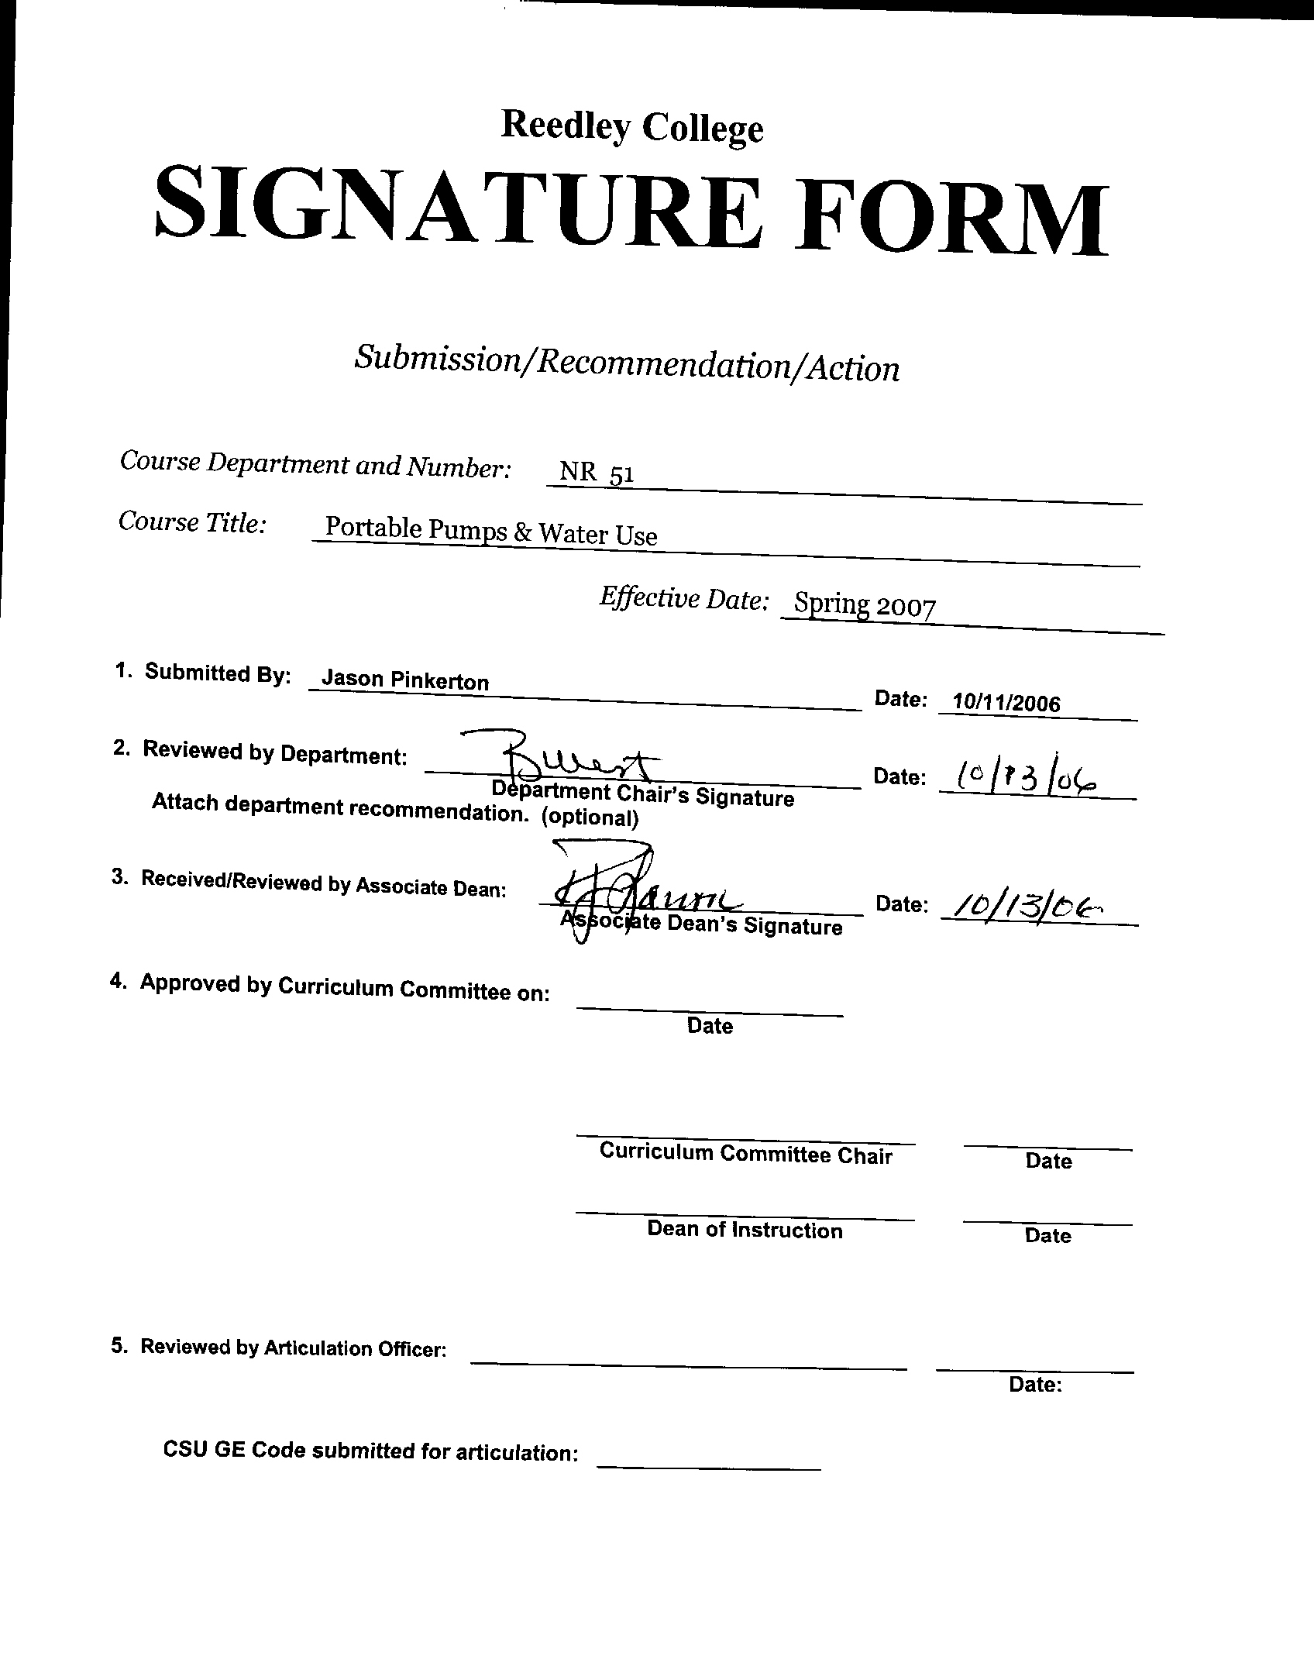


CREDIT COURSE OUTLINE

I. COVER PAGE

(1)  Course ID: NR 51 |  | (2)  Course Title: Portable Pumps & Water Use |  | (3)  Units: 1.0

(4) Lecture / Lab Hours: |  |  | (8)Classification:
Semester course  Hours per week | Lec hrs:
 | Lab hrs: |  |  |  | Degree applicable: |  |  | X
Lab will generate ______ hour(s) per week outside work. |  |  |  |  | Non-degree applicable:
Short-term course:  Hours per course | Lec hrs: | 16 |  |  | Pre-collegiate basic skills:
 | Lab hrs: | 8
Lab will generate ______ total hour(s) outside work. |  |  | (9)RC | Fulfills AS/AA degree requirement: (area)
(5)Grading Basis: | Grading scale only |  |  | General education category:
 | CR/NC option | X |  | Major:
 | CR/NC only
(6)Basic Skills Prerequisites: |  |  | (10)CSU: |  | Baccalaureate:
(11) Repeatable: (A course may be repeated
three times)
Basic Skills Advisories:  Eligibility for ENGL 125, ENGL 126 and MATH 101 |  |  | For Office Use Only
 |  |  | CATID: |  |  |  | DATATEL:
(7)Subject Prerequisites (requires C grade or better): |  |  | Course LHE: |  |  |  | Unit Code:
 |  |  | VEA Code: |  |  |  | SAM Priority:
 |  |  | TOPS Code: |  |  |  | Effective Date:
Subject Corequisites: |  |  | CSU: |  |  |  | Replaces:
Subject Advisories: |  |  |  |  |  |  | Replaced by:  Date:
(12)Catalog Description:
This course covers principles of positive displacement pumps but focuses on Wajax-Pacific Mark III Pump which is primarily used by National Fire Equipment System. It provides instruction with an emphasis on effectively and efficiently utilizing portable pumps and water under field conditions.

Course ID: NR 51 |  | Course Title: Portable Pumps & Water Use

II. COURSE OUTCOMES:

(Specify the learning skills the student demonstrates through completing the course and link critical thinking skills to specific course content and objectives.)

Upon completion of this course, students will be able to:

- Select the appropriate water delivery technique under specific circumstances.
- Select appropriate personal protective equipment (PPE) to safely operate the portable pump.
- Troubleshoot mechanical problems associated with a portable pump and perform appropriate field repairs.
- Operate and maintain various portable pump systems.
- Apply knowledge of pump systems to various fire situations.

III. COURSE OBJECTIVES:

(Specify major objectives in terms of the observable knowledge and/or skills to be attained.)

In the process of completing this course, students will:

A. Select pump equipment required to maintain a flow of water as required by the incident management objective.
B. Install pumps, hose lays, and holding tanks to provide water for all phases of the incident.
C. Perform required field maintenance on a portable pump.
D. Describe the differences between two-cycle and four-cycle engines.
E. Describe and diagram various types of delivery systems used in initial attack and mopup of fires.
F. Describe the use and effectiveness of water additives.
G. Use hose packs and rolled hose to establish a simple and three lateral progressive hose lay.
H. Identify (PPE) of the portable pump operator.

Course ID: NR 51 |  | Course Title: Portable Pumps & Water Use

IV. COURSE CONTENT OUTLINE:

Lecture Outline  A. Supply of Water  a. Types of pumps  b. Two-cycle engines  c. Four-cycle engines  d. Role of Pump operator  e. Portable Pump setup  B. Delivery of Water  a. Hydraulics  b. Fitting and hoses  c. Hose deployment  d. Hose, lays  e. Series, parallel and staged pumping  C. Application of Water  a. Tactics  b. Surfactants and foam | Lab Outline  A. Portable pumps  a. set-up  b. maintenance  c. trouble shooting  d. operation  B. Parallel , series, and staged pumps  a. set-up  b. operation  C. Care and handling  a. pumps  b. fittings  c. hose  d. tools  D. Hose lays  a. hose packs  b. rolled hose  c. simple hose lay  d. three lateral progressive hose lay  E. Retrieving and rolling used hose  a. watermelon  b. figure eight  c. single  d. double  e. rolling  F. Demobilization techniques  a. retrieving and packaging equipment  b. pump draining

Course ID: NR 51 |  | Course Title: Portable Pumps & Water Use

V. APPROPRIATE READINGS

Reading assignments may include but are not limited to the following:

A. Sample Text Title: 1. NWCG 1997. Portable Pumps and Water Use (S-211)

B. Other Readings:

Lab Manual: 1. NWCG 1997. Portable Pumps and Water Use (S-211)

Global or international materials or concepts are appropriately included in this course
Multicultural materials and concepts are appropriately included in this course.

If either line is checked, write a paragraph indicating specifically how global/international and/or multicultural materials and concepts relate to content outline and/or readings.

Course ID: NR 51 |  | Course Title: Portable Pumps & Water Use

VI. METHODS TO MEASURE STUDENT ACHIEVEMENT AND DETERMINE GRADES:
Students in this course will be graded in at least one of the following four categories. Please check those appropriate. A degree applicable course must have a minimum of one response in category A, B or C.

A. Writing
Check either 1 or 2 below
 | 1. Substantial writing assignments are required. Check the appropriate boxes below and provide a written description in the space provided.
X | 2. Substantial writing assignments are NOT required. If this box is checked leave this section blank. For degree applicable courses you must complete category B and/or C.
 | a. essay exam(s) |  | d. written homework
 | b. term or other papers(s) |  | e. reading reports
 | c. laboratory reports |  | f. other (specify)
Required assignments may include but are not limited to the following:

B. Problem Solving
1. Computational or non-computational problem-solving demonstrations, including:
 | a. exam(s) |  | d. laboratory reports
X | b. quizzes | X | e. field work
 | c. homework problems |  | f. other (specify)
Required assignments may include, but are not limited to the following:

Example problems:

1. Identify various pump components and define their use.

Course ID: NR 51 |  | Course Title: Portable Pumps & Water Use

C. Skill demonstrations, including:
X | a. class performance(s) | X | c. performance exam(s)
X | b. field work |  | d. other (specify)
Required assignments may include, but are not limited to the following:

1. Set-up and demonstrate the use of a staged pump.

D. Objective examinations, including:
X | a. multiple choice |  | d. completion
X | b. true/false | X | e. other (specify) practical field exercise
 | c. matching items

COURSE GRADE DETERMINATION:
Description/Explanation: Based on the categories checked in A-D, it is the recommendation of the department that the instructor’s grading methods fall within the following departmental guidelines; however, the final method of grading is still at the discretion of the individual instructor. The instructor’s syllabus must reflect the criteria by which the student’s grade has been determined. (A minimum of five (5) grades must be recorded on the final roster.)

If several methods to measure student achievement are used, indicate here the approximate weight or percentage each has in determining student final grades.

Final Grade Determination:

50% Field skills demonstration
50% Exam

FOR DEGREE APPLICABLE COURSES

Course ID: NR 51 |  | Course Title: Portable Pumps & Water Use

VII. EDUCATIONAL MATERIALS
For degree applicable courses, the adopted texts, as listed in the college bookstore, or instructor-prepared materials have been certified to contain college-level materials.

Validation Language Level (check where applicable): | College-Level  Criteria Met
 | Yes | No
Textbook
Reference materials | X
Instructor-prepared materials
Audio-visual materials

Indicate method of evaluation:
Used readability formulae (grade level 10 or higher)
Text is used in a college-level course | X
Used grading provided by publisher
Other: (please explain; relate to Skills Levels) Satisfactory

Computation Level (Eligible for MATH 101 level or higher where applicable) |  | X

Content
Breadth of ideas covered clearly meets college-level learning objectives of this course |  | X
Presentation of content and/or exercises/projects:
Requires a variety of problem-solving strategies including inductive and deductive reasoning. |  | X
Requires independent thought and study |  | X
Applies transferring knowledge and skills appropriately and efficiently to new situations or  problems. |  | X
List of Reading/Educational Materials
1. NWCG 1997. Portable Pumps and Water Use (S-211)

Comments:

 | This course requires special or additional library materials (list attached).
 | This course requires special facilities:

FORM A
TARGET COURSE | NR 51 |  | Portable Pumps & Water Use
 | Number |  | Title

BASIC SKILLS ADVISORIES PAGE The skills listed are those needed for eligibility for English 125, 126, and Math 101. These skills are listed as the outcomes from English 252, 262, and Math 250. In the right hand column, list at least three major basic skills needed at the beginning of the target course and check off the corresponding basic skills listed at the left.

Math Skills (eligibility for Math 101)  (as outcomes for Math 250)  x Performing the four arithmetic operations on whole numbers, arithmetic fractions, and decimal fractions.  x Making the conversions from arithmetic fractions to decimal fractions, from decimal fractions to percents, and then reversing the process.  x Applying the concepts listed above to proportions, percents, simple interest, markup and discount.  Applying the operations of integers in solving simple equations.  x Converting between the metric and English measurement systems | - Ability to convert English to metric systems when working with machinery.  - Calculate volumes and area related to machinery and forest treatments.  - Convert from fractions to decimals.
Reading Skills (eligibility for English 126)  (as outcomes for English 262)  x Using phonetic, structural, contextual, and dictionary skills to attack and understand words.  x Applying word analysis skills to reading in context.  x Using adequate basic functional vocabulary skills.  Using textbook study skills and outlining skills.  Using a full range of literal comprehension skills and basic analytical skills such as predicting, inferring, concluding, and evaluating. | - Ability to read and comprehend textbook.  - Ability to understand and use specialized vocabulary within the context of the course.  - Ability to read and comprehend recent literature related to the course.
Writing Skills (eligibility for English 125)  (as outcomes for English 252)  x Writing complete English sentences and avoiding errors most of the time.  x Using the conventions of English writing: capitalization, punctuation, spelling, etc.  x Using verbs correctly in present, past, future, and present perfect tenses, and using the correct forms of common irregular verbs.  x Expanding and developing basic sentence structure with appropriate modification.  x Combining sentences using coordination, subordination, and phrases.  Expressing the writer's ideas in short personal papers utilizing the writing process in their development. | - Ability to write short answers to test questions.  - Organize thoughts into paragraphs to respond to written material.  - Ability to write laboratory reports.
Check the appropriate spaces.
x Eligibility for Math 101 is advisory for the target course.
x Eligibility for English 126 is advisory for the target course.
x Eligibility for English 125 is advisory for the target course.
If the reviewers determine that an advisory or advisories in Basic Skills are all that are necessary for success in the target course, stop here, provide the required signatures, and forward this form to the department chair, the appropriate associate dean, and the curriculum committee.

Content review completed by |  | Date

