Reedley College

New Credit Course Outline

Course # / Title | NR 33 – Introduction to Chain Saw Operation

CHECK OFF SHEET
PRELIMINARY STEPS (Do before completing Course Outline):

☑ 1. | Communicate with the Curriculum Chair regarding intent to propose a new course (scheduling an appointment for discussion is highly recommended for first time proposers).

☑ 2. | List term for Implementation: | [ ] | Fall |  | [ X] | Spring | 2007 | [ ] | Summer

☑ 3. | Determine if there is a similar course or program at FCC:
 | Yes
X | No

If yes, you will fill out the RC/FCC Course Alignment form (included in packet) after you have completed the cover page (Part I, Items 1-12) of the Course Outline of Record.

☑ 4. | Determine placement of course:
Desired CSU General Education Code | Yes |  | No | X
Transfer Baccalaureate List | Yes |  | No | X
Corresponds for CSUF Course? | Yes |  | No | X

If Yes, schedule an appointment with the Articulation Officer.

☑ 5. | Course repeatability for credit: If any of these are checked
 | Yes
X | No

If yes, secure a Course Repetition form from the Curriculum Office.

☑ 6. | Suggested maximum enrollment for course: | 21

☑ COURSE OUTLINE OF RECORD completed.

FINAL steps (Do after completing Course Outline of Record)

☑ 1. | Signature Form. Secure signatures of the Department Chair and the Associate Dean before submitting the completed course proposal to the Curriculum Office.

☑ 2. | Program Description. Course will change an existing program/is part of a new program which is or will be described in the college catalogue.
X | Yes
 | No

If yes, fill out the Program Description form (included in packet) before submitting your finalized proposal to the Curriculum Office.

☑ 3. | Final Check. All items above have been completed and checked off before proposal is submitted.

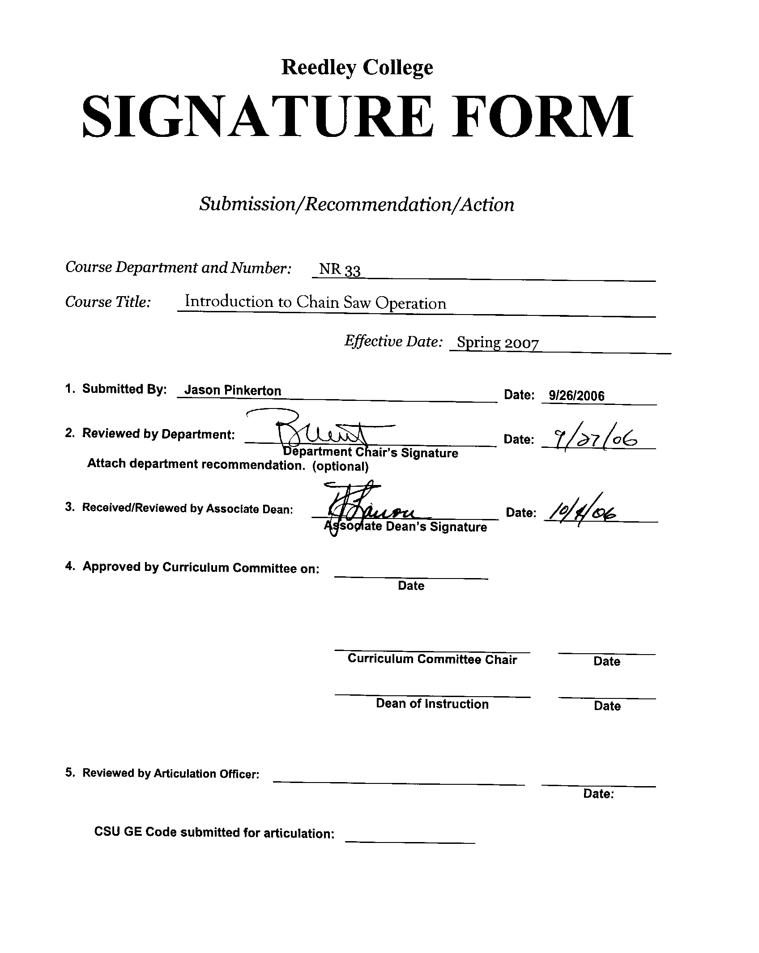



CREDIT COURSE OUTLINE

I. COVER PAGE

(1)  Course ID: NR 33 |  | (2)  Course Title: Introduction to Chain Saw Operation |  | (3)  Units: 1.0

(4) Lecture / Lab Hours: |  |  | (8)Classification:
Semester course  Hours per week | Lec hrs:
 | Lab hrs: |  |  |  | Degree applicable: |  |  | X
Lab will generate ______ hour(s) per week outside work. |  |  |  |  | Non-degree applicable:
Short-term course:  Hours per course | Lec hrs: | 9 |  |  | Pre-collegiate basic skills:
 | Lab hrs: | 27
Lab will generate ______ total hour(s) outside work. |  |  | (9)RC | Fulfills AS/AA degree requirement: (area)
(5)Grading Basis: | Grading scale only |  |  | General education category:
 | CR/NC option | X |  | Major:
 | CR/NC only
(6)Basic Skills Prerequisites: |  |  | (10)CSU: |  | Baccalaureate:
(11) Repeatable: (A course may be repeated
three times)
Basic Skills Advisories:  Eligibility for ENGL 125, ENGL 126, and MATH 101 |  |  | For Office Use Only
 |  |  | CATID: |  |  |  | DATATEL:
(7)Subject Prerequisites (requires C grade or better): |  |  | Course LHE: |  |  |  | Unit Code:
 |  |  | VEA Code: |  |  |  | SAM Priority:
 |  |  | TOPS Code: |  |  |  | Effective Date:
Subject Corequisites: |  |  | CSU: |  |  |  | Replaces:
Subject Advisories: |  |  |  |  |  |  | Replaced by:  Date:
(12)Catalog Description:
Provides introductory level training for the use of chain saws in the forestry and natural resources field. Emphasis is placed on defining and applying chain saw safety standards, maintenance and function of personal protective equipment (PPE), identification of chain saw parts, maintenance, tuning, and tactical application of techniques required for brushing, limbing, bucking, and falling trees.

Course ID: NR 33 |  | Course Title: Introduction to Chain Saw Operation

II. COURSE OUTCOMES:

(Specify the learning skills the student demonstrates through completing the course and link critical thinking skills to specific course content and objectives.)

Upon completion of this course, students will be able to:

- Apply chain saw safety standard skills outlined by Occupational Safety & Health Administration (OSHA).
- Differentiate among basic chain saw parts nomenclature, maintenance, tuning, troubleshooting, and safety features.
- Select the approved use, maintenance, and function of personal protective equipment (PPE) required for safe chain saw operation.
- Select the appropriate field maintenance tasks required for proper chain saw operation.
- Apply the tactical chain saws skills related to brushing, limbing, bucking, and falling wood material.

III. COURSE OBJECTIVES:

(Specify major objectives in terms of the observable knowledge and/or skills to be attained.)

In the process of completing this course, students will:

- List and define chain saw safety standards outlined by Occupational Safety & Health Administration (OSHA).
- Identify basic chain saw parts nomenclature, maintenance, tuning, troubleshooting, and safety features.
- Know the approved use, maintenance, and function of personal protective equipment (PPE) required for safe chain saw operation.
- Demonstrate field maintenance tasks required for chain saw operation.
- Demonstrate the tactical application of chain saws in brushing, limbing, bucking, and falling wood material.

Course ID: NR 33 |  | Course Title: Introduction to Chain Saw Operation

IV. COURSE CONTENT OUTLINE:

Lecture Outline  A. Introduction  Purpose of course  History  General use and purpose  B. Safety Requirements  Job Hazard Analysis (JHA)  Basic first aid  Emergency evacuation and situation awareness  Personal Protective Equipment (PPE)  Safety with regard to brushing, limbing, bucking, and felling  C. Maintenance and Operation  Basic chain saw nomenclature, maintenance, tuning, and safety features  Basic field maintenance  Chain saw starting and handling procedures  Troubleshooting problems  D. Tasks and Techniques  Components of hazard assessment and situation awareness  Types of binds and bucking methods  Procedural approach to brushing, limbing, bucking, and felling  E. Fireline Construction and Mopup  Duties and responsibilities of chain saw operator and swamper  Methods of removing cut debris  Tactics for multiple saw teams | Lab Outline  A. Safety Requirements  Job Hazard Analysis (JHA) forms  Basic first aid  Emergency evacuation and situation awareness  Personal Protective Equipment (PPE)  Safety with regard to brushing, limbing, bucking, and felling  B. Maintenance and Operation  Basic chain saw nomenclature, maintenance, tuning, and safety features  Basic field maintenance  Chain saw starting and handling procedures  Troubleshooting problems  C. Tasks and Techniques  Sizeup and safety considerations  Types of binds and bucking methods  Proper use of dogs  Bind direction  Cutting sequence  Procedural approach to brushing, limbing, bucking, and felling  Undercut, holding wood, backcut, wedging, analyzing stump  D. Field Exercise  Secure felling area  Monitor cutting procedures  Skills demonstration  Limbing, brushing, and bucking  Tree felling

Course ID: NR 33 |  | Course Title: Introduction to Chain Saw Operation

V. APPROPRIATE READINGS

Reading assignments may include but are not limited to the following:

A. Sample Text Title: 1. National Wildfire Coordinating Group (NWCG). 2004. Wildland Fire Chain Saws S-212

B. Other Readings: 1. Dent, D.D. 1974. Professional timber falling, a procedural approach

- Conway, S. 1973. Timber cutting practices

- Workers Compensation Board of British Colombia. 1990. Fallers' & buckers' handbook: practical methods for falling and bucking timber safety

- Soderstorm, N. 1982. Chainsaw savvy: a complete guide to cutting, sharpening, & troubleshooting

Lab Manual: 1. National Wildfire Coordinating Group (NWCG). 2004. Wildland Fire Chain Saws S-212

Global or international materials or concepts are appropriately included in this course
Multicultural materials and concepts are appropriately included in this course.

If either line is checked, write a paragraph indicating specifically how global/international and/or multicultural materials and concepts relate to content outline and/or readings.

Course ID: NR 33 |  | Course Title: Introduction to Chain Saw Operation

VI. METHODS TO MEASURE STUDENT ACHIEVEMENT AND DETERMINE GRADES:
Students in this course will be graded in at least one of the following four categories. Please check those appropriate. A degree applicable course must have a minimum of one response in category A, B or C.

A. Writing
Check either 1 or 2 below
 | 1. Substantial writing assignments are required. Check the appropriate boxes below and provide a written description in the space provided.
X | 2. Substantial writing assignments are NOT required. If this box is checked leave this section blank. For degree applicable courses you must complete category B and/or C.
 | a. essay exam(s) |  | d. written homework
 | b. term or other papers(s) |  | e. reading reports
 | c. laboratory reports |  | f. other (specify)
Required assignments may include but are not limited to the following:

B. Problem Solving
1. Computational or non-computational problem-solving demonstrations, including:
 | a. exam(s) |  | d. laboratory reports
X | b. quizzes | X | e. field work
 | c. homework problems |  | f. other (specify)
Required assignments may include, but are not limited to the following:

Demonstrate competence in safely limbing, brushing, bucking, and falling a tree in the least complex situation.

Example problems:

- Define and describe types of binds.
- Troubleshoot the following scenario. The chain saw engine will not idle.
- List the procedural approach to limbing, bucking, and felling trees.

Course ID: NR 33 |  | Course Title: Introduction to Chain Saw Operation

C. Skill demonstrations, including:
X | a. class performance(s) | X | c. performance exam(s)
X | b. field work |  | d. other (specify)
Required assignments may include, but are not limited to the following:

Theory and practices covered in lecture will be internalized and transferred to application in the laboratory through field exercises. Assignments may include:

- Troubleshooting chain saw problems (i.e. engine will not start, chain continues moving with throttle released, and engine produces heavy smoke).
- Identifying chain saw parts and function.

D. Objective examinations, including:
X | a. multiple choice |  | d. completion
X | b. true/false | X | e. other (specify) practical field exercise
 | c. matching items

COURSE GRADE DETERMINATION:
Description/Explanation: Based on the categories checked in A-D, it is the recommendation of the department that the instructor’s grading methods fall within the following departmental guidelines; however, the final method of grading is still at the discretion of the individual instructor. The instructor’s syllabus must reflect the criteria by which the student’s grade has been determined. (A minimum of five (5) grades must be recorded on the final roster.)

If several methods to measure student achievement are used, indicate here the approximate weight or percentage each has in determining student final grades.

Final Grade Determination: 30% Quizzes
30% Participation
40% Practical Field Exercise

FOR DEGREE APPLICABLE COURSES

Course ID: NR 33 |  | Course Title: Introduction to Chain Saw Operation

VII. EDUCATIONAL MATERIALS
For degree applicable courses, the adopted texts, as listed in the college bookstore, or instructor-prepared materials have been certified to contain college-level materials.

Validation Language Level (check where applicable): | College-Level  Criteria Met
 | Yes | No
Textbook
Reference materials | X
Instructor-prepared materials
Audio-visual materials

Indicate method of evaluation:
Used readability formulae (grade level 10 or higher)
Text is used in a college-level course | X
Used grading provided by publisher
Other: (please explain; relate to Skills Levels) Satisfactory

Computation Level (Eligible for MATH 101 level or higher where applicable) |  | x

Content
Breadth of ideas covered clearly meets college-level learning objectives of this course |  | x
Presentation of content and/or exercises/projects:
Requires a variety of problem-solving strategies including inductive and deductive reasoning. |  | x
Requires independent thought and study |  | x
Applies transferring knowledge and skills appropriately and efficiently to new situations or  problems. |  | x
List of Reading/Educational Materials
1. National Wildfire Coordinating Group (NWCG). 2004. Wildland Fire Chain Saws S-212
2. Dent, D.D. 1974. Professional timber falling, a procedural approach
3. Conway, S. 1973. Timber cutting practices
4. Workers Compensation Board of British Colombia. 1990. Fallers' & buckers' handbook: practical methods for falling and bucking timber safety
- Soderstorm, N. 1982. Chainsaw savvy: a complete guide to cutting, sharpening, & troubleshooting
Lab Manual:
1. National Wildfire Coordinating Group (NWCG). 2004. Wildland Fire Chain Saws S-212

Comments:

 | This course requires special or additional library materials (list attached).
X | This course requires special facilities: Reedley College Farm and the school forest at Sequoia Lake
FORM A
TARGET COURSE | NR 33 |  | Introduction to Chain Saw Operation
 | Number |  | Title

BASIC SKILLS ADVISORIES PAGE The skills listed are those needed for eligibility for English 125, 126, and Math 101. These skills are listed as the outcomes from English 252, 262, and Math 250. In the right hand column, list at least three major basic skills needed at the beginning of the target course and check off the corresponding basic skills listed at the left.

Math Skills (eligibility for Math 101)  (as outcomes for Math 250)  x Performing the four arithmetic operations on whole numbers, arithmetic fractions, and decimal fractions.  Making the conversions from arithmetic fractions to decimal fractions, from decimal fractions to percents, and then reversing the process.  Applying the concepts listed above to proportions, percents, simple interest, markup and discount.  x Applying the operations of integers in solving simple equations.  x Converting between the metric and English measurement systems | Ability to convert metric units to English.  Ability to calculate ratios when mixing fuels.  Ability to measure RPM for a particular chainsaw size.
Reading Skills (eligibility for English 126)  (as outcomes for English 262)  x Using phonetic, structural, contextual, and dictionary skills to attack and understand words.  x Applying word analysis skills to reading in context.  x Using adequate basic functional vocabulary skills.  x Using textbook study skills and outlining skills.  Using a full range of literal comprehension skills and basic analytical skills such as predicting, inferring, concluding, and evaluating. | Ability to read and comprehend equipment manual.  Ability to understand written instructions.  Ability to comprehend literature related to forestry.
Writing Skills (eligibility for English 125)  (as outcomes for English 252)  x Writing complete English sentences and avoiding errors most of the time.  x Using the conventions of English writing: capitalization, punctuation, spelling, etc.  x Using verbs correctly in present, past, future, and present perfect tenses, and using the correct forms of common irregular verbs.  Expanding and developing basic sentence structure with appropriate modification.  Combining sentences using coordination, subordination, and phrases.  Expressing the writer's ideas in short personal papers utilizing the writing process in their development. | Ability to write a technical field report.  Ability to communicate in writing, technical issues with faulty equipment.  Ability to answer critical thinking questions in an organized, grammatically correct format.

Check the appropriate spaces.
x Eligibility for Math 101 is advisory for the target course.
x _Eligibility for English 126 is advisory for the target course.
x Eligibility for English 125 is advisory for the target course.
If the reviewers determine that an advisory or advisories in Basic Skills are all that are necessary for success in the target course, stop here, provide the required signatures, and forward this form to the department chair, the appropriate associate dean, and the curriculum committee.

Content review completed by |  | Date

