Reedley College

New Credit Course Outline

Course # / Title | NR 90 / Backpacking

CHECK OFF SHEET
PRELIMINARY STEPS (Do before completing Course Outline):

☑ 1. | Communicate with the Curriculum Chair regarding intent to propose a new course (scheduling an appointment for discussion is highly recommended for first time proposers).

☑ 2. | List term for Implementation: | [ ] | Fall |  | [x ] | Spring | 2007 | [ ] | Summer

☑ 3. | Determine if there is a similar course or program at FCC:
 | Yes
x | No

If yes, you will fill out the RC/FCC Course Alignment form (included in packet) after you have completed the cover page (Part I, Items 1-12) of the Course Outline of Record.

☑ 4. | Determine placement of course:
Desired CSU General Education Code | Yes |  | No | x
Transfer Baccalaureate List | Yes |  | No | x
Corresponds for CSUF Course? | Yes | x | No

If Yes, schedule an appointment with the Articulation Officer.

☑ 5. | Course repeatability for credit: If any of these are checked
x | Yes
 | No

If yes, secure a Course Repetition form from the Curriculum Office.

☑ 6. | Suggested maximum enrollment for course: | 15

☑ COURSE OUTLINE OF RECORD completed.

FINAL steps (Do after completing Course Outline of Record)

☑ 1. | Signature Form. Secure signatures of the Department Chair and the Associate Dean before submitting the completed course proposal to the Curriculum Office.

☑ 2. | Program Description. Course will change an existing program/is part of a new program which is or will be described in the college catalogue.
x | Yes
 | No

If yes, fill out the Program Description form (included in packet) before submitting your finalized proposal to the Curriculum Office.

☑ 3. | Final Check. All items above have been completed and checked off before proposal is submitted.

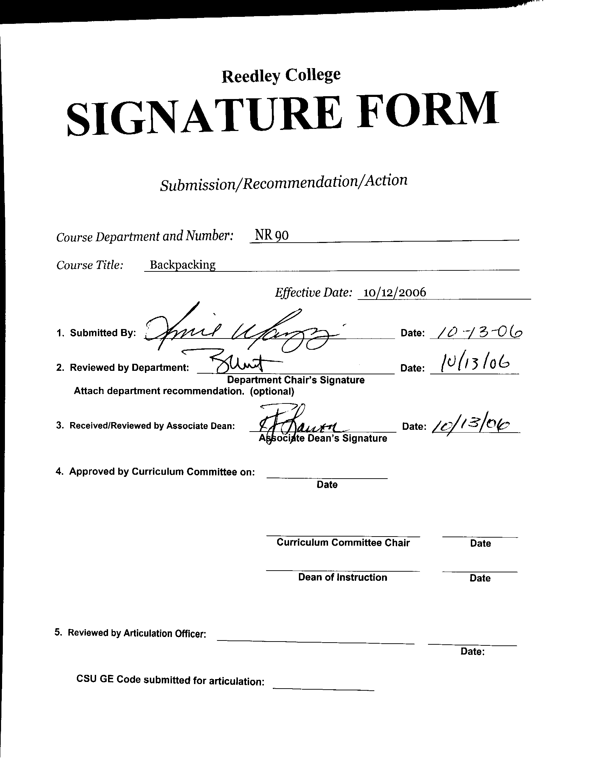



CREDIT COURSE OUTLINE

I. COVER PAGE

(1)  Course ID: NR 90 |  | (2)  Course Title: Backpacking |  | (3)  Units: 1.0

(4) Lecture / Lab Hours: |  |  | (8)Classification:
Semester course  Hours per week | Lec hrs:
 | Lab hrs: |  |  |  | Degree applicable: |  |  | x
Lab will generate ______ hour(s) per week outside work. |  |  |  |  | Non-degree applicable:
Short-term course:  Hours per course | Lec hrs: | 9 |  |  | Pre-collegiate basic skills:
 | Lab hrs: | 27
Lab will generate ______ total hour(s) outside work. |  |  | (9)RC | Fulfills AS/AA degree requirement: (area)
(5)Grading Basis: | Grading scale only |  |  | General education category:
 | CR/NC option | x |  | Major:
 | CR/NC only
(6)Basic Skills Prerequisites: |  |  | (10)CSU: |  | Baccalaureate:
 |  |  | (11) Repeatable: (A course may be repeated  three times) |  |  |  |  | 3
Basic Skills Advisories:  Math 101, Engl 125, Engl 126 |  |  | For Office Use Only
 |  |  | CATID: |  |  |  | DATATEL:
(7)Subject Prerequisites (requires C grade or better): |  |  | Course LHE: |  |  |  | Unit Code:
 |  |  | VEA Code: |  |  |  | SAM Priority:
 |  |  | TOPS Code: |  |  |  | Effective Date:
Subject Corequisites: |  |  | CSU: |  |  |  | Replaces:
Subject Advisories: |  |  |  |  |  |  | Replaced by:  Date:
(12)Catalog Description:

This course is designed to give students basic skills in backcountry travel. Topics covered will include route planning, equipment selection, multiple night travel, trail etiquette, food preparation, campsite selection, basic map reading and compass use, and backcountry safety. Students will gain basic knowledge and experience aimed at increase their confidence in traveling in the backcountry.

Course ID: NR 90 |  | Course Title: Backpacking

II. COURSE OUTCOMES:

(Specify the learning skills the student demonstrates through completing the course and link critical thinking skills to specific course content and objectives.)

Upon completion of this course, students will be able to:

A. Gain confidence in backcountry travel and navigation.

B. Prepare food using a backpacking stove, water filter and dried food.

C. Navigate trails in mountain terrain using a map and compass.

D. Practice appropriate trail etiquette and “leave no trace” camping methods.

E. Recognize potential backcountry hazards and minimize risks.

III. COURSE OBJECTIVES:

(Specify major objectives in terms of the observable knowledge and/or skills to be attained.)

In the process of completing this course, students will:

A. Identify and select necessary equipment for backcountry travel.

B. Use a map and compass to identify travel routes and current location.

C. Set up and operate a backpacking stove to prepare meals.

D. Identify “leave no trace” principles.

E. Select appropriate equipment for specific conditions.

Course ID: NR 90 |  | Course Title: Backpacking

IV. COURSE CONTENT OUTLINE:

Lecture Outline Laboratory Outline
A. Equipment selection A. Pack fitting

B. Trip planning B. Pack loading and organization

C. Map and compass use C. Stove and filter operation

D. Stove and water filter use D. Map reading and compass use

E. “Leave no trace” techniques E. Campsite selection

F. Backcountry safety F. Food storage and preparation

G. Backcountry hazards G. Hazard identification

H. Campsite selection H. Safety and hygeine

I. Backcountry rules and regulations

Course ID: NR 90 |  | Course Title: Backpacking

V. APPROPRIATE READINGS

Reading assignments may include but are not limited to the following:

- Sample Text Title:

Lightweight Backpacking and Camping: A Field Guide to Wilderness Equipment, Technique, and Style (Backpacking Light) (Paperback) by George Cole, Alan Dixon, et al. Beartooth Mountain Press. 2005.

B. Other Readings:

Global or international materials or concepts are appropriately included in this course
Multicultural materials and concepts are appropriately included in this course.

If either line is checked, write a paragraph indicating specifically how global/international and/or multicultural materials and concepts relate to content outline and/or readings.

Course ID: NR 90 |  | Course Title: Backpacking

VI. METHODS TO MEASURE STUDENT ACHIEVEMENT AND DETERMINE GRADES:
Students in this course will be graded in at least one of the following four categories. Please check those appropriate. A degree applicable course must have a minimum of one response in category A, B or C.

A. Writing
Check either 1 or 2 below
 | 1. Substantial writing assignments are required. Check the appropriate boxes below and provide a written description in the space provided.
X | 2. Substantial writing assignments are NOT required. If this box is checked leave this section blank. For degree applicable courses you must complete category B and/or C.
 | a. essay exam(s) |  | d. written homework
 | b. term or other papers(s) |  | e. reading reports
 | c. laboratory reports |  | f. other (specify)
Required assignments may include but are not limited to the following:

B. Problem Solving
1. Computational or non-computational problem-solving demonstrations, including:
 | a. exam(s) |  | d. laboratory reports
 | b. quizzes | X | e. field work
 | c. homework problems |  | f. other (specify)
Required assignments may include, but are not limited to the following:

Select an acceptable campsite and identify potential hazards.

Course ID: NR 90 |  | Course Title: Backpacking

C. Skill demonstrations, including:
 | a. class performance(s) |  | c. performance exam(s)
X | b. field work |  | d. other (specify)
Required assignments may include, but are not limited to the following:

Set up a backpacking stove and prepare a meal.

D. Objective examinations, including:
 | a. multiple choice |  | d. completion
 | b. true/false |  | e. other (specify)
 | c. matching items

COURSE GRADE DETERMINATION:
Description/Explanation: Based on the categories checked in A-D, it is the recommendation of the department that the instructor’s grading methods fall within the following departmental guidelines; however, the final method of grading is still at the discretion of the individual instructor. The instructor’s syllabus must reflect the criteria by which the student’s grade has been determined. (A minimum of five (5) grades must be recorded on the final roster.)

If several methods to measure student achievement are used, indicate here the approximate weight or percentage each has in determining student final grades.

50% participation
50% skill demonstration

FOR DEGREE APPLICABLE COURSES

Course ID: NR 90 |  | Course Title: Backpacking

VII. EDUCATIONAL MATERIALS
For degree applicable courses, the adopted texts, as listed in the college bookstore, or instructor-prepared materials have been certified to contain college-level materials.

Validation Language Level (check where applicable): | College-Level  Criteria Met
 | Yes | No
Textbook | x
Reference materials |  | x
Instructor-prepared materials | x
Audio-visual materials | x

Indicate method of evaluation:
Used readability formulae (grade level 10 or higher)
Text is used in a college-level course | x
Used grading provided by publisher
Other: (please explain; relate to Skills Levels)

Computation Level (Eligible for MATH 101 level or higher where applicable) |  | x

Content
Breadth of ideas covered clearly meets college-level learning objectives of this course
Presentation of content and/or exercises/projects:
Requires a variety of problem-solving strategies including inductive and deductive reasoning. |  | x
Requires independent thought and study |  | x
Applies transferring knowledge and skills appropriately and efficiently to new situations or  problems. |  | x
List of Reading/Educational Materials

Lightweight Backpacking and Camping: A Field Guide to Wilderness Equipment, Technique, and Style (Backpacking Light) (Paperback) by George Cole, Alan Dixon, et al. Beartooth Mountain Press. 2005.

Comments:

 | This course requires special or additional library materials (list attached).
x | This course requires special facilities: Backpacking lab will take place in outdoor area away from campus

FORM A
TARGET COURSE | NR 90 |  | Backpacking
 | Number |  | Title

BASIC SKILLS ADVISORIES PAGE The skills listed are those needed for eligibility for English 125, 126, and Math 101. These skills are listed as the outcomes from English 252, 262, and Math 250. In the right hand column, list at least three major basic skills needed at the beginning of the target course and check off the corresponding basic skills listed at the left.

Math Skills (eligibility for Math 101)  (as outcomes for Math 250)  x Performing the four arithmetic operations on whole numbers, arithmetic fractions, and decimal fractions.  x Making the conversions from arithmetic fractions to decimal fractions, from decimal fractions to percents, and then reversing the process.  Applying the concepts listed above to proportions, percents, simple interest, markup and discount.  x Applying the operations of integers in solving simple equations.  x Converting between the metric and English measurement systems | Students will need to determine cost effectiveness in purchasing equipment items.  Students will need to calculate quantities based on number of individuals.  Students will need to use percents and multiplication to determine distance and elevation gain.  Students will need to convert metric to English units in determining distance and temperature.
Reading Skills (eligibility for English 126)  (as outcomes for English 262)  x Using phonetic, structural, contextual, and dictionary skills to attack and understand words.  x Applying word analysis skills to reading in context.  Using adequate basic functional vocabulary skills.  Using textbook study skills and outlining skills.  x Using a full range of literal comprehension skills and basic analytical skills such as predicting, inferring, concluding, and evaluating. | Students will need to read instructions and apply them to equipment operation.  Students will need to read and understand the supporting text.  Students will need to read and comprehend maps, guidebooks and permits.
Writing Skills (eligibility for English 125)  (as outcomes for English 252)  x Writing complete English sentences and avoiding errors most of the time.  x Using the conventions of English writing: capitalization, punctuation, spelling, etc.  x Using verbs correctly in present, past, future, and present perfect tenses, and using the correct forms of common irregular verbs.  Expanding and developing basic sentence structure with appropriate modification.  x Combining sentences using coordination, subordination, and phrases.  Expressing the writer's ideas in short personal papers utilizing the writing process in their development. | Students will need to write complete statements on use permits.  Students will need to communicate effectively, through writing, to classmates and by note taking.  Students will need to use words correctly to communicate with classmates and in writing brief reports.

Check the appropriate spaces.
x Eligibility for Math 101 is advisory for the target course.
x Eligibility for English 126 is advisory for the target course.
x Eligibility for English 125 is advisory for the target course.
If the reviewers determine that an advisory or advisories in Basic Skills are all that are necessary for success in the target course, stop here, provide the required signatures, and forward this form to the department chair, the appropriate associate dean, and the curriculum committee.

Content review completed by |  | Date

Reedley College

REQUEST FOR COURSE REPEATABILITY
(For reasons other than alleviating substandard work)

Course ID: NR 90 |  | Course Title: Backpacking | Date: 10/12/06
Number of times course may be repeated, excluding initial enrollment (1, 2, or 3): |  |  | 3
or
Maximum units to which course may be repeated, including initial enrollment:

The following information is required under Title V, Part VI, Section 58161
1. Explain how the course content differs each time it is offered:

Backpacking trips will occur in different locations with various topographic features, climate and regulations.

2. Using reasons “A” or “B” listed below, explain how the student, by repeating this course will gain an expanded educational experience (A or B):
x | A. Skills or proficiencies are enhanced by supervised repetition and practice within class periods. Explanation:
Students will gain confidence and experience with differing conditions each time the course is taken. Backpacking trips will occur in different locations with various topographic features, climate and regulations. Students will need to use problem-solving skills to adjust as they are exposed to varying conditions.

 | B. Active Participatory experience in individual study or group assignments is the basic means by which learning objectives are attained. Explanation:

