Reedley College
Proposed Course Modification

Course # / Title | PHILOSOPHY 6-INTRODUCTION TO LOGIC

CHECK OFF SHEET
PRELIMINARY STEPS. Do before completing Course Modification Form.
(EACH BOX SHOULD BE CHECKED AS COMPLETED BEFORE SUBMISSION.)
☑ 1. Communicate with the Curriculum Chair regarding intent to modify an existing course outline (recommended, not required).
☑ 2. List term for implementation of modifications:
 | Fall |  | [x ] | Spring | 2007 | [ ] | Summer
☑ 3. Check one:
Do not complete Fresno City College course alignment page if:
 | No similar course or program at FCC.
x | Course currently in common with FCC course or accepted in lieu of and changes will not affect status.

Complete Fresno City College course alignment page if:
Course currently in common with FCC course or accepted in lieu of. Changes may affect status. Consult with counterparts at FCC and complete alignment page
Course not in common or accepted in lieu of but may be with proposed changes consult with FCC counterparts

☑ 4. Changes sought in the following:

CSU General Education Code | Yes |  | No | x
Transfer Baccalaureate List | Yes |  | No | x

If yes to either, schedule an appointment with the Articulation Officer
☑ 5. Changes sought in number of repeats for credit:

 | Yes
x | No

If yes, secure a Course Repetition form from the Curriculum Office.
PROPOSED COURSE MODIFICATION FORM
☑ Appropriate sections of Course Outline of Record completed.

FINAL steps (Do after completing Course Outline of Record)

☑ 1. Signature Form. Secure signatures of the Department Chair and the Associate Dean before submitting the completed course proposal to the Curriculum Office.

☑ 2. Program Description. Course modification will change an existing program which is or will be described in the college catalogue.

 | Yes | x | No

If yes, complete Program Description Form before submitting modification.

☑ 3. Final Check. All items above have been completed and checked off before modification is submitted.

Reedley College
PROPOSED COURSE MODIFICATION

All changes and modifications in the official course outline must come to the Curriculum Committee. Though minor changes may seem obvious, even these need to come to committee for information and to update the official curriculum. Changes in programs or in several department offerings should be submitted together if possible so that the whole picture is clear.

OUTLINE. Please fill in current existing course number, title, and units for course to be modified.

Department | Philosophy | Course No. | PHIL 6
Course Title | Introduction to Logic | Units | 3
 | Effective Date | January 04, 2007

A. PROPOSED CHANGES.
(Indicate below all proposed changes to be made in the course outline.)

I. Cover Page
 | 1. Course ID |  |  | 8. Classification (Degree applicable, Non-degree applicable, or
 | 2. Course Title |  |  | Pre-collegiate Basic skills)
 | 3. Units |  |  | 9. General Education Pattern, Graduation Requirement, and
 | 4. Lecture/Lab Hours |  |  | Major Category
 | 5. Grading Basis |  |  | 10. General Education Pattern/Baccalaureate (CSU)
 | 6. Entrance Skills: Basic Skills Prerequisites/Advisories |  |  | 11. Repeatability
 | 7. Subject Prerequisites/Corequisites/Advisories |  |  | 12. Catalog Description

Other pages

x | II. Course Outcomes |  | x | VI. Methods of Grading
 | III. Course Objectives |  |  | VII. Levels of Educational Materials
 | IV. Course Content Outline |  | Additional Pages (optional depending on course)
x | V. Approved Readings |  |  | Request for Repeatability/Limitation on Enrollment

B. DESCRIPTION OF CHANGES AND MODIFICATIONS.

ITEM NO. | CHANGED FROM | CHANGED TO | REASON
II | No separate Outcomes section on the old form. | Outcomes added (See new section) | To conform to the requirement to include outcomes.
V | Old editions of textbooks | Current editions of textbooks | To update the approved readings
VI | No examples of assignments required on the old form | Include examples of assignments | To conform to the new requirement, to add specificity and detail
VI | Method of determining course grade did not include a recommended weight for a writing assignment | A writing assignment of 750-1500 words may be weighted as 20% of the course grade. | To make explicit the importance of the writing assignment.

(Additional sheets may be attached if necessary.)

C. EXPLANATIONS. If course modification results in changes in the program which will require use of the program description form, please give rationale.

Please attach the complete outline before modifications to this form. If only the first page of the outline is being modified, also attach the new first page. If other pages of the outline are being modified, please attach the complete new outline.

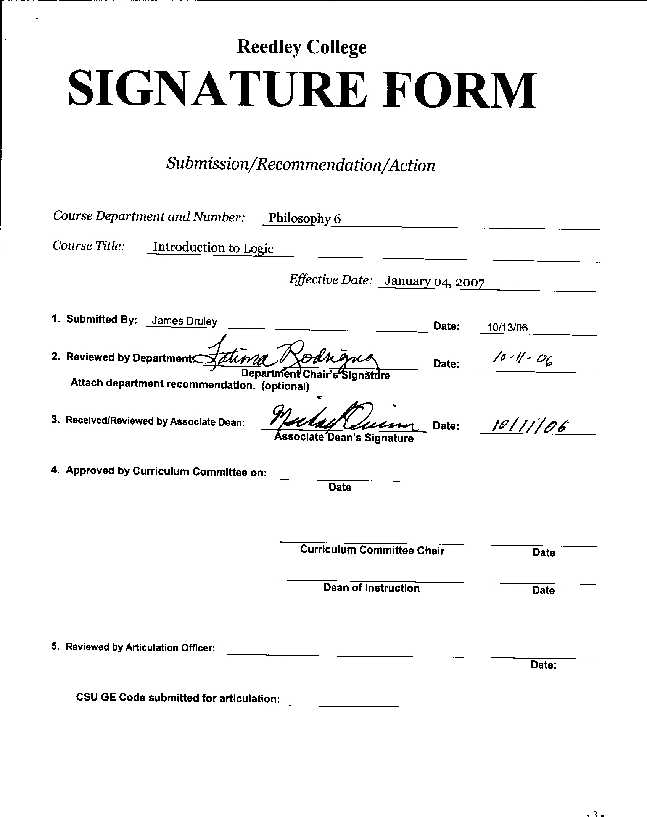

COURSE ALIGNMENT
REEDLEY COLLEGE/FRESNO CITY COLLEGE

Complete only if YES was checked on New Course Proposal Packet check off sheet for a similar department or course at FCC.

FCC Course | Philosophy 6-Introduction to Logic

RC Course ID | PHIL 6 | Course Title | Introduction to Logic

The RC and FCC faculty members of the Philosophy Department have communicated regarding the attached course. The following determination has been made:

Check the appropriate boxes:
☑ The course department is the same ☑* Prerequisites/Corequisites are the same.
☑ The course number is the same □* The catalog descriptions are the same.
☑ The course title is the same. ☑* The number of repeats are the same.
☑ The units are the same
☑ The lecture/lab hours are the same. (rationale if not the same)
☑ The grading basis is the same. (CR-NC/A-F)

☑ It was determined that this course is a match.
(*Items with asterisk do not need to be an exact match.)
□ The course does not match but should be evaluated for acceptance in lieu of FCC’s
□ This course is not a match.

Please provide an explanation of the differences:

RC Instructor |  | Date
Department Chair |  | Date
Associate Dean |  | Date



CREDIT COURSE OUTLINE

I. COVER PAGE

(1)  Course ID: PHIL 6 |  | (2)  Course Title: Introduction to Logic |  | (3)  Units: 3

(4) Lecture / Lab Hours: |  |  | (8)Classification:
Semester course  Hours per week | Lec hrs: | 3
 | Lab hrs: |  |  |  | Degree applicable: |  |  | X
Lab will generate ______ hour(s) per week outside work. |  |  |  |  | Non-degree applicable:
Short-term course:  Hours per course | Lec hrs: |  |  |  | Pre-collegiate basic skills:
 | Lab hrs:
Lab will generate ______ total hour(s) outside work. |  |  | (9)RC | Fulfills AS/AA degree requirement: (area)
(5)Grading Basis: | Grading scale only |  |  | General education category:
 | CR/NC option | X |  | Major: |  | Liberal Studies
 | CR/NC only
(6)Basic Skills Prerequisites: |  |  | (10)CSU: |  | Baccalaureate: |  |  | X
 |  |  | (11) Repeatable: (A course may be repeated  three times) |  |  |  |  | No
Basic Skills Advisories:  Eligibility for ENGL 125 and ENGL 126 |  |  | For Office Use Only
 |  |  | CATID: |  |  |  | DATATEL:
(7)Subject Prerequisites (requires C grade or better): |  |  | Course LHE: |  |  |  | Unit Code:
 |  |  | VEA Code: |  |  |  | SAM Priority:
 |  |  | TOPS Code: |  |  |  | Effective Date:
Subject Corequisites: |  |  | CSU: |  |  |  | Replaces:
Subject Advisories: |  |  |  |  |  |  | Replaced by:  Date:
(12)Catalog Description:
Basic concepts, methods and principles used to distinguish correct from incorrect reasoning, with an emphasis on deduction. Traditional categorical logic, propositional and predicate symbolic logic.

Course ID: PHIL 6 |  | Course Title: Introduction to Logic

II. COURSE OUTCOMES:

(Specify the learning skills the student demonstrates through completing the course and link critical thinking skills to specific course content and objectives.)

Upon completion of this course, students will be able to:

- Recognize arguments in ordinary language and distinguish them from nonarguments.

- Analyze arguments by identifying premises and conclusions, by determining whether they express deductive or inductive reasoning, and by paraphrasing and diagramming them.

- Evaluate deductive arguments for validity in traditional categorical logic or in contemporary symbolic logic.

III. COURSE OBJECTIVES:

(Specify major objectives in terms of the observable knowledge and/or skills to be attained.)

In the process of completing this course, students will:

- Differentiate arguments from nonarguments, identify premises and conclusions, analyze, using diagrams, the intended relationship between premises and conclusions, distinguish deductive from inductive reasoning, evaluate arguments intuitively, construct well-reasoned arguments of their own and express them in clearly written prose.

- Interpret ordinary English statements using the class interpretation of traditional categorical logic, evaluate immediate inferences in traditional logic for validity, and evaluate syllogisms for validity.

- Articulate the value of special symbols for the elimination of vagueness and ambiguity, translate ordinary English statements into truth-functional logic, create and use truth tables to determine whether a proposition is contingent, necessary or self-contradictory, create and use truth tables to evaluate arguments for validity and to identify standard formal fallacies, and/or use truth trees for the same purposes, and prove the validity of arguments using the rules and (non-mechanical) techniques of natural deduction.

- Translate English statements into predicate logic, use the rules of inference for introducing and eliminating quantifiers, use rules for changing quantifiers and derive conclusions of (valid) arguments via natural deduction in predicate logic.

Course ID: PHIL 6 |  | Course Title: Introduction to Logic

IV. COURSE CONTENT OUTLINE:

A. Introduction to Arguments
1. Definition of Argument
2. Premises and Conclusions
3. Recognizing Arguments
4. Deduction vs. Induction, Kinds of Deductive and Inductive Arguments
5. Concepts of Deductive Argument Evaluation: Validity, Truth, Soundness
6. Concepts of Inductive Argument Evaluation: Weakness and Strength
7. Argument Diagrams
8. Construction of Arguments; Clear Expression of Arguments

B. Categorical Logic
1. Immediate Inferences
2. Venn Diagrams
3. Syllogisms
4. Enthymemes and Sorites

C. Propositional Logic
1. Symbols and Translation
2. Truth Functions
3. Truth Tables for Propositions
4. Truth Tables for Arguments
5. Indirect Truth Tables
6. Argument Forms and Fallacies
7. Truth Trees
8. Natural Deduction

D. Predicate Logic
1. Symbols and Translation
2. Rules of Inference and Change of Quantifier Rules
3. Proving Validity

Course ID: PHIL 6 |  | Course Title: Introduction to Logic

V. APPROPRIATE READINGS

Reading assignments may include but are not limited to the following:

A. Sample Text Title: Copi, Irving M. and Cohen, Carl, Introduction to Logic, Prentice Hall, 12th edition, 2005

B. Other Readings: Hurley, Patrick J., A Concise Introduction to Logic, Thomson/Wadsworth, 9th edition, 2006

 | Global or international materials or concepts are appropriately included in this course
X | Multicultural materials and concepts are appropriately included in this course.

If either line is checked, write a paragraph indicating specifically how global/international and/or multicultural materials and concepts relate to content outline and/or readings.

Since reasoning can be about any topic, and, when deductive, is completely distinct from the subject matter (or content) of the argument, the methods and techniques used in this course can be applied to discourse from an unlimited variety of cultures. Examples of arguments to be analyzed will be drawn from both other world cultures and from marginalized cultures within the United States.

Course ID: PHIL 6 |  | Course Title: Introduction to Logic

VI. METHODS TO MEASURE STUDENT ACHIEVEMENT AND DETERMINE GRADES:
Students in this course will be graded in at least one of the following four categories. Please check those appropriate. A degree applicable course must have a minimum of one response in category A, B or C.

A. Writing
Check either 1 or 2 below
X | 1. Substantial writing assignments are required. Check the appropriate boxes below and provide a written description in the space provided.
 | 2. Substantial writing assignments are NOT required. If this box is checked leave this section blank. For degree applicable courses you must complete category B and/or C.
X | a. essay exam(s) | X | d. written homework
 | b. term or other papers(s) |  | e. reading reports
 | c. laboratory reports | X | f. other (specify) Writing arguments in class
Required assignments may include but are not limited to the following:

(Sample)
Write on each of the following questions.
1. How does the truth table method effectively demonstrate the difference between valid and invalid truth-functional arguments?

2. What is the form for Modus Tollens? (You may express it in Loglish.) Use English statements as substitution instances for the symbols in Modus Tollens to construct a valid argument from the specific form, i.e., write an argument in English that has the form Modus Tollens. Would any English statements work to create a valid argument if they are substituted for statement variables in that form? Why?

3. What is the difference between material equivalence and logical equivalence? Why is the distinction important in logic?

4. What are the three “laws of thought”? Why do modern logicians generally no longer consider them as primary principles of thought?

Answer each question in a separate essay. Your assignment should be approximately 750-1500 words in total length. Type and double-space your paper, using standard margins and font. Staple the pages in the upper left-hand corner. Use no folders or binders.

B. Problem Solving
1. Computational or non-computational problem-solving demonstrations, including:
X | a. exam(s) |  | d. laboratory reports
X | b. quizzes |  | e. field work
X | c. homework problems |  | f. other (specify)
Required assignments may include, but are not limited to the following:

Put each of the following syllogisms into standard form, name its mood and figure, and test its validity by means of a Venn diagram. For those that are invalid, name the fallacy or fallacies committed. (Reduce each syllogism to its form, using capital letters to represent the terms.) (Two samples follow; many more problems are always included.)

1. No fetuses are persons, and all beings with moral rights are persons, so no fetuses are beings with moral rights. (Simplified from Mary Anne Warren.)

2. All fetuses are beings with a future like ours, and all beings with a future like ours are individuals whom it is wrong to kill. Therefore, all fetuses are individuals whom it is wrong to kill. (Simplified from Don Marquis.)

Course ID: PHIL 6 |  | Course Title: Introduction to Logic

C. Skill demonstrations, including:
 | a. class performance(s) |  | c. performance exam(s)
 | b. field work |  | d. other (specify)
Required assignments may include, but are not limited to the following:

D. Objective examinations, including:
X | a. multiple choice |  | d. completion
 | b. true/false |  | e. other (specify)
 | c. matching items

COURSE GRADE DETERMINATION:
Description/Explanation: Based on the categories checked in A-D, it is the recommendation of the department that the instructor’s grading methods fall within the following departmental guidelines; however, the final method of grading is still at the discretion of the individual instructor. The instructor’s syllabus must reflect the criteria by which the student’s grade has been determined. (A minimum of five (5) grades must be recorded on the final roster.)

If several methods to measure student achievement are used, indicate here the approximate weight or percentage each has in determining student final grades.

Exams: 80% (Four exams, 20% each)

Writing assignment: 20%

Bonus credit may be given for excellent attendance, preparation, and participation.

FOR DEGREE APPLICABLE COURSES

Course ID: PHIL 6 |  | Course Title: Introduction to Logic

VII. EDUCATIONAL MATERIALS
For degree applicable courses, the adopted texts, as listed in the college bookstore, or instructor-prepared materials have been certified to contain college-level materials.

Validation Language Level (check where applicable): | College-Level  Criteria Met
 | Yes | No
Textbook | X
Reference materials | X
Instructor-prepared materials | X
Audio-visual materials | X

Indicate method of evaluation:
Used readability formulae (grade level 10 or higher)
Text is used in a college-level course | X
Used grading provided by publisher
Other: (please explain; relate to Skills Levels)

Computation Level (Eligible for MATH 101 level or higher where applicable) |  |  | X

Content
Breadth of ideas covered clearly meets college-level learning objectives of this course |  | X
Presentation of content and/or exercises/projects:
Requires a variety of problem-solving strategies including inductive and deductive reasoning. |  | X
Requires independent thought and study |  | X
Applies transferring knowledge and skills appropriately and efficiently to new situations or  problems. |  | X
List of Reading/Educational Materials

Copi, Irving M. and Cohen, Carl, Introduction to Logic, Prentice Hall, 12th edition, 2005

Hurley, Patrick J., A Concise Introduction to Logic, Thomson/Wadsworth, 9th edition, 2006

Comments:

 | This course requires special or additional library materials (list attached).
 | This course requires special facilities:

FORM A
TARGET COURSE | PHIL 6 |  | Introduction to Logic
 | Number |  | Title

BASIC SKILLS ADVISORIES PAGE The skills listed are those needed for eligibility for English 125, 126, and Math 101. These skills are listed as the outcomes from English 252, 262, and Math 250. In the right hand column, list at least three major basic skills needed at the beginning of the target course and check off the corresponding basic skills listed at the left.

Math Skills (eligibility for Math 101)
(as outcomes for Math 250)

Performing the four arithmetic operations on whole numbers, arithmetic fractions, and decimal fractions.
Making the conversions from arithmetic fractions to decimal fractions, from decimal fractions to percents, and then reversing the process.
Applying the concepts listed above to proportions, percents, simple interest, markup and discount.
Applying the operations of integers in solving simple equations.
Converting between the metric and English measurement systems
Reading Skills (eligibility for English 126)  (as outcomes for English 262)  X Using phonetic, structural, contextual, and dictionary skills to attack and understand words.  X Applying word analysis skills to reading in context.  X Using adequate basic functional vocabulary skills.  X Using textbook study skills and outlining skills.  X Using a full range of literal comprehension skills and basic analytical skills such as predicting, inferring, concluding, and evaluating. | - The ability to read and comprehend a college-level textbook.  - The ability to use the techniques of highlighting, outlining, and summarizing, both for the textbook and for the class notes.  - The ability to identify the main point of a complex argumentative passage and to infer a conclusion from one or more premises.
Writing Skills (eligibility for English 125)  (as outcomes for English 252)  X Writing complete English sentences and avoiding errors most of the time.  X Using the conventions of English writing: capitalization, punctuation, spelling, etc.  X Using verbs correctly in present, past, future, and present perfect tenses, and using the correct forms of common irregular verbs.  X Expanding and developing basic sentence structure with appropriate modification.  X Combining sentences using coordination, subordination, and phrases.  X Expressing the writer's ideas in short personal papers utilizing the writing process in their development. | - The ability to clearly state the premises and conclusions of arguments in complete sentences.  - The ability to state the premises and conclusions of arguments in complete sentences that competently employ the conventions of English.  - The ability to explain concepts and express arguments in clearly written and stylistically competent paragraphs.

Check the appropriate spaces.
Eligibility for Math 101 is advisory for the target course.
X Eligibility for English 126 is advisory for the target course.
X Eligibility for English 125 is advisory for the target course.
If the reviewers determine that an advisory or advisories in Basic Skills are all that are necessary for success in the target course, stop here, provide the required signatures, and forward this form to the department chair, the appropriate associate dean, and the curriculum committee.

Content review completed by |  | Date

