Reedley College
Proposed Course Modification

Course # / Title | GEOG 4A World Geography

CHECK OFF SHEET
PRELIMINARY STEPS. Do before completing Course Modification Form.
(EACH BOX SHOULD BE CHECKED AS COMPLETED BEFORE SUBMISSION.)
☑ 1. Communicate with the Curriculum Chair regarding intent to modify an existing course outline (recommended, not required).
☑ 2. List term for implementation of modifications:
[ ] | Fall |  | [ ] | Spring | 2007 | [ ] | Summer
☑ 3. Check one:
Do not complete Fresno City College course alignment page if:
 | No similar course or program at FCC.
x | Course currently in common with FCC course or accepted in lieu of and changes will not affect status.

Complete Fresno City College course alignment page if:
x | Course currently in common with FCC course or accepted in lieu of. Changes may affect status. Consult with counterparts at FCC and complete alignment page
 | Course not in common or accepted in lieu of but may be with proposed changes consult with FCC counterparts

☑ 4. Changes sought in the following:

CSU General Education Code | Yes |  | No | x
Transfer Baccalaureate List | Yes |  | No | x

If yes to either, schedule an appointment with the Articulation Officer
☑ 5. Changes sought in number of repeats for credit:

 | Yes
x | No

If yes, secure a Course Repetition form from the Curriculum Office.
PROPOSED COURSE MODIFICATION FORM
☑ Appropriate sections of Course Outline of Record completed.

FINAL steps (Do after completing Course Outline of Record)

☑ 1. Signature Form. Secure signatures of the Department Chair and the Associate Dean before submitting the completed course proposal to the Curriculum Office.

☑ 2. Program Description. Course modification will change an existing program which is or will be described in the college catalogue.

 | Yes |  | No

If yes, complete Program Description Form before submitting modification.

☑ 3. Final Check. All items above have been completed and checked off before modification is submitted.

Reedley College
PROPOSED COURSE MODIFICATION

All changes and modifications in the official course outline must come to the Curriculum Committee. Though minor changes may seem obvious, even these need to come to committee for information and to update the official curriculum. Changes in programs or in several department offerings should be submitted together if possible so that the whole picture is clear.

OUTLINE. Please fill in current existing course number, title, and units for course to be modified.

Department | Science and Technology | Course No. | GEOG 4A
Course Title | World Geography | Units | 3
 | Effective Date

A. PROPOSED CHANGES.
(Indicate below all proposed changes to be made in the course outline.)

I. Cover Page
 | 1. Course ID |  |  | 8. Classification (Degree applicable, Non-degree applicable, or
 | 2. Course Title |  |  | Pre-collegiate Basic skills)
 | 3. Units |  |  | 9. General Education Pattern, Graduation Requirement, and
 | 4. Lecture/Lab Hours |  |  | Major Category
 | 5. Grading Basis |  |  | 10. General Education Pattern/Baccalaureate (CSU)
 | 6. Entrance Skills: Basic Skills Prerequisites/Advisories |  |  | 11. Repeatability
 | 7. Subject Prerequisites/Corequisites/Advisories |  |  | 12. Catalog Description

Other pages

X | II. Course Outcomes |  |  | VI. Methods of Grading
 | III. Course Objectives |  |  | VII. Levels of Educational Materials
 | IV. Course Content Outline |  | Additional Pages (optional depending on course)
 | V. Approved Readings |  |  | Request for Repeatability/Limitation on Enrollment

B. DESCRIPTION OF CHANGES AND MODIFICATIONS.

ITEM NO. | CHANGED FROM | CHANGED TO | REASON
II |  | Identify and discuss the major geographic features of all continents studied. | Need to separate SLO from objectives
II |  | Outline the geological history of a given region and discuss how these events contributed to the observed geographic features. | Need to separate SLO from objectives
II |  | Compare and contrast the geographic features of two different regions and discuss how these have determined the type of biome represented. | Need to separate SLO from objectives

(Additional sheets may be attached if necessary.)

C. EXPLANATIONS. If course modification results in changes in the program which will require use of the program description form, please give rationale.

Please attach the complete outline before modifications to this form. If only the first page of the outline is being modified, also attach the new first page. If other pages of the outline are being modified, please attach the complete new outline.

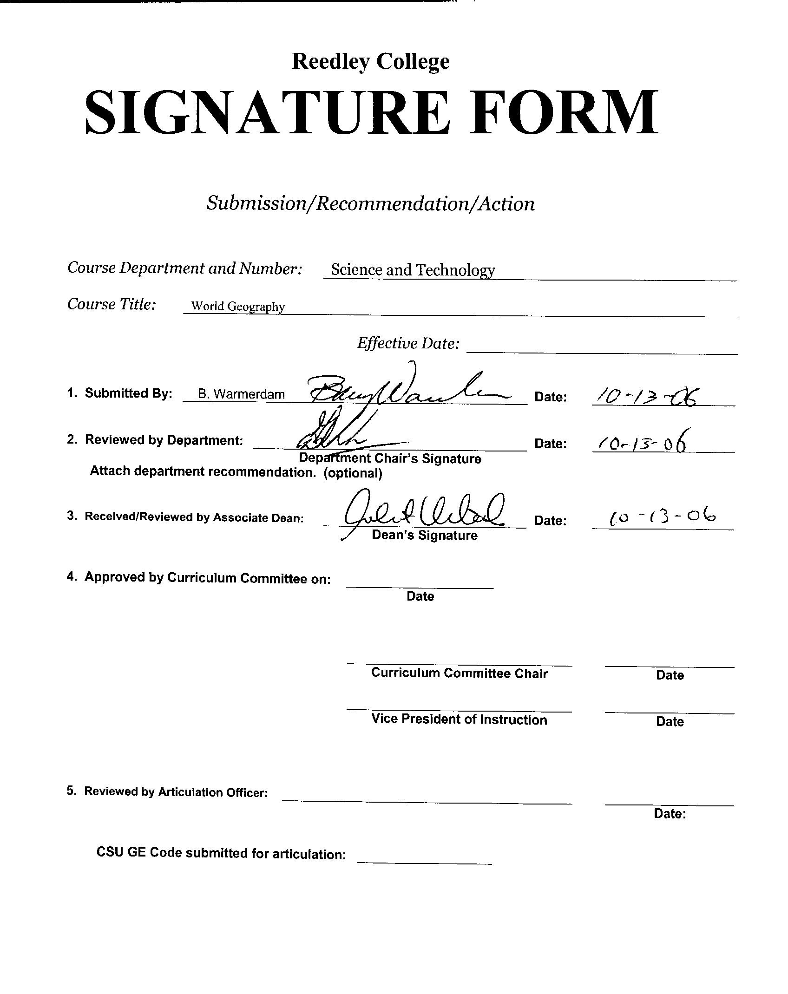

COURSE ALIGNMENT
REEDLEY COLLEGE/FRESNO CITY COLLEGE

Complete only if YES was checked on New Course Proposal Packet check off sheet for a similar department or course at FCC.

FCC Course | World Geography

RC Course ID | GEOG 4A | Course Title | World Geography

The RC and FCC faculty members of the Department have communicated regarding the attached course. The following determination has been made:

Check the appropriate boxes:
 The course department is the same □* Prerequisites/Corequisites are the same.
 The course number is the same □* The catalog descriptions are the same.
 The course title is the same. □* The number of repeats are the same.
 The units are the same
 The lecture/lab hours are the same. (rationale if not the same)
 The grading basis is the same. (CR-NC/A-F)

 It was determined that this course is a match.
(*Items with asterisk do not need to be an exact match.)
□ The course does not match but should be evaluated for acceptance in lieu of FCC’s
□ This course is not a match.

Please provide an explanation of the differences:

RC Instructor |  | Date
Department Chair |  | Date
Dean |  | Date



CREDIT COURSE OUTLINE

I. COVER PAGE

(1)  Course ID: GEOG 4A |  | (2)  Course Title: World Geography |  | (3)  Units: 3

(4) Lecture / Lab Hours: |  |  | (8)Classification:
Semester course  Hours per week | Lec hrs: | 3
 | Lab hrs: |  |  |  | Degree applicable: |  |  | x
Lab will generate ______ hour(s) per week outside work. |  |  |  |  | Non-degree applicable:
Short-term course:  Hours per course | Lec hrs: |  |  |  | Pre-collegiate basic skills:
 | Lab hrs:
Lab will generate ______ total hour(s) outside work. |  |  | (9)RC | Fulfills AS/AA degree requirement: (area)
(5)Grading Basis: | Grading scale only |  |  | General education category:
 | CR/NC option | x |  | Major:
 | CR/NC only
(6)Basic Skills Prerequisites: |  |  | (10)CSU: |  | Baccalaureate: |  |  | x
 |  |  | (11) Repeatable: (A course may be repeated  three times) |  |  |  |  | No
Basic Skills Advisories: |  |  | For Office Use Only
 |  |  | CATID: |  |  |  | DATATEL:
(7)Subject Prerequisites (requires C grade or better): |  |  | Course LHE: |  |  |  | Unit Code:
 |  |  | VEA Code: |  |  |  | SAM Priority:
 |  |  | TOPS Code: |  |  |  | Effective Date:
Subject Corequisites: |  |  | CSU: |  |  |  | Replaces:
Subject Advisories:  Eligibility for ENGL 125 and ENGL 126 |  |  |  |  |  |  | Replaced by:  Date:
(12)Catalog Description:

This course covers Europe, the post-Soviet Region, Asia, and Africa. A study of the physical settings, population patterns, natural resources, and economic and political status of these regions.

Course ID: GEOG 4A |  | Course Title: World Geography

II. COURSE OUTCOMES:

(Specify the learning skills the student demonstrates through completing the course and link critical thinking skills to specific course content and objectives.)

Upon completion of this course, students will be able to:

- Identify and discuss the major geographic features of all continents studied.

- Outline the geological history of a given region and discuss how these events contributed to the observed geographic features.

- Compare and contrast the geographic features of two different regions and discuss how these have determined the type of biome represented.

III. COURSE OBJECTIVES:

(Specify major objectives in terms of the observable knowledge and/or skills to be attained.)

In the process of completing this course, students will:

- Students will be able to identify on a map the major countries, cities, and physical features of the industrialized world.
- Students will be able to recognize simple geographic terms and comprehend geographic principles.
- Students will be able to comprehend the factors that determine the development of countries and regions.

Course ID: GEOG 4A |  | Course Title: World Geography

IV. COURSE CONTENT OUTLINE:

- Introduction to World Geography
- Europe
- Post-Soviet Region
- East Asia
- South and Southeast Asia
- Africa
- Southwest Asia

Course ID: GEOG 4A |  | Course Title: World Geography

V. APPROPRIATE READINGS

Reading assignments may include but are not limited to the following:

A. Sample Text Title: World Regional Geography ( Salter/Hobbs), 2004

B. Other Readings:

x | Global or international materials or concepts are appropriately included in this course
x | Multicultural materials and concepts are appropriately included in this course.

If either line is checked, write a paragraph indicating specifically how global/international and/or multicultural materials and concepts relate to content outline and/or readings.

Course ID: GEOG 4A |  | Course Title: World Geography

VI. METHODS TO MEASURE STUDENT ACHIEVEMENT AND DETERMINE GRADES:
Students in this course will be graded in at least one of the following four categories. Please check those appropriate. A degree applicable course must have a minimum of one response in category A, B or C.

A. Writing
Check either 1 or 2 below
 | 1. Substantial writing assignments are required. Check the appropriate boxes below and provide a written description in the space provided.
 | 2. Substantial writing assignments are NOT required. If this box is checked leave this section blank. For degree applicable courses you must complete category B and/or C.
 | a. essay exam(s) | x | d. written homework
x | b. term or other papers(s) |  | e. reading reports
 | c. laboratory reports |  | f. other (specify)
Required assignments may include but are not limited to the following:

B. Problem Solving
1. Computational or non-computational problem-solving demonstrations, including:
 | a. exam(s) |  | d. laboratory reports
 | b. quizzes |  | e. field work
 | c. homework problems |  | f. other (specify)
Required assignments may include, but are not limited to the following:

Course ID: GEOG 4A |  | Course Title: World Geography

C. Skill demonstrations, including:
 | a. class performance(s) |  | c. performance exam(s)
 | b. field work |  | d. other (specify)
Required assignments may include, but are not limited to the following:

- The course covers many concepts of both physical and human geography; it is imperative for the students to read the pages assigned outside of class, and to complete the written homework assignments, in order to fully comprehend the material.
- Critical thinking skills required for successful completion of the course include:
  - Linking theory about development to facts about countries and regions.
  - Recognizing patterns of organization in the world that produce its regions and relationships.
  - Comparing and contrasting regions of the world.

D. Objective examinations, including:
x | a. multiple choice |  | d. completion
 | b. true/false |  | e. other (specify)
x | c. matching items

COURSE GRADE DETERMINATION:
Description/Explanation: Based on the categories checked in A-D, it is the recommendation of the department that the instructor’s grading methods fall within the following departmental guidelines; however, the final method of grading is still at the discretion of the individual instructor. The instructor’s syllabus must reflect the criteria by which the student’s grade has been determined. (A minimum of five (5) grades must be recorded on the final roster.)

If several methods to measure student achievement are used, indicate here the approximate weight or percentage each has in determining student final grades.

The map tests require students to identify major countries, cities, and physical features of each of the world’s industrialized regions.

10% Written Homework
20% Term Paper
70% Exams

FOR DEGREE APPLICABLE COURSES

Course ID: GEOG 4A |  | Course Title: World Geography

VII. EDUCATIONAL MATERIALS
For degree applicable courses, the adopted texts, as listed in the college bookstore, or instructor-prepared materials have been certified to contain college-level materials.

Validation Language Level (check where applicable): | College-Level  Criteria Met
 | Yes | No
Textbook | X
Reference materials
Instructor-prepared materials | X
Audio-visual materials | X

Indicate method of evaluation:
Used readability formulae (grade level 10 or higher)
Text is used in a college-level course | X
Used grading provided by publisher
Other: (please explain; relate to Skills Levels)

Computation Level (Eligible for MATH 101 level or higher where applicable)

Content
Breadth of ideas covered clearly meets college-level learning objectives of this course
Presentation of content and/or exercises/projects:
Requires a variety of problem-solving strategies including inductive and deductive reasoning. |  | X
Requires independent thought and study |  | X
Applies transferring knowledge and skills appropriately and efficiently to new situations or  problems. |  | X
List of Reading/Educational Materials

Comments:

 | This course requires special or additional library materials (list attached).
 | This course requires special facilities:

FORM A
TARGET COURSE | GEOG 4A |  | World Geography
 | Number |  | Title

BASIC SKILLS ADVISORIES PAGE The skills listed are those needed for eligibility for English 125, 126, and Math 101. These skills are listed as the outcomes from English 252, 262, and Math 250. In the right hand column, list at least three major basic skills needed at the beginning of the target course and check off the corresponding basic skills listed at the left.

Math Skills (eligibility for Math 101)  (as outcomes for Math 250)  Performing the four arithmetic operations on whole numbers, arithmetic fractions, and decimal fractions.  Making the conversions from arithmetic fractions to decimal fractions, from decimal fractions to percents, and then reversing the process.  Applying the concepts listed above to proportions, percents, simple interest, markup and discount.  Applying the operations of integers in solving simple equations.  X Converting between the metric and English measurement systems | Some discussion of the different units of measurement is needed to understand foreign standards of measure.
Reading Skills (eligibility for English 126)  (as outcomes for English 262)  Using phonetic, structural, contextual, and dictionary skills to attack and understand words.  Applying word analysis skills to reading in context.  x Using adequate basic functional vocabulary skills.  x Using textbook study skills and outlining skills.  x Using a full range of literal comprehension skills and basic analytical skills such as predicting, inferring, concluding, and evaluating. | The textbook is required reading.  Research for term papers requires college level comprehension.
Writing Skills (eligibility for English 125)  (as outcomes for English 252)  x Writing complete English sentences and avoiding errors most of the time.  x Using the conventions of English writing: capitalization, punctuation, spelling, etc.  x Using verbs correctly in present, past, future, and present perfect tenses, and using the correct forms of common irregular verbs.  Expanding and developing basic sentence structure with appropriate modification.  Combining sentences using coordination, subordination, and phrases.  Expressing the writer's ideas in short personal papers utilizing the writing process in their development. | A term paper is required for this course.  Exams will require short essays.  Complete sentences are required for exams.

Check the appropriate spaces.
Eligibility for Math 101 is advisory for the target course.
Eligibility for English 126 is advisory for the target course.
Eligibility for English 125 is advisory for the target course.
If the reviewers determine that an advisory or advisories in Basic Skills are all that are necessary for success in the target course, stop here, provide the required signatures, and forward this form to the department chair, the appropriate associate dean, and the curriculum committee.

Content review completed by |  | Date

FORM B
TARGET COURSE | GEOG 4A |  | World Geography
 | Number |  | Title

CONTENT REVIEW FOR ALL COURSES IN ADDITION TO BASIC SKILLS COURSES
List in Column 1 at least three specific major concepts, skills, or kinds of knowledge that a student will learn in the pre- or corequisite or advisory course that are essential to the successful completion in the target course. In Column 2, state why the skill in Column 1 is essential in relation to the content listed in the course outline of the target course.

COLUMN 1: Concepts, Skills, Kinds of Knowledge | COLUMN 2: Specifically how this is necessary in the target course
(List each prerequisite or advisory separately here. If you need more space, attach a second page B. Be sure to explain each course in Column 2.)  Name of prerequisite or advisory course:  _____ENGL 125, 126___________________________  Concepts, skills, etc. (List these)  Ability to write complete sentences.  Ability to organize and write a report.  Ability to research a topic.  Ability to effectively communicate. | A report is required for this course.  Exams will require short essays.  Complete sentences are required for exams.

If the courses listed in Column 1 are advisory, complete the information below and do not go on to the next page.

Advisory course(s):

Content review completed by
 | Signature(s) |  | Date

Vice President of Instruction’s Signature
Date

Please forward this completed form to the Curriculum Committee.

