Reedley College
Proposed Course Modification

Course # / Math5B | Math Analysis II

CHECK OFF SHEET
PRELIMINARY STEPS. Do before completing Course Modification Form.
(EACH BOX SHOULD BE CHECKED AS COMPLETED BEFORE SUBMISSION.)
☑ 1. Communicate with the Curriculum Chair regarding intent to modify an existing course outline (recommended, not required).
☑ 2. List term for implementation of modifications:
[ ] | Fall |  | [ x ] | Spring | 2007 | [ ] | Summer
☑ 3. Check one:
Do not complete Fresno City College course alignment page if:
 | No similar course or program at FCC.
x | Course currently in common with FCC course or accepted in lieu of and changes will not affect status.

Complete Fresno City College course alignment page if:
Course currently in common with FCC course or accepted in lieu of. Changes may affect status. Consult with counterparts at FCC and complete alignment page
Course not in common or accepted in lieu of but may be with proposed changes consult with FCC counterparts

☑ 4. Changes sought in the following:

CSU General Education Code | Yes |  | No | x
Transfer Baccalaureate List | Yes |  | No | x

If yes to either, schedule an appointment with the Articulation Officer
☑ 5. Changes sought in number of repeats for credit:

 | Yes
x | No

If yes, secure a Course Repetition form from the Curriculum Office.
PROPOSED COURSE MODIFICATION FORM
☑ Appropriate sections of Course Outline of Record completed.

FINAL steps (Do after completing Course Outline of Record)

☑ 1. Signature Form. Secure signatures of the Department Chair and the Associate Dean before submitting the completed course proposal to the Curriculum Office.

☑ 2. Program Description. Course modification will change an existing program which is or will be described in the college catalogue.

 | Yes | x | No

If yes, complete Program Description Form before submitting modification.

☑ 3. Final Check. All items above have been completed and checked off before modification is submitted.

Reedley College
PROPOSED COURSE MODIFICATION

All changes and modifications in the official course outline must come to the Curriculum Committee. Though minor changes may seem obvious, even these need to come to committee for information and to update the official curriculum. Changes in programs or in several department offerings should be submitted together if possible so that the whole picture is clear.

OUTLINE. Please fill in current existing course number, title, and units for course to be modified.

Department | Math and Technology | Course No. | Math 5B
Course Title | Math Analysis II | Units | 4
 | Effective Date

A. PROPOSED CHANGES.
(Indicate below all proposed changes to be made in the course outline.)

I. Cover Page
 | 1. Course ID |  |  | 8. Classification (Degree applicable, Non-degree applicable, or
 | 2. Course Title |  |  | Pre-collegiate Basic skills)
 | 3. Units |  |  | 9. General Education Pattern, Graduation Requirement, and
 | 4. Lecture/Lab Hours |  |  | Major Category
 | 5. Grading Basis |  |  | 10. General Education Pattern/Baccalaureate (CSU)
 | 6. Entrance Skills: Basic Skills Prerequisites/Advisories |  |  | 11. Repeatability
 | 7. Subject Prerequisites/Corequisites/Advisories |  | x | 12. Catalog Description

Other pages

x | II. Course Outcomes |  | x | VI. Methods of Grading
x | III. Course Objectives |  |  | VII. Levels of Educational Materials
 | IV. Course Content Outline |  | Additional Pages (optional depending on course)
x | V. Approved Readings |  |  | Request for Repeatability/Limitation on Enrollment

B. DESCRIPTION OF CHANGES AND MODIFICATIONS.

ITEM NO. | CHANGED FROM | CHANGED TO | REASON
12. | See old catalog description | See new catalog description | Re-worded for clarity
II. | NA | See new outline | New forms add this section
III. | See old outline | See new outline | New forms cause modification to this section
V. | “Current Edition” | 2005 edition | More detail
VI. | 90% Exams 10% Homework | 85% Exams 15% Homework | Modify to current practice

(Additional sheets may be attached if necessary.)

C. EXPLANATIONS. If course modification results in changes in the program which will require use of the program description form, please give rationale.

Please attach the complete outline before modifications to this form. If only the first page of the outline is being modified, also attach the new first page. If other pages of the outline are being modified, please attach the complete new outline.

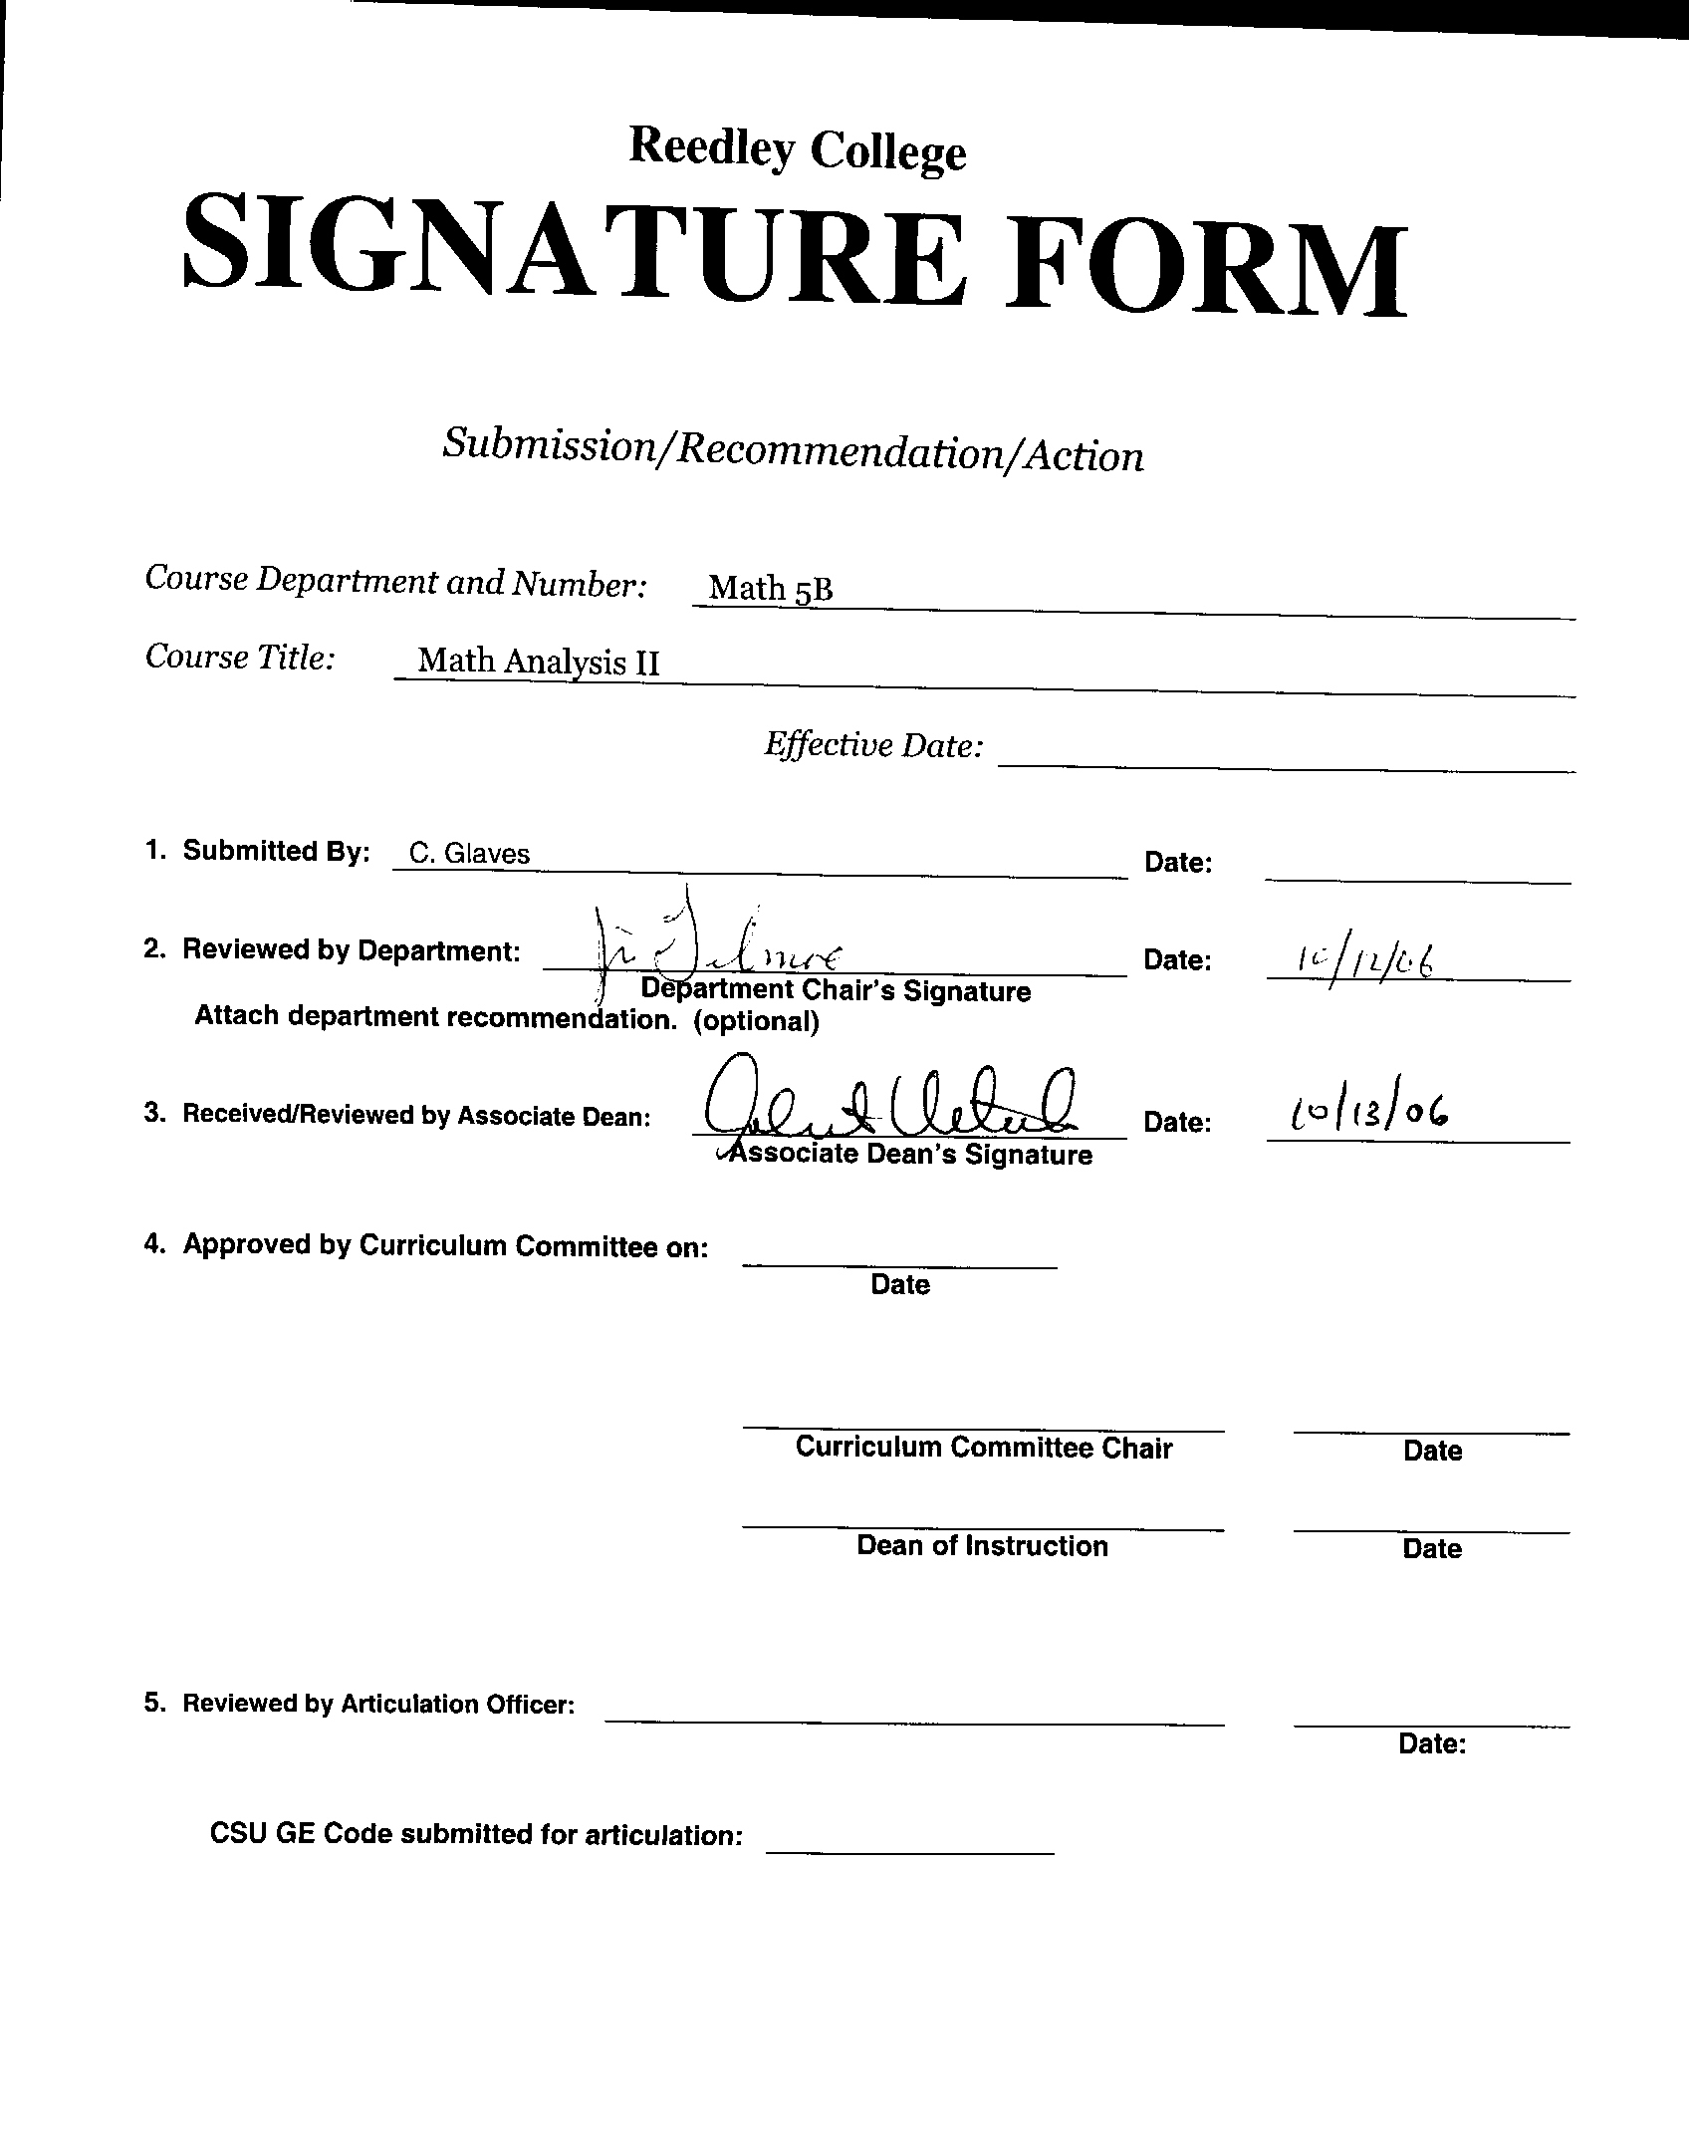



CREDIT COURSE OUTLINE

I. COVER PAGE

(1)  Course ID: Math 5B |  | (2)  Course Title: Math Analysis II |  | (3)  Units: 4

(4) Lecture / Lab Hours: |  |  | (8)Classification:
Semester course  Hours per week | Lec hrs: | 4
 | Lab hrs: |  |  |  | Degree applicable: |  |  | x
Lab will generate ______ hour(s) per week outside work. |  |  |  |  | Non-degree applicable:
Short-term course:  Hours per course | Lec hrs: |  |  |  | Pre-collegiate basic skills:
 | Lab hrs:
Lab will generate ______ total hour(s) outside work. |  |  | (9)RC | Fulfills AS/AA degree requirement: (area) |  |  |  | Math Competency
(5)Grading Basis: | Grading scale only |  |  | General education category:
 | CR/NC option | x |  | Major: |  | Mathematics/Physical Science
 | CR/NC only
(6)Basic Skills Prerequisites: |  |  | (10)CSU: |  | Baccalaureate: |  |  | x
(11) Repeatable: (A course may be repeated
three times)
Basic Skills Advisories:  Eligibility for ENGL 125 and ENGL 126 |  |  | For Office Use Only
 |  |  | CATID: |  |  |  | DATATEL:
(7)Subject Prerequisites (requires C grade or better):  Math 5A |  |  | Course LHE: |  |  |  | Unit Code:
 |  |  | VEA Code: |  |  |  | SAM Priority:
 |  |  | TOPS Code: |  |  |  | Effective Date:
Subject Corequisites: |  |  | CSU: |  |  |  | Replaces:
Subject Advisories: |  |  |  |  |  |  | Replaced by:  Date:
(12)Catalog Description:

Applications of integration, techniques of integration, improper integrals, parametric equations, polar coordinates and functions, conic sections, exponential growth/decay models, infinite series including Maclaurin and Taylor Series.

Course ID: Math 5B |  | Course Title: Math Analysis II

II. COURSE OUTCOMES:

(Specify the learning skills the student demonstrates through completing the course and link critical thinking skills to specific course content and objectives.)

Upon completion of this course, students will be able to:

A. Determine the area between two curves.

B. Determine the volume of solids of revolution using the disk, washer, and shell methods.

C. Solve application problems involving force, pressure and work.

D. Integrate functions using the techniques of parts, trig integrals, trig substitution, partial fraction decomposition, and tables.

E. Define and analyze functions given in parametric and polar forms.

F. Graph and analyze conic sections.

G. Mathematically model simple exponential growth and decay problems.

H. Derive Taylor and Maclaurin polynomials.

III. COURSE OBJECTIVES:

(Specify major objectives in terms of the observable knowledge and/or skills to be attained.)

In the process of completing this course, students will:

- Determine the area between two curves in the coordinate plane.
- Determine the volumes of solids of revolution using the disk and shell methods.
- Determine the length of a curve in the coordinate plane.
- Solve application problems involving force, pressure, and work.
- Evaluate and use hyperbolic functions.
- Use the technique of integration by parts to evaluate definite and indefinite integrals.
- Evaluate definite and indefinite integrals involving combinations of trigonometric functions.
- Use the technique of trig substitution to evaluate definite and indefinite integrals.
- Use the technique of integration by partial fraction decomposition to evaluate definite and indefinite integrals.
- Learn to use integral tables to evaluate definite and indefinite integrals.
- Apply Simpson’s Rule to numerically evaluate integrals.
- Evaluate improper integrals.
- Use, differentiate, and integrate parametrically defined functions.
- Use polar coordinates to define and analyze polar functions.
- Derive the equations for and graph conic sections.
- Investigate the behavior of exponential functions.
- Mathematically model exponential growth and decay phenomena.
- Investigate the behavior of sequences and series.
- Apply convergence tests including the Comparison, Ratio, and Root Tests.
- Derive and use Maclaurin and Taylor Series.
- Derive and use power series.
- Investigate the convergence of Taylor Series and use the Remainder Theorem.

Course ID: Math 5B |  | Course Title: Math Analysis II

IV. COURSE CONTENT OUTLINE:

I Applications of the Definite Integral
  - Area between two curves
- Volumes by disk and washer methods
- Volumes by shell method
- Length of a plane curve
- Work, Pressure and Force
- Hyperbolic Functions
II Techniques of Integral Evaluation
  - Integration by parts
  - Trigonometric Integrals
  - Trigonometric substitution
  - Partial fractions
  - Using tables of integrals
  - Simpson’s Rule
  - Improper Integrals
III Analytic Geometry
  - Parametric equations
  - Polar coordinates and equations
  - Parabolas
  - Ellipses
  - Hyperbolas
IV Exponential Growth and Decay Applications
  - Exponential functions
  - Modeling physical phenomena with differential equations

V Infinite Series
  - Sequences
  - Infinite Series
  - Convergence Tests
  - Taylor and Maclaurin Series
  - Comparison, Ratio and Root Tests
  - Alternating series and conditional convergence
  - Power Series
8. Convergence of Taylor Series

Course ID: Math 5B |  | Course Title: Math Analysis II

V. APPROPRIATE READINGS

Reading assignments may include but are not limited to the following:

A. Sample Text Title: Calculus, Early Trancendentals, Anton, 8th Edition, 2005.

B. Other Readings: none

Global or international materials or concepts are appropriately included in this course
Multicultural materials and concepts are appropriately included in this course.

If either line is checked, write a paragraph indicating specifically how global/international and/or multicultural materials and concepts relate to content outline and/or readings.

Course ID: Math 5B |  | Course Title: Math Analysis II

VI. METHODS TO MEASURE STUDENT ACHIEVEMENT AND DETERMINE GRADES:
Students in this course will be graded in at least one of the following four categories. Please check those appropriate. A degree applicable course must have a minimum of one response in category A, B or C.

A. Writing
Check either 1 or 2 below
 | 1. Substantial writing assignments are required. Check the appropriate boxes below and provide a written description in the space provided.
x | 2. Substantial writing assignments are NOT required. If this box is checked leave this section blank. For degree applicable courses you must complete category B and/or C.
 | a. essay exam(s) |  | d. written homework
 | b. term or other papers(s) |  | e. reading reports
 | c. laboratory reports |  | f. other (specify)
Required assignments may include but are not limited to the following:

B. Problem Solving
1. Computational or non-computational problem-solving demonstrations, including:
x | a. exam(s) |  | d. laboratory reports
 | b. quizzes |  | e. field work
x | c. homework problems |  | f. other (specify)
Required assignments may include, but are not limited to the following:

- Textbook problems require the use of problem solving skills.
- Examinations require the use of problem solving skills.

Course ID: Math 5B |  | Course Title: Math Analysis II

C. Skill demonstrations, including:
 | a. class performance(s) |  | c. performance exam(s)
 | b. field work |  | d. other (specify)
Required assignments may include, but are not limited to the following:

D. Objective examinations, including:
 | a. multiple choice |  | d. completion
 | b. true/false |  | e. other (specify)
 | c. matching items

COURSE GRADE DETERMINATION:
Description/Explanation: Based on the categories checked in A-D, it is the recommendation of the department that the instructor’s grading methods fall within the following departmental guidelines; however, the final method of grading is still at the discretion of the individual instructor. The instructor’s syllabus must reflect the criteria by which the student’s grade has been determined. (A minimum of five (5) grades must be recorded on the final roster.)

If several methods to measure student achievement are used, indicate here the approximate weight or percentage each has in determining student final grades.

85% Four to six exams (including final exam)
15% Homework problems

FOR DEGREE APPLICABLE COURSES

Course ID: Math 5B |  | Course Title: Math Analysis II

VII. EDUCATIONAL MATERIALS
For degree applicable courses, the adopted texts, as listed in the college bookstore, or instructor-prepared materials have been certified to contain college-level materials.

Validation Language Level (check where applicable): | College-Level  Criteria Met
 | Yes | No
Textbook | x
Reference materials
Instructor-prepared materials
Audio-visual materials

Indicate method of evaluation:
Used readability formulae (grade level 10 or higher)
Text is used in a college-level course | x
Used grading provided by publisher
Other: (please explain; relate to Skills Levels)

Computation Level (Eligible for MATH 101 level or higher where applicable) |  | x

Content
Breadth of ideas covered clearly meets college-level learning objectives of this course |  | x
Presentation of content and/or exercises/projects:
Requires a variety of problem-solving strategies including inductive and deductive reasoning. |  | x
Requires independent thought and study |  | x
Applies transferring knowledge and skills appropriately and efficiently to new situations or  problems. |  | x
List of Reading/Educational Materials

Calculus, Early Trancendentals, Anton, 8th Edition, 2005.

Comments:

 | This course requires special or additional library materials (list attached).
 | This course requires special facilities:

FORM A
TARGET COURSE | Math 5B |  | Math Analysis II
 | Number |  | Title

BASIC SKILLS ADVISORIES PAGE The skills listed are those needed for eligibility for English 125, 126, and Math 101. These skills are listed as the outcomes from English 252, 262, and Math 250. In the right hand column, list at least three major basic skills needed at the beginning of the target course and check off the corresponding basic skills listed at the left.

Math Skills (eligibility for Math 101)
(as outcomes for Math 250)

Performing the four arithmetic operations on whole numbers, arithmetic fractions, and decimal fractions.
Making the conversions from arithmetic fractions to decimal fractions, from decimal fractions to percents, and then reversing the process.
Applying the concepts listed above to proportions, percents, simple interest, markup and discount.
Applying the operations of integers in solving simple equations.
Converting between the metric and English measurement systems
Reading Skills (eligibility for English 126)  (as outcomes for English 262)  x Using phonetic, structural, contextual, and dictionary skills to attack and understand words.  x Applying word analysis skills to reading in context.  x Using adequate basic functional vocabulary skills.  x Using textbook study skills and outlining skills.  x Using a full range of literal comprehension skills and basic analytical skills such as predicting, inferring, concluding, and evaluating. | 1. Must be able to read a college level textbook.  2. Must translate written information into mathematical equations and/or geometric diagrams  3. Must read descriptions of mathematical modeling and apply the information to problem solving
Writing Skills (eligibility for English 125)  (as outcomes for English 252)  x Writing complete English sentences and avoiding errors most of the time.  x Using the conventions of English writing: capitalization, punctuation, spelling, etc.  x Using verbs correctly in present, past, future, and present perfect tenses, and using the correct forms of common irregular verbs.  x Expanding and developing basic sentence structure with appropriate modification.  x Combining sentences using coordination, subordination, and phrases.  x Expressing the writer's ideas in short personal papers utilizing the writing process in their development. | - Some homework questions require descriptive answers in paragraph form.  - Some exam questions require descriptive answers in paragraph form.  - Some graphing problems require a paragraph form word description to accompany the graph.

Check the appropriate spaces.
Eligibility for Math 101 is advisory for the target course.
x Eligibility for English 126 is advisory for the target course.
x Eligibility for English 125 is advisory for the target course.
If the reviewers determine that an advisory or advisories in Basic Skills are all that are necessary for success in the target course, stop here, provide the required signatures, and forward this form to the department chair, the appropriate associate dean, and the curriculum committee.

Content review completed by | C. Glaves | Date

FORM B
TARGET COURSE | Math 5B |  | Math Analysis II
 | Number |  | Title

CONTENT REVIEW FOR ALL COURSES IN ADDITION TO BASIC SKILLS COURSES
List in Column 1 at least three specific major concepts, skills, or kinds of knowledge that a student will learn in the pre- or corequisite or advisory course that are essential to the successful completion in the target course. In Column 2, state why the skill in Column 1 is essential in relation to the content listed in the course outline of the target course.

COLUMN 1: Concepts, Skills, Kinds of Knowledge | COLUMN 2: Specifically how this is necessary in the target course
(List each prerequisite or advisory separately here. If you need more space, attach a second page B. Be sure to explain each course in Column 2.)

Name of prerequisite or advisory course: Math 5A

Concepts, skills, etc. (List these.)
Ability to integrate simple functions | Applications of integration (such as volume determination for solids of revolution) are covered in Math 5B. The ability to integrate simple functions is assumed.
Ability to integrate using the substitution method | Simple techniques of integration (such as substitution) are used and built upon to develop more sophisticated techniques of integration in Math 5B.
Ability to differentiate functions | Differentiation is used extensively throughout Math 5B. One example would be in finding the length of a plane curve (Both differentiation and integration are used in this application).

If the courses listed in Column 1 are advisory, complete the information below and do not go on to the next page.

Advisory course(s):

Content review completed by | C. Glaves
 | Signature(s) |  | Date

Vice President of Instruction’s Signature
Date

Please forward this completed form to the Curriculum Committee.
