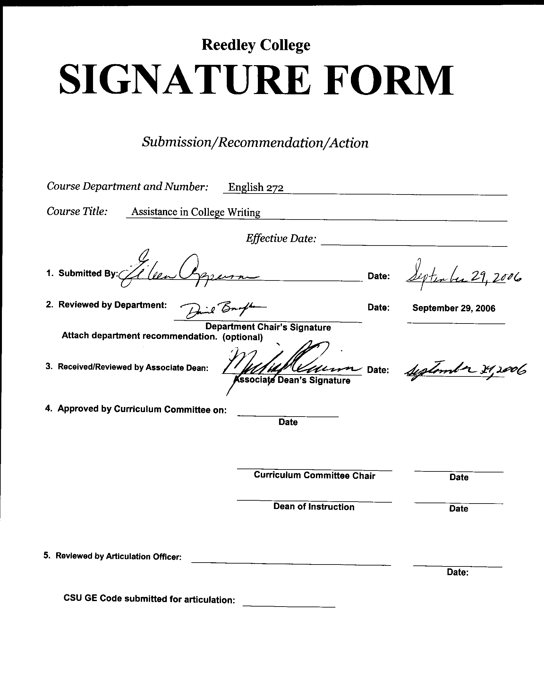
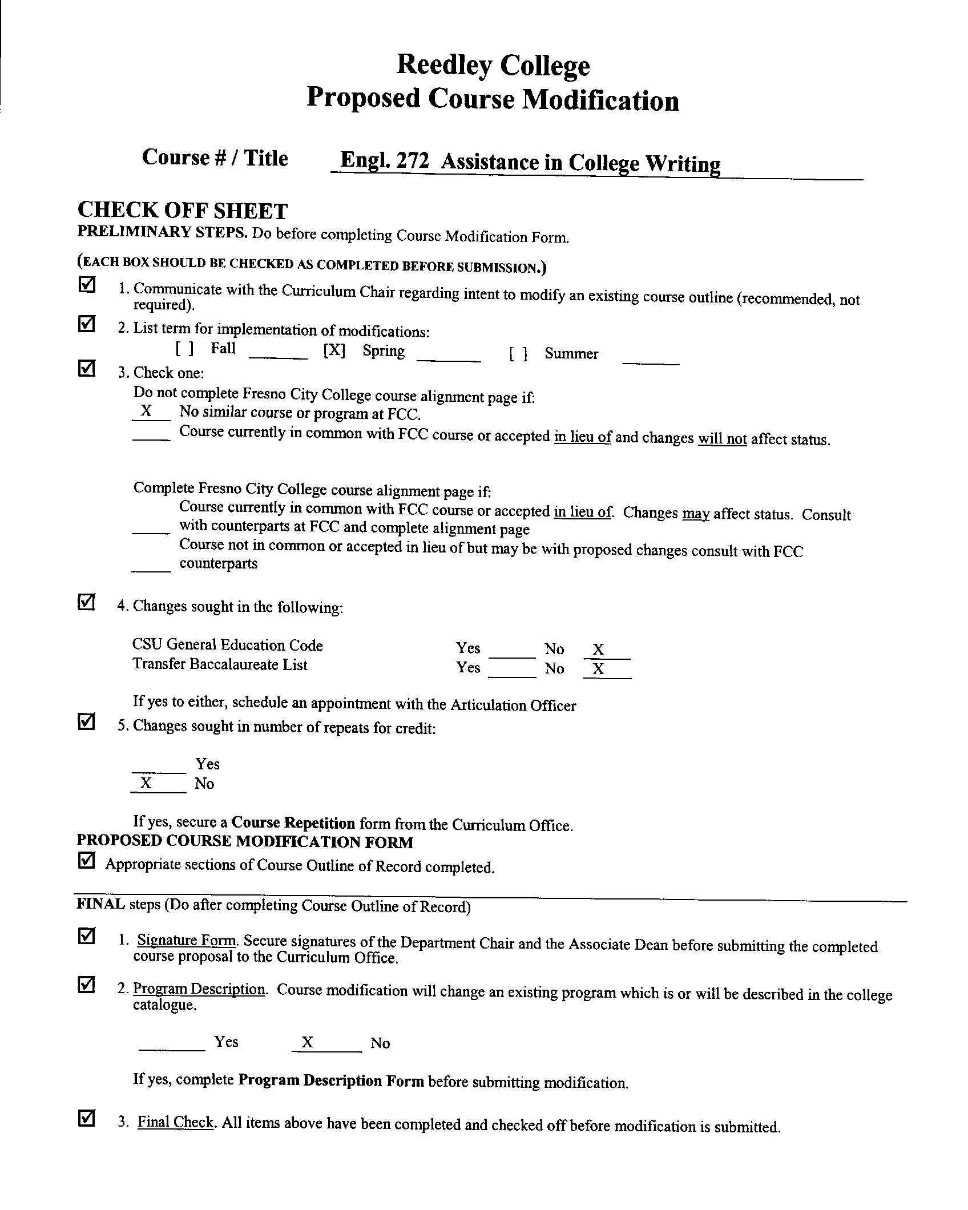
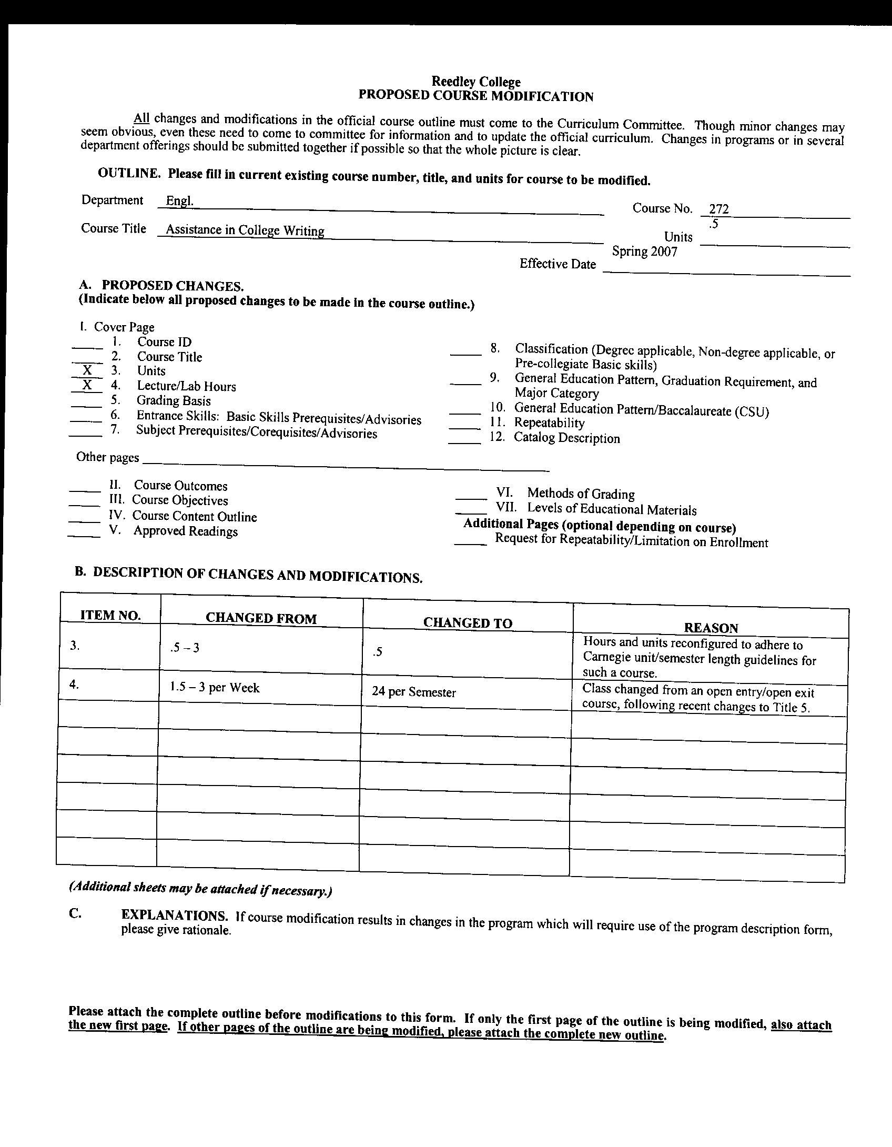


CREDIT COURSE OUTLINE

I. COVER PAGE

(1)  Course ID: ENGL 272 |  | (2)  Course Title: Assistance in College Writing |  | (3)  Units: .5 - 1

(4) Lecture / Lab Hours: |  |  | (8)Classification:
Semester course  Hours per week | Lec hrs:
 | Lab hrs: |  |  |  | Degree applicable:
Lab will generate ______ hour(s) per week outside work. |  |  |  |  | Non-degree applicable: |  |  |  | X
Short-term course:  Hours per course | Lec hrs: |  |  |  | Pre-collegiate basic skills:
 | Lab hrs: | 24 - 48
Lab will generate ______ total hour(s) outside work. |  |  | (9)RC | Fulfills AS/AA degree requirement: (area)
(5)Grading Basis: | Grading scale only |  |  | General education category:
 | CR/NC option |  |  | Major:
 | CR/NC only | X
(6)Basic Skills Prerequisites:  None |  |  | (10)CSU: |  | Baccalaureate:
 |  |  | (11) Repeatable: (A course may be repeated  three times) |  |  |  |  |  | 3
Basic Skills Advisories:

 |  |  | For Office Use Only
(7)Subject Prerequisites:  None |  |  | CATID: 60040700 |  |  | DATATEL:  3607 |  | Org Code: 242010
 |  |  | Tops Code: 1501.00 |  |  |  |  | SAM Priority: E
 |  |  | VEA Code: N |  |  |  |  | Course LHE: 1.13
Subject Corequisites: |  |  | Effective Date: Spring 2007 |  |  |  |  | Replaces:
Subject Advisories: |  |  | CSU GE Code: 9.1 |  |  |  |  | Replaced by:  Date:
(12)Catalog Description:

This course is intended for any student requiring help with written compositions in any discipline. The course will provide intensive assistance in writing and critical thinking. Students will develop, improve, and refine compositions to sustain focus, employ analysis, reflection, organization, and logical structure. All stages of the writing process are practiced.

11/00

I. COURSE OUTCOMES:
By the end of this course, the student will have developed a successful process for college level writing. He/she will:

- Generate, narrow, and select appropriate topics for written compositions.
- Generate ideas appropriate for the development of the written composition’s topic.
- Produce effective supporting details.
- Plan the rhetorical strategies of each writing task.
- Organize ideas effectively.
- Analyze his/her own (and others’) compositions for development, focus, logic, and clarity.
- Provide useful feedback about compositions and respond appropriately to peers’ feedback.
- Incorporate revision techniques.
- Edit and proofread for sentence mechanics such as punctuation and grammar usage.

II. COURSE OBJECTIVES:
(Specify major objectives in terms of the observable knowledge and/or skills to be attained.)

In the process of completing this course, the student will:

- Know how to generate and develop an effective written composition.
- Employ various writing strategies for a variety of written assignments.
- Discuss and analyze his/her own written compositions.
- Describe his/her own revision process.
- Recognize and correct his/her own sentence level errors.
- Use new revision and editing/proofreading techniques.

This course will serve students seeking help in writing for the following courses:

Agriculture 5—Ag Sales and Communication
Agriculture and Natural Resources 1—Career Preparation
Animal Science 6—Livestock Selection and Evaluation
Anthropology 3—Introduction to Archaeology and Prehistory
Art 2—Art Appreciation
Art 5 Art History 1
Art 6—Art History 6
Art 6H—Honors Art History 2
Aviation Maintenance Technology 1--Aviation Maintenance Technology
Aviation Maintenance Technology 11--Aviation Maintenance Technology
Aviation Maintenance Technology 13--Aviation Maintenance Technology
Business Administration 5—Business Communication
Business Administration 10—Introduction to Business
Business Administration 15—Introduction to Management
Business Administration 18—Business and the Legal Environment
Business Administration 27—Students in Free Enterprise
Business Administration 33—Human Relations in Business
Business Administration 38—Operation of the Small Business
Business Administration 47—Careers-Business
Business Administration103—Customer Service in Business
Child Development 12—Child Abuse
Child Development 38—Lifespan Development
Child Development 39—Child Development
Child Development 40A—Administration of Childhood Programs
Child Development 151—Introduction to Family Child Care
Child Development 207—Starting a Family Child Care
Criminal Justice 1—Introduction to Criminal Justice
Criminal Justice 2—Traffic Control
Criminal Justice 3—Criminal Evidence
Criminal Justice 4—Criminal Legal Procedure
Criminal Justice 5—Community Relations
Criminal Justice 6A—Criminal Law
Criminal Justice 6B—Criminal Law
Criminal Justice 7A—Police Operations and Procedures
Criminal Justice 7B—Police Operations and Procedures
Criminal Justice 8—Investigation of Crime Scene
Criminal Justice 10—Vice Control
Criminal Justice 11—Juvenile Procedures
Criminal Justice 12—Justice System Communications
Criminal Justice 14—Multicultural Issues within Public Safety
Criminal Justice 19—Criminal Justice Cooperative Work Experience
Criminal Justice 20—Correctional Institutions
Criminal Justice 28—Probation and Parole
Dental Assisting 101—Dental Assisting
Dental Assisting 102—Dental Assisting 2
Dental Assisting 103—Dental Assisting 3
Developmental Services 240—Bridge To College Reading
Developmental Services 251—Workability Preparation and Job Placement
Developmental Services 259—Strategies Intervention
Developmental Services 283—Computer Applications of Software To Reading and Writing
Economics 1A—Introduction to Macroeconomics
Economics 1B—Introduction to Microeconomics
Education 200A—Preparation for C-BEST-English
English 1A—Reading and Composition
English 1AH—Honors Reading and Composition
English 1B—Introduction to the Study of Literature
English 1BH—Honors Introduction to the Study of Literature
English 2—Critical Reading and Writing Through Literature
English 3—Critical Reading and Writing
English 3H—Honors Critical Reading and Writing
English 15A—Creative Writing: Poetry
English 15B—Creative Writing: Fiction
English 15E—Creative Writing: Creative Non-Fiction
English 41—Themes in Literature
English 44A—World Literature to the Renaissance
English 44B—World Literature Since the Renaissance
English 46A—English Literature to 1800
English 46B—English Literature From 1800 to the Present
English 47—Shakespeare
English 48—American Literature
English 49—Latino and Chicano Literature
English 72—Writing Center Practice and Theory
English 105—Grammar and Punctuation
English 125—Writing Skills for College
English 126—Reading Skills for College
English 250—Basic Writing
English 252—Writing Improvement
English 254—Sentence Writing
English 255—Basic Literacy Skills
English 258—Reading for Word Use
English 260—Basic Reading
English 260A—Basic Reading: Introduction to Reading
English 260B—Basic Reading: Reading Strategies
English 262—Reading Improvement
English 262B—Reading Improvement Strategies
English 383—Writing Your Life Story
English as a Second Language 206—ESL for Child Development
English as a Second Language 260—Introduction to Reading, Writing, and Grammar
English as a Second Language 260LS—Introduction to Oral Skills
English as a Second Language 261—Basic Reading and Writing
English as a Second Language 261I—Intensive Basic Reading, Writing, and Grammar
English as a Second Language 261LS—Basic Oral Skills
English as a Second Language 264—Fundamentals of Reading, Writing, and Grammar
English as a Second Language 264LS—Fundamentals of Oral Skills
English as a Second Language 265—Understanding Reading, Writing, and Grammar
English as a Second Language 265LS—Integrating Oral Skills
English as a Second Language 266—Academic Reading and Writing for ESL Students
English as a Second Language 266LS—Academic Oral Communication
English as a Second Language 266R—Academic Reading and Vocabulary
English as a Second Language 266W—Academic Grammar and Writing
English as a Second Language 269A—Basic Pronunciation and Oral Communication Skills
English as a Second Language 269B—Intermediate Pronunciation and Oral Communication Skills
English as a Second Language 269C—Academic Pronunciation and Oral Communication Skills
Ethnic Studies 5—African People in the New World
Ethnic Studies 32—History of the Mexican American People
Film 1—Introduction to Film Studies
Foods and Nutrition 35—Nutrition and Health
Foods and Nutrition 40—Nutrition
Guidance Studies 34—Career Awareness
Guidance Studies 40—Planning for Academic and Personal Success
Guidance Studies 47—Learning Strategies
Guidance Studies 53—College and Life Management
Guidance Studies 105—Academic Language and Skills Preparation
Guidance Studies 120—College Introduction
Guidance Studies 171—Personal Development
Guidance Studies 172—Employability Skills
Guidance Studies 173—Job Search Skills
Guidance Studies 263—Leadership Development
Guidance Studies 264—First Year College Orientation
Guidance Studies 266—Assertiveness Training
Guidance Studies 281—Life Strategies for Success
Guidance Studies 282—Practical Money Skills
Guidance Studies 283—Parenting Strategies and Family Relationships
History 1—Western Civilization to 1648
History 2—Western Civilization from 1648
History 5—African People in the New World
History 6—Women’s Role in United States History
History 11—History of the United States to 1877
History 12—History of the United States since 1865
History 12H—Honors History of the United States since 1865
History 20—Comparative World Civilizations to 1600
History 32—History of the Mexican American People
Individual Study 49—(Course Title To Be Selected)
Journalism 1—Introduction to Mass Communications
Journalism 3—News Writing
Journalism 7—Writing by Design: Publication and Production
Journalism 8—Newspaper Staff
Linguistics 10—Introduction to Language
Linguistics 11—Introduction to Language
Marketing 10—Marketing
Marketing 11—Salesmanship
Marketing 12—Advertising and Promotion
Marketing 14—Retailing
Marketing 17—Visual Merchandise
Marketing 260—Topics in Marketing
Music 1B—Music Theory II
Music 2B—Music Theory IV
Music 12—Music Appreciation
Music 16—Jazz History and Appreciation
Natural Resources 1—Introduction to Forestry
Natural Resources 7—Conservation of Natural Resources
Natural Resources 35—Interpretation of Natural Resources
Natural Resources 36—Natural Resources Law Enforcement
Office Technology 4—Machine Transcription
Office Technology 5—Document Formatting
Office Technology 10—Medical Terminology
Office Technology 20—Office System Procedures
Office Technology 27—Medical Transcription
Office Technology 49—Business English
Philosophy 1—Introduction to Philosophy
Philosophy 1C—Ethics
Philosophy 2—Critical Thinking and Writing
Political Science 2—American Government
Political Science 2H Honors American Government and Institutions
Political Science 5—Comparative Government
Political Science 110—American Institutions
Psychology 2—General Psychology
Psychology 2H—Honors General Psychology
Psychology 5—Social Psychology
Psychology 6—Introduction to Laboratory Methods
Psychology 16—Abnormal Psychology
Psychology 25—Human Sexuality
Psychology 33—Personal and Social Adjustment
Psychology 38—Lifespan Development
Real Estate 140—Real Estate Principles
Real Estate 142—Legal Aspects of Real Estate
Sociology 1A—Introduction to Sociology
Sociology 2—American Minority Groups
Sociology 32—Courtship, Marriage, and Divorce: Family and Interpersonal Relationships
Speech 1—Public Speaking
Speech 1H—Honors Public Speaking
Speech 2—Interpersonal Communications
Speech 8—Group Communication
Speech 12—Fundamentals of Interpretation
Speech 25--Argumentation

III. COURSE CONTENT OUTLINE:

Will include individualized help with writing skills related to assignments such as:

- Selecting and refining a topic.
- Generating ideas: brainstorming, clustering, mapping, freewriting, listing, and questioning.
- Developing purposes for writing: to reflect, to explore ideas, to explain, to entertain, and to persuade.
- Utilizing strategies for development: narration, description, illustration, definition, classification, comparison/contrast, process, cause and effect analysis, problem/solution analysis, and argument.
- Planning compositions.
- Considering audience.
- Composing various forms of writing: essays, memos, reports, stories, and letters.
- Drafting paragraphs and longer pieces of writing.
- Responding to peers’ writing.
- Revising.
- Making sentence sense.
- Editing and proofreading.
- Reflecting on the writing process.

IV. APPROPRIATE READINGS

Reading assignments may include but are not limited to the following:

1. Text (sample):

Carter, Bonnie and Craig Skates. The Rinehart Guide to Grammar Usage. Harcourt, 1993.
Hacker, Diana. A Writer’s Reference. St. Martin’s, 1998.
Murray, Donald. The Craft of Revision. Harcourt, 2001.

Global or international materials or concepts are appropriately included in this course
Multicultural materials and concepts are appropriately included in this course.

If either line is checked, write a paragraph indicating specifically how global/international and/or multicultural materials and concepts relate to content outline and/or readings.

 | This course requires special or additional library materials (list attached).
x | This course requires special facilities: Writing Center

V. METHODS TO MEASURE STUDENT ACHIEVEMENT AND DETERMINE GRADES:
Students in this course will be graded in at least one of the following four categories. Please check those appropriate. A degree applicable course must have a minimum of one response in category A, B or C.

A. Writing
Check either 1 or 2 below
 | 1. Substantial writing assignments are required. Check the appropriate boxes below and provide a written description in the space provided.
 | 2. Substantial writing assignments are NOT required. If this box is checked leave this section blank. For degree applicable courses you must complete category B and/or C.
 | a. essay exam(s) |  | d. written homework
 | b. term or other papers(s) |  | e. reading reports
 | c. laboratory reports |  | f. other (specify)
Required assignments may include but are not limited to the following:

B. Problem Solving
1. Computational or non-computational problem-solving demonstrations, including:
 | a. exam(s) |  | d. laboratory reports
 | b. quizzes |  | e. field work
 | c. homework problems |  | f. other (specify)

Required assignments may include, but are not limited to the following:

C. Skill demonstrations, including:
X | a. class performance(s) |  | c. performance exam(s)
 | b. field work |  | d. other (specify
Required assignments may include, but are not limited to the following:

In addition to meeting with their instructional learning assistants for at least the required number of hours during the semester, student writers must submit a portfolio of their writing they have revised during the semester. This portfolio must show progress in writing ability and that the student has actively engaged in the writing process. The portfolio will be due at the end of the semester and contain at least two papers—draft through final product.

D. Objective examinations, including:
 | a. multiple choice |  | d. completion
 | b. true/false |  | e. other (specify)
 | c. matching items

Description/Explanation: Based on the categories checked, it is the recommendation of the department that the instructor’s grading methods fall within the following departmental guidelines; however, the final method of grading is still at the discretion of the individual instructor. The instructor’s syllabus must reflect the criteria by which the student’s grade has been determined. (A minimum of five (5) grades must be recorded on the final roster.)

If several methods to measure student achievement are used, indicate here the approximate weight or percentage each has in determining student final grades.

Reedley College

REQUEST FOR COURSE REPEATABILITY
(For reasons other than alleviating substandard work)

Course ID: ENGL 272 |  | Course Title: Assistance in College Writing | Date:
Number of times course may be repeated, excluding initial enrollment (1, 2, or 3): |  |  | 3
or
Maximum units to which course may be repeated, including initial enrollment:

The following information is required under Title V, Part VI, Section 58161
1. Explain how the course content differs each time it is offered:

Each time this course is repeated, the student will be matched with a new instructional learning assistant and group of peer writers. This new group of student writers will be bringing to the sessions new writing situations, abilities, and assignments from across the curriculum.

2. Using reasons “A” or “B” listed below, explain how the student, by repeating this course will gain an expanded educational experience (A or B):
 | A. Skills or proficiencies are enhanced by supervised repetition and practice within class periods. Explanation:
x | B. Active Participatory experience in individual study or group assignments is the basic means by which learning objectives are attained. Explanation:

