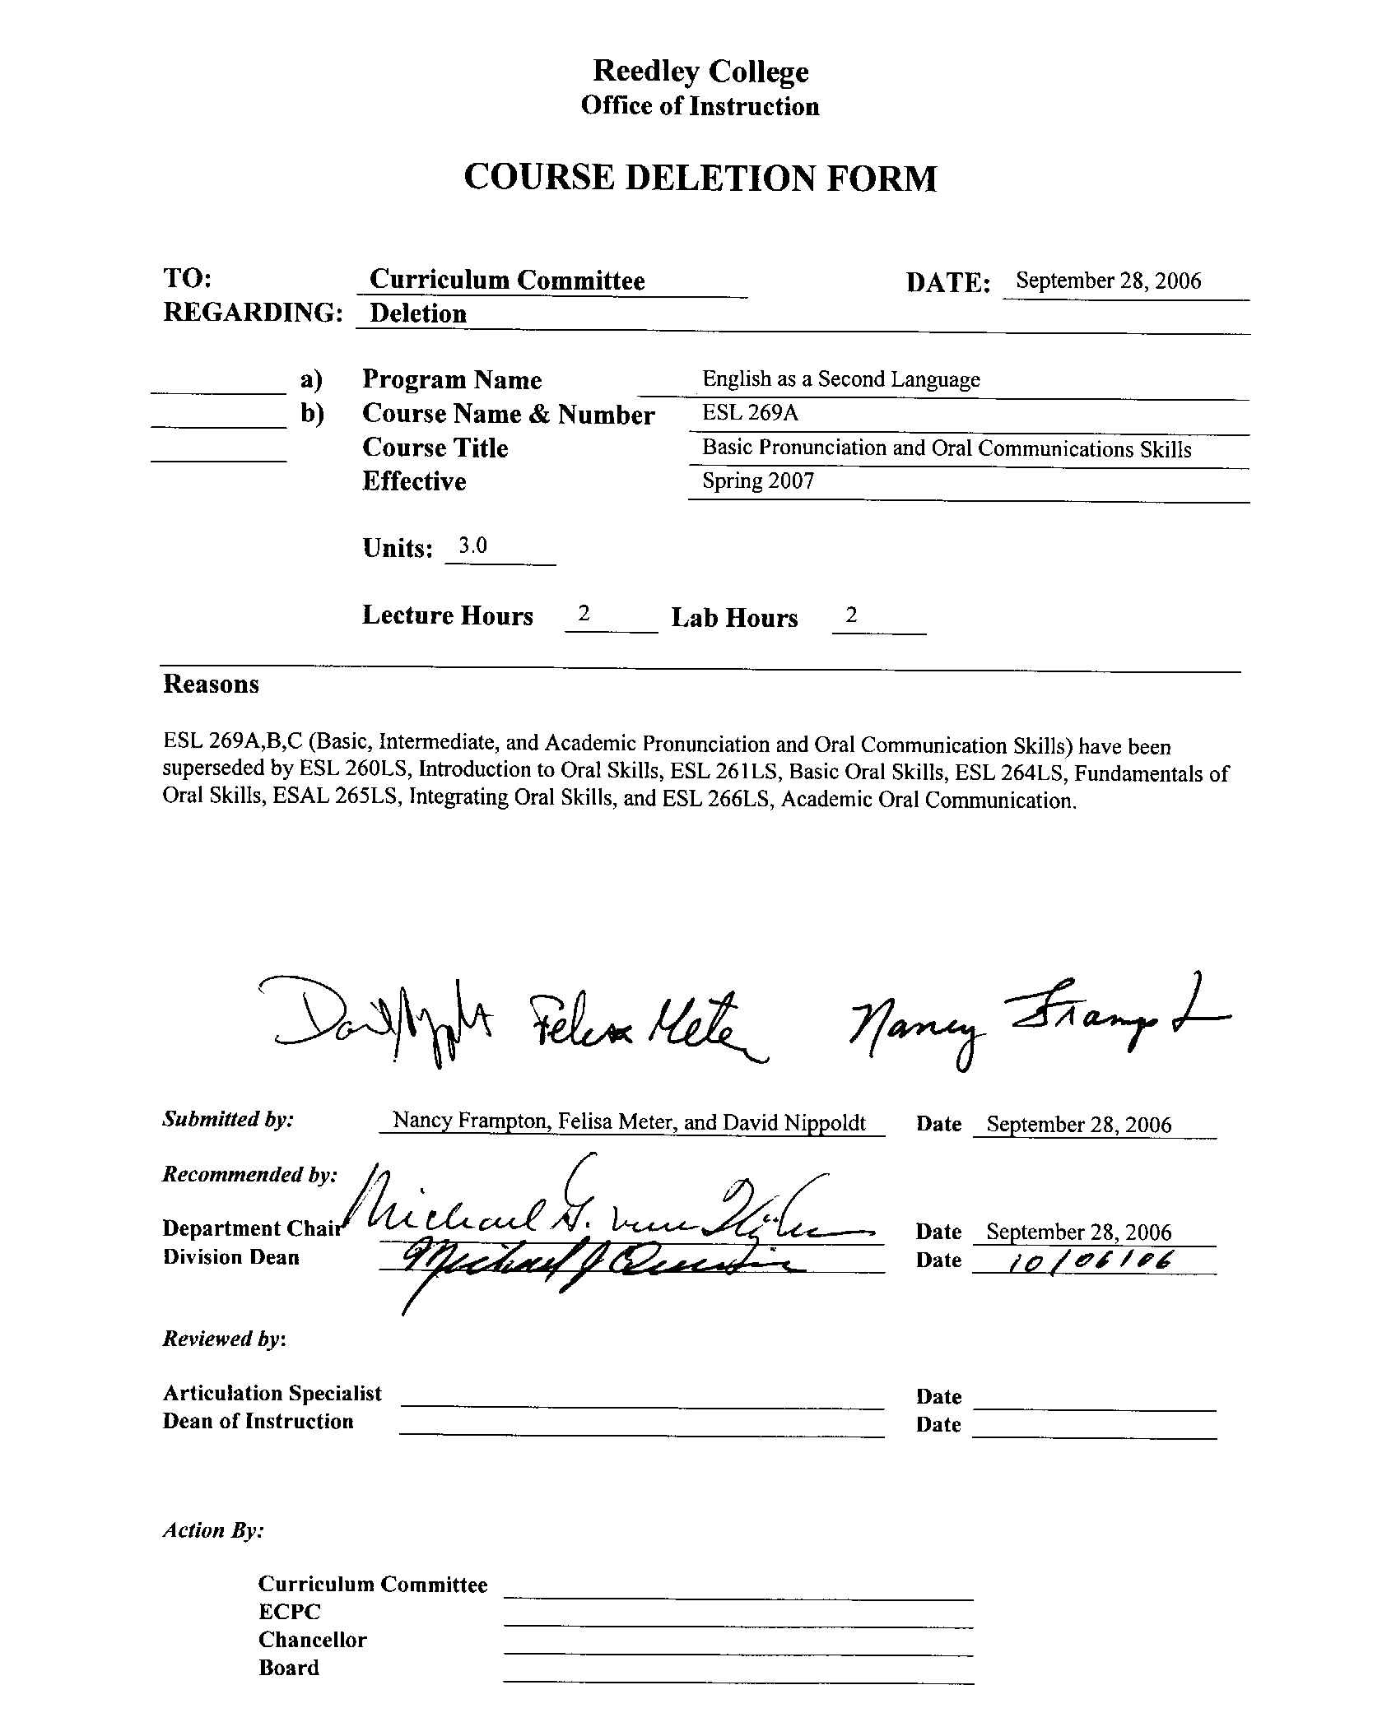
REEDLEY COLLEGE

CREDIT COURSE OUTLINE

(1)  Course ID: ESL 269A |  | (2)  Course Title: Basic Pronunciation and Oral Communication Skills |  |  |  |  |  | (3)  Units: 3.0
(4)Semester Course:  Hours per week | Lec hrs: |  | 2 | (8)Classification:
(4)Semester Course:  Hours per week | Lab hrs: |  | 2 |  | Degree applicable:
*Lab will generate 1 hour(s) per week outside work. |  |  |  |  | Non-degree applicable: |  |  | X
Short-term Course:  Hours per course | Lec hrs: |  |  |  | Pre-collegiate basic skills:
Short-term Course:  Hours per course | Lab hrs:
*Lab will generate ______ total hour(s) outside work.
(5)Grading Basis: | Grading scale only |  |  | (9)RC: | General education:
(5)Grading Basis: | CR/NC option |  |  | (9)RC: | Graduation requirement:
(5)Grading Basis: | CR/NC only |  | X | (9)RC: | Major category:
(6)Basic Skills Prerequisites: None |  |  |  | (10)CSU: | Baccalaureate:
 |  |  |  | (11)Variable units: |  |  |  | No
Basic Skills Advisories: |  |  |  | (12)Repeatable: (A course may be repeated  three times) |  |  |  | 1
 |  |  |  | For Office Use Only
(7)Subject Prerequisites: None |  |  |  | Catid: 10384301 |  | Org Code: 241510
 |  |  |  | Tops Code: 1501.00 |  | SAM Priority: E
 |  |  |  | VEA Code: N |  | Course LHE: 3.50
Subject Corequisites: |  |  |  | Effective Date: Fall 2002 |  | Replaces: ESL 69A
Subject Advisories: |  |  |  | CSU GE Code: 9.1 |  | Replaced by: ESL 260LS, ESL 261LS, ESL 264LS, ESL 265LS, ESL 266LS  Date: Spring 2005, Fall 2004
(13)Catalog Description:

This pronunciation oral communication course is designed for the student with little or no knowledge of English. This course may be repeated once. Designed to be taken concurrently with ESL 260 and ESL 261. Placement by college assessment process.

*See lecture/lab hours in Curriculum Handbook. re 1/98

Course ID: ESL 269A |  | Course Title: Basic Pronunciation and Oral Communication Skills
Course Outcomes /Objectives:

List major objectives in terms of the observable knowledge and/or skills to be attained as a result of completing this course.

Students will:

A. listen with increased comprehension to normal spoken English.

B. make and understand statements and questions within the scope of their knowledge of English vocabulary and grammar.

C. detect and self correct errors they make in spoken English given minimal clues from teachers and other students.

Course Outline:

A. Basic Pronunciation Skills Covered in the Context of Short Phrases and Very Short Dialogues
1. Consonant and vowel sounds
2. Stress and intonation patterns
3. Minimal pairs
4. Reductions

B. Basic Understanding of Short Phrases and Very Short Dialogues

C. Topics Covered
1. Functioning in American societyCschool, family and work
2. Improving consumer and personal skillsCmedical and legal structures
3. Understanding American cultureCliving within a multi-ethnic society

X | Multicultural materials and concepts are appropriately included in this course.  If this line is checked and multicultural materials and concepts are not already included in the outline itself, please write a short paragraph indicating specifically how multicultural materials and concepts may fit into the sections of the outline above.
 | Global or international materials or concepts are appropriately included in this course.

Course ID: ESL 269A |  | Course Title: Basic Pronunciation and Oral Communication Skills
METHODS TO MEASURE STUDENT ACHIEVEMENT AND DETERMINE GRADES:
Students in this course will be graded in at least one of the following four categories. Please check those appropriate. A degree applicable course must have a minimum of one response in category 1, 2, or 3.
Writing
1. Substantial writing assignments, including:
a. essay exam(s) |  |  | d. written homework plus oral (on tape) | X
b. term or other papers(s) |  |  | e. reading reports
c. laboratory reports |  |  | f. other (specify) | X
g. Substantial writing assignments in this degree applicable course are inappropriate because:
 | The course is primarily computational in nature.
 | The course primarily involves skill demonstrations or problem solving.
X | Other rationale (explain) This is primarily an oral course.
Problem Solving
2. Computational or non-computational problem-solving demonstrations, including:
a. exam(s) oral |  | X | d. laboratory reports oral work | X
b. quizzes |  |  | e. field work
c. homework problems |  |  | f. other (specify)
3. Skill demonstrations, including:
a. class performance(s) |  | X | c. performance exam(s) oral presentations | X
b. field work |  |  | d. other (specify) oral lab work | X
4. Objective examinations, including:
a. multiple choice |  | X | d. completion | X
b. true/false |  |  | e. other (specify) listening comprehension | X
c. matching items |  | X
Description/Explanation: Based on the categories checked, it is the recommendation of the department that the instructor=s grading methods fall within the following departmental guidelines; however, the final method of grading is still at the discretion of the individual instructor.

If several methods to measure student achievement are used, indicate here the approximate weight or percentage each has in determining student final grades.

30% Exams
30% Lab Work
20% Homework
20% Final

Reedley College

REQUEST FOR COURSE REPEATABILITY
(For reasons other than alleviating substandard work)

Course ID: ESL 269A |  | Course Title: Basic Pronunciation and Oral Communication Skills | Date: 4/9/98
Number of times course may be repeated, excluding initial enrollment (1, 2, or 3): |  |  |  | 1
or
Maximum units to which course may be repeated, including initial enrollment:
The following information is required under Title V, Part VI, Section 58161
1. Explain how the course content differs each time it is offered:

Oral assignments allow students to work at their level of proficiency and advance at their own rate.

2. Using reasons AA@ or AB@ listed below, explain how the student, by repeating this course, will gain an expanded educational experience (A or B):
X | A. Skills or proficiencies are enhanced by supervised repetition and practice within class periods. Explanation:
Pronunciation and oral communication skills are learned at different rates. Some students require much more time on task.

 | B. Active participatory experience in individual study or group assignments is the basic means by which learning objectives are attained. Explanation:
re 2/98

