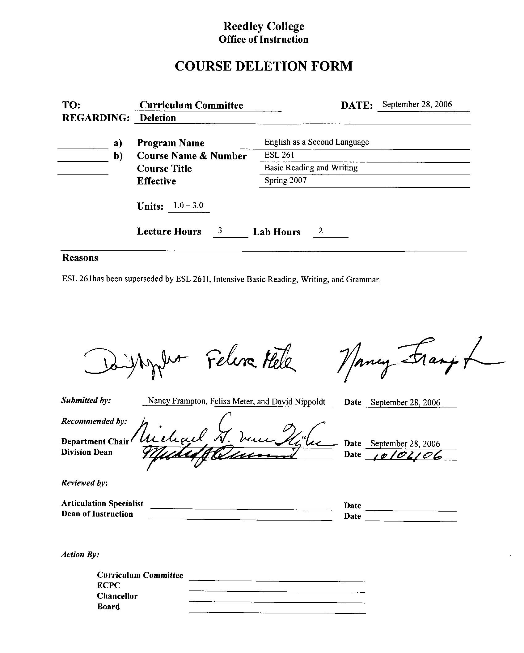
REEDLEY COLLEGE

CREDIT COURSE OUTLINE

(1)  Course ID: ESL 261 |  | (2)  Course Title: Basic Reading and Writing |  |  |  |  | (3) Units:  1.0-3.0
(4)Semester Course:  Hours per week | Lec hrs: |  | 3 | (8)Classification:
(4)Semester Course:  Hours per week | Lab hrs: |  | 2 |  | Degree applicable:
Short-term Course:  Hours per course | Lec hrs: |  |  |  | Non-degree applicable: |  | X
Short-term Course:  Hours per course | Lab hrs: |  |  |  | Pre-collegiate basic skills:
(5)Grading Basis: | Grading scale only |  |  | (9)RC: | General education:
(5)Grading Basis: | CR/NC option |  |  | (9)RC: | Graduation requirement:
(5)Grading Basis: | CR/NC only |  | X | (9)RC: | Major category:
(6)Basic Skills Prerequisites: |  |  |  | (10)CSU: | Baccalaureate:
 |  |  |  | (11)Variable units: |  |  | Yes
Basic Skills Advisories:  Diagnostic ESL test and/or referral from ESL 260 or ESL 264 instructor |  |  |  | (12)Repeatable: (A course may be repeated  three times) |  |  | 1
 |  |  |  | For Office Use Only
(7)Subject Prerequisites: None |  |  |  | Catid: 11032412 |  | Org Code 241510
 |  |  |  | Tops Code: 1501.00 |  | SAM Priority: E
 |  |  |  | VEA Code: N |  | Course LHE: 4.50
Subject Corequisites: |  |  |  | Effective Date: Fall 2002 |  | Replaces: ENGL 61
Subject Advisories: |  |  |  | CSU GE Code: |  | Replaced by: ESL 261I
(13)Catalog Description:

A beginning survival course in English for speakers of other languages. This course is designed to build basic skills in reading, and writing. Can be taken concurrently with ESL 260 or ESL 264.

re 2/97

Course ID: ESL 261 |  | Course Title: Basic Reading and Writing
Course Outcomes /Objectives:

List major objectives in terms of the observable knowledge and/or skills to be attained as a result of completing this course.

A. Reading: Knows alphabet, 500 sight words, can decode basic vocabulary. Identifies basic written vocabulary related to home, work, school, and community in context and can read and respond to basic charts, forms for biographical and employment purposes.

B. Writing: Complete basic charts, forms for biographical and employment purposes. Write simple sentences. Write descriptions.

Course Outline:
A. Vocabulary:

1. Basic home, school, and community vocabulary.

B. Grammar:

1. Articles, demonstratives, quantities
2. Verbs: be, have, can, do, go, buy, sell, work, like, etc.
3. Singular/plural: subject/object pronouns, possessives
4. Tense: Present progressive, simple present
5. Structures: negative/affirmative construction, contractions,
6. Question formation: yes/no, WH- questions

C. Life Skills:

1. Read and write biographical information, numbers, days/months, money. Read telephone directory, classified ads.

D. Writing:

1. Prewriting: List by categories words related by place, use, type.
2. Writing: Construct acceptable, basic English sentences describing self, likes/dislikes, home, school, community environs.

E. Reading:

1. Prereading: Alphabet, sight words, decoding skills, phonetic and morphological analysis.
2. Reading: Factual paragraphs with picture cues.

X | Multicultural materials and concepts are appropriately included in this course.  The textbooks and materials chosen will reflect the multicultural make-up of both the nation and the campus. Students will become familiar with the US which will facilitate their transition to an English-speaking multicultural society.
X | Global or international materials or concepts are appropriately included in this course.  Textbooks and materials will reflect the global background of ESL students.

Course ID: ESL 261 |  | Course Title: Basic Reading and Writing
METHODS TO MEASURE STUDENT ACHIEVEMENT AND DETERMINE GRADES:
Students in this course will be graded in at least one of the following four categories. Please check those appropriate. A degree applicable course must have a minimum of one response in category 1, 2, or 3.
WRITING
1. Substantial writing assignments, including:
a. essay exam(s) |  |  | d. written homework | X
b. term or other papers(s) |  |  | e. reading reports
c. laboratory reports |  |  | f. other (specify) Personal information forms, applications,  medical questionnaires, and other practical forms for everyday survival | X
g. Substantial writing assignments in this degree applicable course are inappropriate because:
 | The course is primarily computational in nature.
 | The course primarily involves skill demonstrations or problem solving.
 | Other rationale (explain)
PROBLEM SOLVING
2. Computational or non-computational problem-solving demonstrations, including:
a. exam(s) |  |  | d. laboratory reports
b. quizzes |  |  | e. field work
c. homework problems |  |  | f. other (specify)
3. SKILL demonstrations, including:
a. class performance(s) |  | X | c. performance exam(s)
b. field work |  |  | d. other (specify)
4. OBJECTIVE examinations, including:
a. multiple choice |  | X | d. completion | X
b. true/false |  | X | e. other (specify)
c. matching items |  | X
Description/Explanation: Based on the categories checked, it is the recommendation of the department that the instructor=s grading methods fall within the following departmental guidelines; however, the final method of grading is still at the discretion of the individual instructor.

If several methods to measure student achievement are used, indicate here the approximate weight or percentage each has in determining student final grades.

EVALUATION Writing Assignments (Homework)* 30%
CRITERIA: Objective Tests (Reading Comprehension) 30%
Computer Lab Work (Reading and Writing) 20%
Final 20%

*Assignments such as short descriptions, dialogues, reports on interviews, summaries of readings, and letters.

UNITS: 80-100% 3 units
70-79% 2 units
60-69% 1 unit
Below 60% No Credit

This is a non-degree applicable Credit/No Credit class. Units recognize student's achievement. Students who are given 1-3 units, receive credit for the class. A student who receives 3 units is best prepared for the next level of instruction.

SAMPLE METHODS OF EVALUATION

A. Subjective

1. Reading and writing activities as follow up of oral activities
2. Writing sentences and short, one-paragraph controlled compositions based on visuals and manipulatives, such as Language Experience and Magnetic Board activities, flash card and picture activities, and anything else which stimulates meaningful written self-expression by students
3. Meaningful reading and writing activities in which English is a tool for expression, not an end in itself

B. Objective

1. Reading and responding to written directions
2. Completion of written exercises
3. Sentence writing

Reedley College

REQUEST FOR COURSE REPEATABILITY
(For reasons other than alleviating substandard work)

Department: English/Foreign Language Date: 5/9/97

Course Number and Title: ESL 261 Basic Reading and Writing
Number of times course may be repeated, excluding initial enrollment (1, 2, or 3): 1
or
Maximum units to which course may be repeated, including initial enrollment:

The following information is required under Title V, Part VI, Section 58161:

1. Explain how the course content differs each time it is offered:

Different reading materials and writing cues will be used every other semester. The level of difficulty will remain the same.

2. Using reasons "A" or "B" listed below, explain how the student, by repeating this course, will gain an expanded educational experience (A or B): A

A. Skills or proficiencies are enhanced by supervised repetition and practice within class periods. Explanation:

ESL students who lack reading and writing skills in their native language need additional repetition and practice. This course will provide such practice for the student who is not ready to continue to the next level, and the repetition should further prepare the student.

B. Active participatory experience in individual study or group assignments is the basic means by which learning objectives are attained. Explanation:

