Reedley College
Proposed Course Modification

Course # / Title | ASL 2, High-Beginning American Sign Language

CHECK OFF SHEET
PRELIMINARY STEPS. Do before completing Course Modification Form.
(EACH BOX SHOULD BE CHECKED AS COMPLETED BEFORE SUBMISSION.)
☑ 1. Communicate with the Curriculum Chair regarding intent to modify an existing course outline (recommended, not required).
☑ 2. List term for implementation of modifications:
[ ] | Fall |  | [ x ] | Spring | 2007 | [ ] | Summer
☑ 3. Check one:
Do not complete Fresno City College course alignment page if:
 | No similar course or program at FCC.
x | Course currently in common with FCC course or accepted in lieu of and changes will not affect status.

Complete Fresno City College course alignment page if:
Course currently in common with FCC course or accepted in lieu of. Changes may affect status. Consult with counterparts at FCC and complete alignment page
Course not in common or accepted in lieu of but may be with proposed changes consult with FCC counterparts

☑ 4. Changes sought in the following:

CSU General Education Code | Yes |  | No | x
Transfer Baccalaureate List | Yes |  | No | x

If yes to either, schedule an appointment with the Articulation Officer
☑ 5. Changes sought in number of repeats for credit:

 | Yes
x | No

If yes, secure a Course Repetition form from the Curriculum Office.
PROPOSED COURSE MODIFICATION FORM
☑ Appropriate sections of Course Outline of Record completed.

FINAL steps (Do after completing Course Outline of Record)

☑ 1. Signature Form. Secure signatures of the Department Chair and the Associate Dean before submitting the completed course proposal to the Curriculum Office.

☑ 2. Program Description. Course modification will change an existing program which is or will be described in the college catalogue.

 | Yes | x | No

If yes, complete Program Description Form before submitting modification.

☑ 3. Final Check. All items above have been completed and checked off before modification is submitted.

Reedley College
PROPOSED COURSE MODIFICATION

All changes and modifications in the official course outline must come to the Curriculum Committee. Though minor changes may seem obvious, even these need to come to committee for information and to update the official curriculum. Changes in programs or in several department offerings should be submitted together if possible so that the whole picture is clear.

OUTLINE. Please fill in current existing course number, title, and units for course to be modified.

Department | Reading and Languages | Course No. | ASL 2
Course Title | High-Beginning American Sign Language | Units | 4.0
 | Effective Date | Spring 2007

A. PROPOSED CHANGES.
(Indicate below all proposed changes to be made in the course outline.)

I. Cover Page
 | 1. Course ID |  |  | 8. Classification (Degree applicable, Non-degree applicable, or
 | 2. Course Title |  |  | Pre-collegiate Basic skills)
 | 3. Units |  |  | 9. General Education Pattern, Graduation Requirement, and
 | 4. Lecture/Lab Hours |  |  | Major Category
 | 5. Grading Basis |  |  | 10. General Education Pattern/Baccalaureate (CSU)
 | 6. Entrance Skills: Basic Skills Prerequisites/Advisories |  |  | 11. Repeatability
 | 7. Subject Prerequisites/Corequisites/Advisories |  | x | 12. Catalog Description

Other pages

x | II. Course Outcomes |  | x | VI. Methods of Grading
x | III. Course Objectives |  | x | VII. Levels of Educational Materials
x | IV. Course Content Outline |  | Additional Pages (optional depending on course)
x | V. Approved Readings |  |  | Request for Repeatability/Limitation on Enrollment

B. DESCRIPTION OF CHANGES AND MODIFICATIONS.

ITEM NO. | CHANGED FROM | CHANGED TO | REASON
II. | See current outline | See proposed modification | Distinguish outcomes from objectives
III. | “ | “ | Distinguish outcomes from objectives
IV. | “ | “ | Simplify; avoid redundancy
V. | “ | “ | Update recommended and supplementary readings
VI. | “ | “ | Provide explanation and consistency
VII. | “ | “ | Update recommended and supplementary readings

(Additional sheets may be attached if necessary.)

C. EXPLANATIONS. If course modification results in changes in the program which will require use of the program description form, please give rationale.

Please attach the complete outline before modifications to this form. If only the first page of the outline is being modified, also attach the new first page. If other pages of the outline are being modified, please attach the complete new outline.

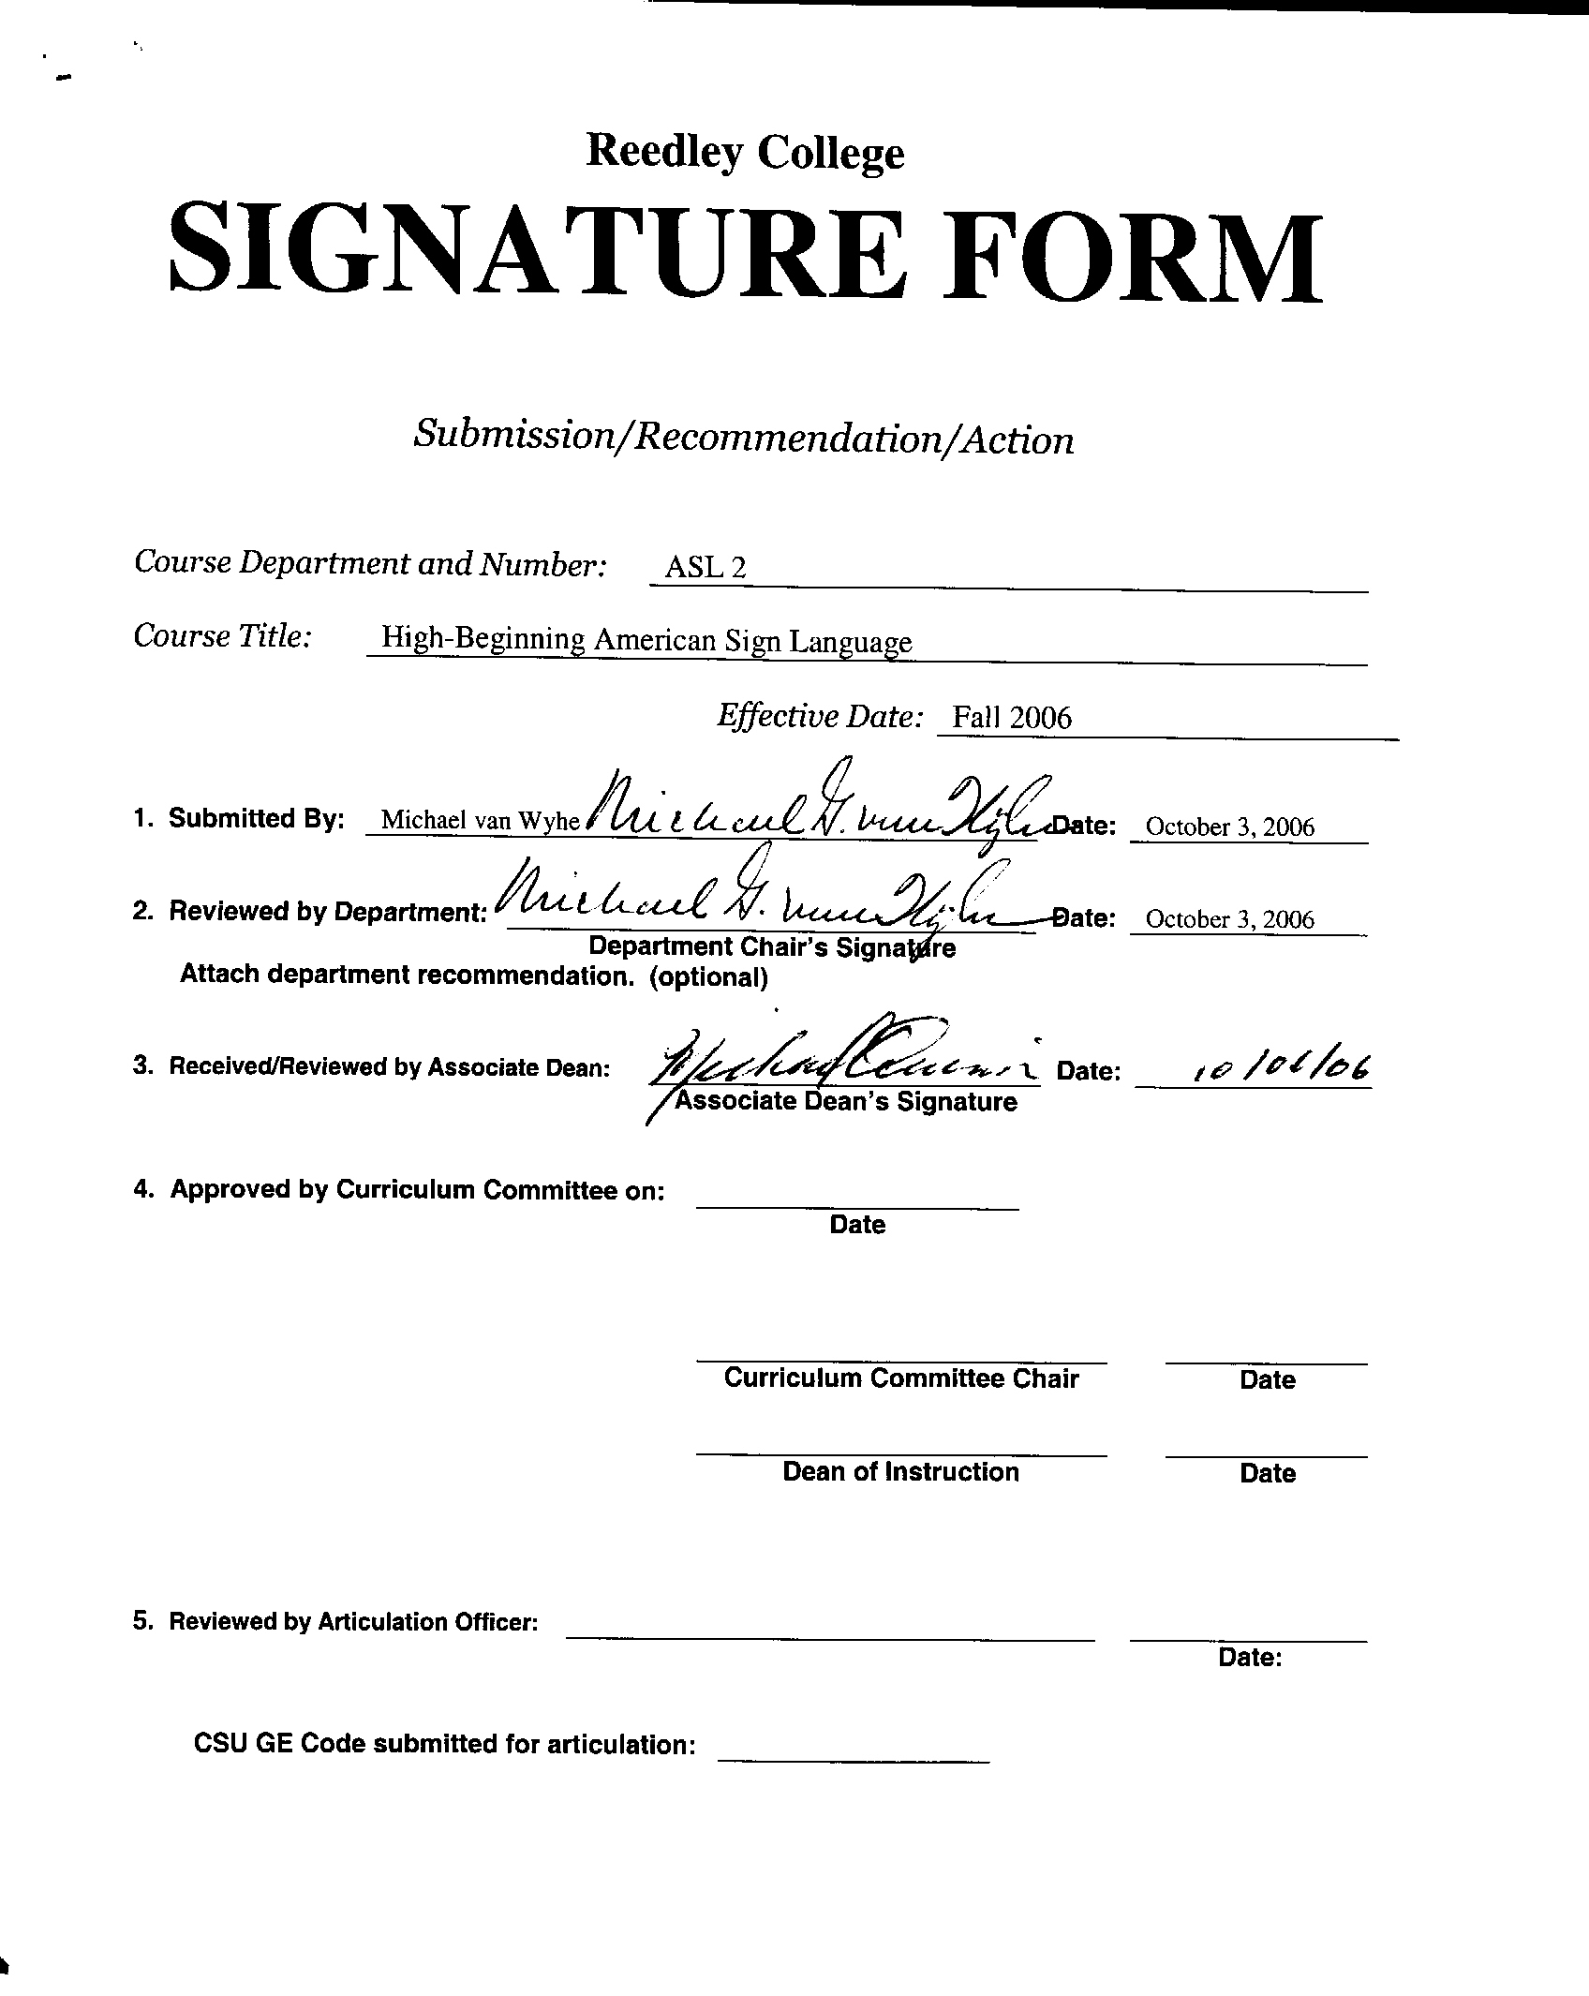



CREDIT COURSE OUTLINE

I. COVER PAGE

(1)  Course ID: ASL 2 |  | (2)  Course Title: High-Beginning American Sign Language |  | (3)  Units: 4.0

(4) Lecture / Lab Hours: |  |  | (8)Classification:
Semester course  Hours per week | Lec hrs: | 4
 | Lab hrs: |  |  |  | Degree applicable: |  |  | X
Lab will generate ______ hour(s) per week outside work. |  |  |  |  | Non-degree applicable:
Short-term course:  Hours per course | Lec hrs: |  |  |  | Pre-collegiate basic skills:
 | Lab hrs:
Lab will generate ______ total hour(s) outside work. |  |  | (9)RC | Fulfills AS/AA degree requirement: (area)
(5)Grading Basis: | Grading scale only |  |  | General education category: |  |  |  | Area C - Humanities
 | CR/NC option | X |  | Major: |  | Liberal Arts
 | CR/NC only
(6)Basic Skills Prerequisites: |  |  | (10)CSU: |  | Baccalaureate: |  |  | X
 |  |  | (11) Repeatable: (A course may be repeated  three times) |  |  |  |  | 0
Basic Skills Advisories:  Eligibility for English 125 and English 126 |  |  | For Office Use Only
 |  |  | CATID: |  |  |  | DATATEL:
(7)Subject Prerequisites (requires C grade or better):  ASL 1 or equivalent skills as determined by an instructor of American Sign Language |  |  | Course LHE: |  |  |  | Unit Code:
 |  |  | VEA Code: |  |  |  | SAM Priority:
 |  |  | TOPS Code: |  |  |  | Effective Date:
Subject Corequisites: |  |  | CSU: |  |  |  | Replaces:
Subject Advisories: |  |  |  |  |  |  | Replaced by:  Date:
(12)Catalog Description:

Second-semester course in everyday communication with the deaf and severely hearing impaired. Development of grammatical structures and expansion of vocabulary. Further study of the culture of the deaf community and appropriate behavior for social interaction with the deaf. Uses only the target language in class.

Course ID: ASL 2 |  | Course Title: High-Beginning American Sign Language

II. COURSE OUTCOMES:

(Specify the learning skills the student demonstrates through completing the course and link critical thinking skills to specific course content and objectives.)

Upon completion of this course, students will be able to:

- use a variety of structures and principles of ASL to ask and respond to a variety of questions appropriate to everyday school and other social situations.

- use ASL to engage in spontaneous conversations and discussions in everyday school and other social situations.

- read a short story and demonstrate satisfactory comprehension by providing a brief, signed summary and providing signed answers to signed questions.

- demonstrate a high beginner level of proficiency in ASL reception and production.

- recognize and state various aspects of the culture of the deaf community and various differences between deaf and hearing cultures.

- demonstrate appropriate and acceptable behavior in social interaction with members of the deaf community.

III. COURSE OBJECTIVES:

(Specify major objectives in terms of the observable knowledge and/or skills to be attained.)

In the process of completing this course, students will:

- employ various techniques to recognize, understand, and use new vocabulary.
- employ various techniques to recognize, understand, and use new grammatical structures.
- watch and respond to a variety of simple signed instructions, conversations, and discussions.
- prepare and deliver signed summaries of short stories and other reading assignments.
- ask signed questions about reading assignments.
- respond to signed questions about reading assignments.
- observe the cultural interaction of the deaf in a variety of social situations.
- observe and practice appropriate social customs and conventions of interaction of the deaf and the hearing in a variety of social situations.

Course ID: ASL 2 |  | Course Title: High-Beginning American Sign Language

IV. COURSE CONTENT OUTLINE:

A. Self-Expression K. Current Events
1. Satisfaction and dissatisfaction 1. Recent news
2. Agreement and disagreement 2. Current issues and topics of interest
3. Concern and feelings

B. Experience L. How Things Are Done
1. Current activity 1. Processes
2. A past event 2. Measurement: Width, length, height, and weight

C. Future Plans and Obligations
1. General future plans
2. Arranging to meet
3. Future obligations
4. Cultural information

D. Directions and Instructions
1. Directions
2. Descriptions of places
3. Instructions

E. Suggestions and Advice
1. Suggestions
2. Time and place
3. Advice

F. Attitudes and Opinions
1. What others think
2. Opinions
3. Values

G. Recreational Activities
1. Activities
2. A sequence of activities
3. Seasonal activities

H. Travel
1. Travel experience
3. Travel plans

I. Occupations and Professions
1. Occupations and professions
2. Job activity
3. Work history

J. The Body, Health, and Emergencies
1. Physical conditioning
2. Health and health problems
3. Emergencies
4. Cultural information

Course ID: ASL 2 |  | Course Title: High-Beginning American Sign Language

V. APPROPRIATE READINGS

Reading assignments may include but are not limited to the following:

A. Sample Text Title:

Humphries, Tom and Padden, Carol. Learning American Sign Language, second edition. Englewood Cliffs, New Jersey: Prentice Hall, 2004.

B. Other Readings:

Cleve, John Vickery and Crouch, Barry A. A Place of Place of Their Own: Creating the Deaf Community in America. Washington, D.C.: Gallaudet University Press, 2000.

Global or international materials or concepts are appropriately included in this course
Multicultural materials and concepts are appropriately included in this course.

If either line is checked, write a paragraph indicating specifically how global/international and/or multicultural materials and concepts relate to content outline and/or readings.

Students continue to learn of the diversity of the culture of the deaf and of the differences between deaf and hearing cultures. Many of the course readings, discussions, and activities focus on and develop knowledge of the conventions, customs, and traditions of deaf culture.

Course ID: ASL 2 |  | Course Title: High-Beginning American Sign Language

VI. METHODS TO MEASURE STUDENT ACHIEVEMENT AND DETERMINE GRADES:
Students in this course will be graded in at least one of the following four categories. Please check those appropriate. A degree applicable course must have a minimum of one response in category A, B or C.

A. Writing
Check either 1 or 2 below
x | 1. Substantial writing assignments are required. Check the appropriate boxes below and provide a written description in the space provided.
 | 2. Substantial writing assignments are NOT required. If this box is checked leave this section blank. For degree applicable courses you must complete category B and/or C.
X | a. essay exam(s) | X | d. written homework
X | b. term or other papers(s) | X | e. reading reports
 | c. laboratory reports |  | f. other (specify)
Required assignments may include but are not limited to the following:

Summary, synthesis, and analysis of textbook readings and selected articles and essays on American Sign Language and the deaf culture.

B. Problem Solving
1. Computational or non-computational problem-solving demonstrations, including:
 | a. exam(s) |  | d. laboratory reports
 | b. quizzes |  | e. field work
 | c. homework problems | X | f. other (specify) Reception and production of American Sign Language
Required assignments may include, but are not limited to the following:

Negotiating meaning and self-expression in American Sign Language requires problem-solving techniques.

Course ID: ASL 2 |  | Course Title: High-Beginning American Sign Language

C. Skill demonstrations, including:
X | a. class performance(s) | X | c. performance exam(s)
 | b. field work |  | d. other (specify)
Required assignments may include, but are not limited to the following:

1. Daily participation in class activities and exercises, including homework preparation.
2. Tests and quizzes, signed and/or written, that measure comprehension, expression,
recognition and knowledge of vocabulary, application of grammatical concepts and structures,
reading comprehension, written expression, and an understanding of basic cultural concepts.
3. Signed presentations
4. Projects, portfolios, or journals: Creative analytical semester projects that require the
demonstration of proficiency in communication skills in receptive and expressive ASL.

D. Objective examinations, including:
 | a. multiple choice |  | d. completion
 | b. true/false |  | e. other (specify)
 | c. matching items

COURSE GRADE DETERMINATION:
Description/Explanation: Based on the categories checked in A-D, it is the recommendation of the department that the instructor’s grading methods fall within the following departmental guidelines; however, the final method of grading is still at the discretion of the individual instructor. The instructor’s syllabus must reflect the criteria by which the student’s grade has been determined. (A minimum of five (5) grades must be recorded on the final roster.)

If several methods to measure student achievement are used, indicate here the approximate weight or percentage each has in determining student final grades.

Approximately: Non-computational problem solving: 25%
Written reports: 25%
Skill demonstration: 50%

Students will be required to demonstrate communicative competence in American Sign Language appropriate for the high-beginning level

FOR DEGREE APPLICABLE COURSES

Course ID: ASL 2 |  | Course Title: High-Beginning American Sign Language

VII. EDUCATIONAL MATERIALS
For degree applicable courses, the adopted texts, as listed in the college bookstore, or instructor-prepared materials have been certified to contain college-level materials.

Validation Language Level (check where applicable): | College-Level  Criteria Met
 | Yes | No
Textbook | X
Reference materials | X
Instructor-prepared materials | X
Audio-visual materials | X

Indicate method of evaluation:
Used readability formulae (grade level 10 or higher) | X
Text is used in a college-level course | X
Used grading provided by publisher
Other: (please explain; relate to Skills Levels)

Computation Level (Eligible for MATH 101 level or higher where applicable)

Content
Breadth of ideas covered clearly meets college-level learning objectives of this course |  | X
Presentation of content and/or exercises/projects:
Requires a variety of problem-solving strategies including inductive and deductive reasoning. |  | X
Requires independent thought and study |  | X
Applies transferring knowledge and skills appropriately and efficiently to new situations or  Problems. |  | X
List of Reading/Educational Materials

Humphries, Tom and Padden, Carol. Learning American Sign Language, second edition. Englewood Cliffs, New Jersey: Prentice Hall, 2004.

Cleve, John Vickery and Crouch, Barry A. A Place of Place of Their Own: Creating the Deaf Community in America. Washington, D.C.: Gallaudet University Press, 2000.

Comments:

Frequent use of video presentations for signing demonstrations

 | This course requires special or additional library materials (list attached).
 | This course requires special facilities:

