Survey was created and sent for all employees to participate from 3/14/2017-3/119/2017.

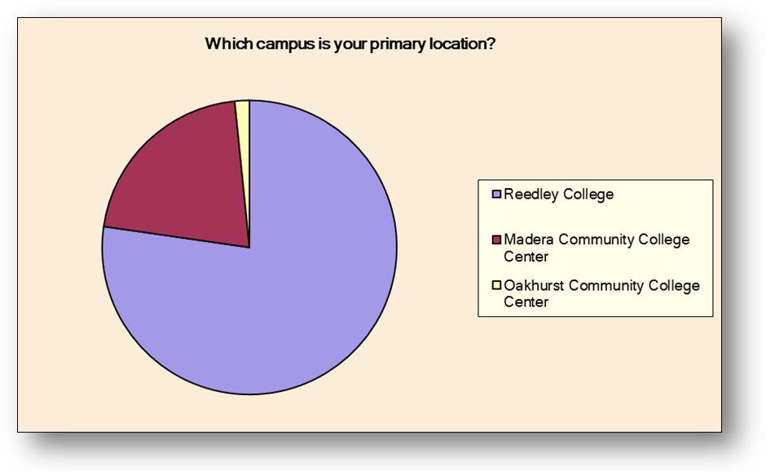
Which campus is your primary location?
Answer Options | Response Percent | Response Count
Reedley College | 77.2% | 95
Madera Community College Center | 21.1% | 26
Oakhurst Community College Center | 1.6% | 2
answered question |  | 123

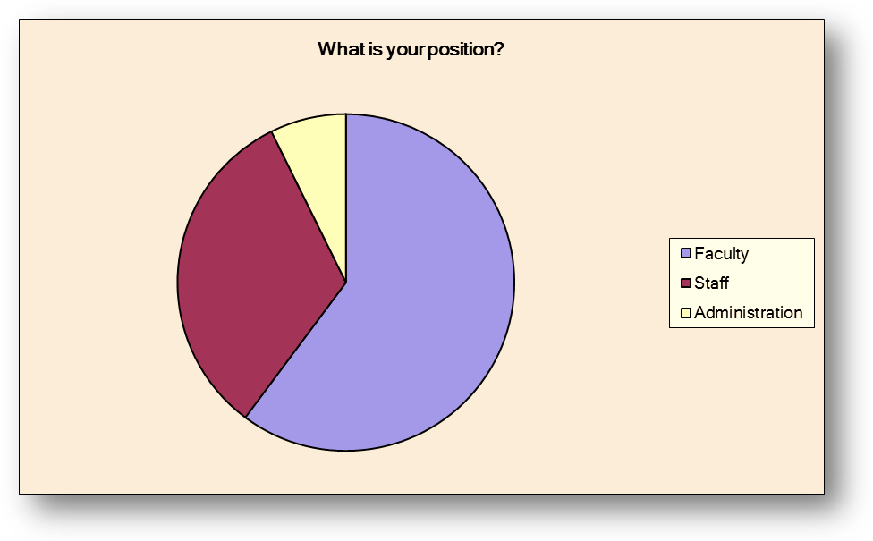
What is your position?
Answer Options | Response Percent | Response Count
Faculty | 60.2% | 74
Staff | 32.5% | 40
Administration | 7.3% | 9
answered question |  | 123

Please select your top FIVE choice of goals:
Answer Options | Response Percent | Response Count | TOP FIVE CHOICES
Basic skills completion, including increasing the number of students successfully transitioning to college-level mathematics and English courses. | 60.2% | 74 | 4
Closing achievement gaps for disproportionately impacted groups. | 44.7% | 55
Improving success rates in degree attainment, certificate attainment, and transfer. | 72.4% | 89 | 1
Improve identification of students at-risk for academic or progress probation and provide support. | 65.9% | 81 | 2
Deeper collaborations with high school districts, workforce agencies, or other community partners, particularly to increase students’ college and job readiness. | 56.1% | 69 | 5
Improve non-credit student success (e.g., course success, non-credit to credit transition and persistence through the program) | 12.2% | 15
Increase student retention through focused engagement in the first term of the students’ attendance. | 65.0% | 80 | 3
Improve access for local students through early college programs and services. | 36.6% | 45
Increase the number of students who complete transfer level math and English in their first year. | 43.9% | 54
Increase student success through contextualized learning and programs. | 31.7% | 39
Other (please specify) | 11.4% | 14
answered question |  | 123
OPEN COMMENT:
Other (please specify) | 11.4% | 14
if we want our students to succeed, we should acknowledge some students do not have the academic skills nor enthusiasm to earn a college degree. Therefore, helping them job obtain skills and learn trades would help these students acheive succeed.
need more trades classes, to help student to learn skills to compete for these good paying Jobs
Teach library resources
Continue to expand CTE programs, equipment & facilities
A systemic change: getting in, getting through, and going beyond. http://www.hup.harvard.edu/catalog.php?isbn=9780674368286
Increase student success through career support prior to college to aid students in selected an informed career goal prior to RTG or the first semester.
develop and require a mandatory first-year Orientation Course
Reedley College should work with feeder high schools to emphasize the necessity of developing academic skills (e.g. listening, note-taking, reading comprehension, studying, etc.), buttressed by discipline and high school administrators who support these goals (and have the will to achieve them).
Living, transportation expenses
Increase Supplemental Instruction offerings.
focus on completing a CTE program
Allowable expenses are specific; these are too general. Unselected above are things that should be done by the College/District regardless of funding source.
online education
A lot of this sounds the same to me??

