
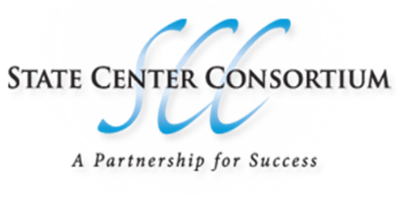

Spring Joint Advisory Meeting

Advisory Committee Minutes

Date: 3/15/2016

Instructor (s) present: David Richey (Reedley College), John Johnson (Reedley College), Keith Zielke (Reedley College, Valley ROP), Jason Asman (Reedley College)

Advisory Members present: Evan DeMello, Administrators, Staff, Others Present: Ronald H. Nishinaka SCCCD Board,

- Meeting Called to Order By Jason Asman
- Minutes reviewed and approved

Second; John Johnson
- Welcome and Introductions
- All members introduced themselves ; Ronald Nishinaka, Student Representative; Evan DeMello RC AMT staff; David Richey, Jason Asman, John Johnson and Keith Zielke

- Industry Trends
  - Labor Market

All RC AMT staff members discussed the many employment opportunities available for fresh A&P mechanics. Several organizations, such as; SkyWest, TechnicAir, NavAir and Northrup Grumman have been looking for new employees. The consensus from all the board members is that the era of huge shortages of aircraft mechanics and pilots is here. Jason reported on. Jason noted that per labor board reports, the aviation technician wages are up approximately 20% since the last reporting term.

  - New Trends in Industry
David Richey gave a summary of Northrop Grumman’s visit; 8 interviewed and 7 job offers. We discussed the new version of FAR147 becoming law this fall and its impact on the program. A lengthy discussion of where the industry is headed and how the new regulation addresses the changes. The trends seem to be going away from hard mechanical skills to system familiarization and heavy use of composites vs aluminum sheet metal. John provided an overview of the Pepestel all-electric flight trainer and its possible implementation in the flight science program, especially during the private flight course and the lack of SLSA status. The aircraft needs a onetime approval to allow commercial use.

  - Equipment and Software

RC AMT staff reported on various ongoing projects and several new teaching aides that have been purchased in the last 12 months; Avotec glass cockpit, Ice and Rain mock-up, CSD cut-a-way and Theilert diesel aircraft engine. Jason Asman reflected on problems with software on our biometric attendance system and the issues with the computers in the lab. Jason commented that the lab computers are due for an update soon. Keith reflected on frustration with trying to purchase parts from Technify for building a usable diesel run up stand. Jason reported on new funds for more lab stations and equipment.
  - Current or Potential Articulations (2+2)

Keith and John gave an overview of dual enrollment for the VROP maintenance and flight. John gave a summery dual enrollment and of the status of the flight program and the issues that still need to be addressed.
- Combined Pathway Events
  - Field Trips and Guest Speakers

  - Job Shadowing/Internships

- Other
  - Dave Richey gave a complete overview of our need to increase enrollment and getting staff members to spend this semester recruiting. John discussed the heavy load that will be placed on our CATS testing site, once the Pilot Program is in place and possible answers.
- Adjournment time: 8:30pm
- Name of Person Taking/Preparing Minutes: Keith Zielke

