Survey was administered 3/28/17 and closed on 3/31/17. Received 104 responses.
This review of responses is from Faculty and Staffs only.
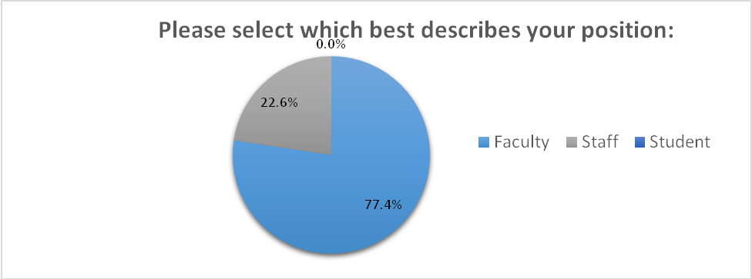

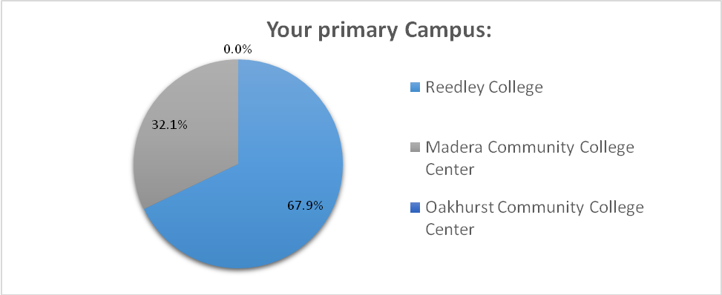

GOAL: Basic skills completion, including increasing the number of students successfully transitioning to college-level mathematics and English courses.

From the list below please select 3 that you believe would have the most significant impact on accomplishing this goal.

TOP 3
Academic Support Centers (i.e. Writing Center, Math Center, STEM Center, etc.) | 59.4% | 60
Increase First Year Experience (FYE) cohorts | 42.6% | 43
Basic Skills Counselor Coordinator (targeting basic skills students and programs) | 39.6% | 40
Remaining
Expand Embedded Tutoring | 38.6% | 39
Expand Supplemental Instruction | 31.7% | 32
Accelerated courses and schedules | 31.7% | 32
Remove Economic Barriers for students (supplies, bus vouchers, meal cards, etc.) | 29.7% | 30
ESL Counselor (targeting ESL students) | 18.8% | 19

GOAL: Improving success rates in degree attainment, certificate attainment, and transfer.

From the list below please select 3 that you believe would have the most significant impact on accomplishing this goal.

TOP 3
Intrusive tracking and follow-up of students through their educational pathway | 54.1% | 53
Increase access to counseling services (for example: online, extended office hours, etc.) | 54.1% | 53
Transfer Counselor | 49.0% | 48

Remaining
Increased marketing around student education plans and graduation requirements | 38.8% | 38
Coordinator for Career & Transfer Services | 37.8% | 37
College visits for transfer | 31.6% | 31
Stackable Certificates | 13.3% | 13
Increase Non-Credit certificate awareness and support | 7.1% | 7

GOAL: Improve identification of students at-risk for academic or progress probation and provide support.

From the list below please select 3 that you believe would have the most significant impact on accomplishing this goal.

TOP 3
Improved participation and follow-up in Early Alert | 63.3% | 62
Intrusive intervention for probation students | 61.2% | 60
Development of Success Plans for probation students | 55.1% | 54

Remaining
Academic success classes for students on probation | 53.1% | 52
Supplemental Instruction for bottleneck classes | 37.8% | 37
Identification of momentum points relevant to retention and academic progress | 23.5% | 23

GOAL: Deeper collaborations with high school districts, workforce agencies, or other community partners, particularly to increase students’ college and job readiness.

From the list below please select 3 that you believe would have the most significant impact on accomplishing this goal.

TOP 3
Increase job development/placement services | 46.9% | 46
College readiness forums (discipline specific meetings with our high school partners) | 43.9% | 43
Collaboration with local feeder schools regarding major selection and career goals. | 40.8% | 40

Remaining
Support for certificate development around local high-demand industries | 39.8% | 39
Targeting of high risk / high need populations (e.g. foster youth, homeless, veterans, etc.) with intrusive counseling and career development | 36.7% | 36
Pathway development for high school enrichment and dual enrollment students | 32.7% | 32
Increased marketing and promotion for current certificates leading to job placement | 31.6% | 31
Increased collaboration with local Adult Education programs. | 20.4% | 20

GOAL: Increase student retention through focused engagement in the first year of the students’ attendance.

From the list below please select 3 that you believe would have the most significant impact on accomplishing this goal.

TOP 3
Expand on-campus face to face orientation. | 79.4% | 77
Comprehensive Summer Bridge program linking high-risk seniors to first semester | 76.3% | 74
Support for conferences and workshops targeting family engagement (ex. Padres Conference) | 45.4% | 44

Remaining
Professional development for culturally responsive pedagogy (conferences) | 34.0% | 33
Annual Cultural Competency Summit focusing on student engagement for disproportionally impacted groups | 24.7% | 24
One Book, One College | 18.6% | 18
Other (please specify) | 21.6% | 21

Mentoring Program focus on first year students
honestly most of the above choices will not increase student engagement
Early Alerts regarding student attendance/grades from Faculty
First year mandatory course - small hour/unit value
none of above. faculty advising; student orientation by major; cohorts by major
Other than expanding orientations, the rest are a waste of time.
College Success Courses
Required counseling/advising suggestions. Connection with a faculty member, or peer connections around a major or foucs of study.
Advertise that attendance is a big part of success
College Prepareness workshops, seminars or classes.
Seminars, either in a topics course format or series of workshops, related to student retention issues.
Well you could hold summits, ------- does not feel it is important enough to show up.
First-year experience cohorts
NONE of these will move the needle. None. SB can work if there is better planning and continuation through the fall and spring. Require math and english in the first semester (or at least year). Certainly one of these classes MUST be taken in the first semester. Incentivize the completion of 30 units in two semesters and a summer. Pay faculty to develop career and major showcases which, when properly marketed will be a community and K-12 draw.
Identification of similar major/interests, cohort students for peer support
More intramural sports that promote team building available to all students
all of these ideas listed for goal-5 are bad
non of this will help student retention
Hire FT Activities Director to coordinate student engagement activities and strategies
Expand first-year orientation to include follow-up programs
connect all incoming students to some kind of program: EOPS, SSS, DSPS, STEM, AG, etc

